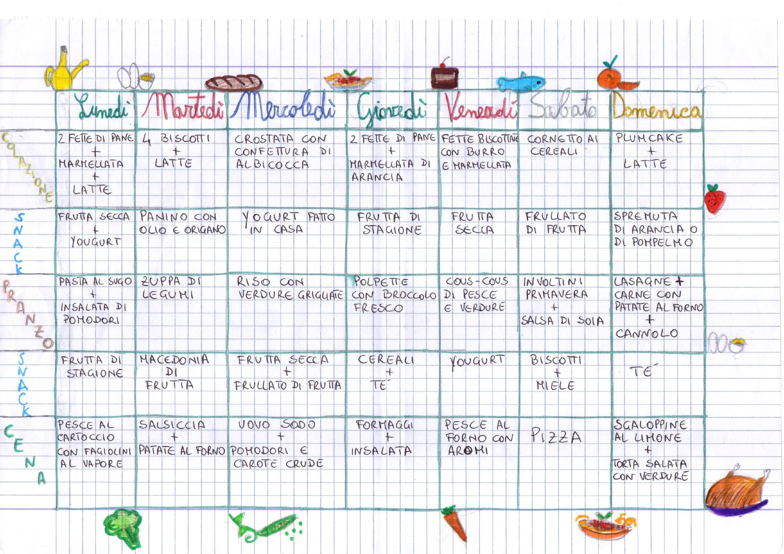Healty family menù

 | Monday | Tuesday | Wednesday | Thursday | Friday | Saturday | Sunday
Break-fast | 2 slides of bread  +Jam  +glass of Milk | 4 biscuits+  +  Glass of  milk | Homemade cake or pie with apricot jam | 2 slides of bread+  Orange jam | 2/3 slides of crisp-bread with butter and jam | Croissant with cereals | Plum-cake  + a glass of Milk
Snack | Dried fruit+  yogurt | sandwich with olive oil and oregano | Home-made Yogurt | Seasons fruit | Dried Fruit | Fruit milk-shake | Orange or  Grapefruit juice
Lunch | Pasta with tomatoes sauce+  Tomatoes salad | Legume soup  (beans, chickpeas,  lentils, ecc…) | Rice with grilled vegetables | meatballs and broccoli | Cous-cous with frish fishes and vegetables | Spring rolls  +  Soy sauce | Lasagne+  Meat with  baked potatoes  + cannolo  (sicilian sweet)
Snack | Frish seasonal fruit | Fruit salad | Dried fruit  +  Fruit milk shake | Cereals  +  tea | Yogurt | Biscuits+  Honey | Tea
Dinner | Baked fish  With steamed green beans | Sousages with baked patatoes | Boiled egg+  Tomatoes and raw carrots | Cheese+  salad | Baked fish with aromas | Pizza | Scallops with lemon  +savory pie with vegetables

