Report Ecoweeks October 1st-26th HEALTHY FOOD
The start
We started thee co weeks ‘healthy food’ with a breakfast in school for all pupils. We started on Monday with information about a healthy breakfast, on Tuesday we had the breakfast for all the pupils. The information was on different levels in the different classes. The breakfast was in mixed groups, younger and older pupils among each other.
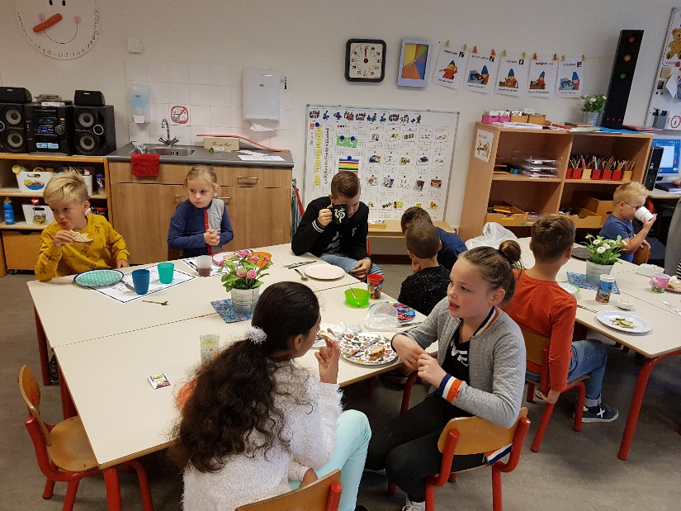

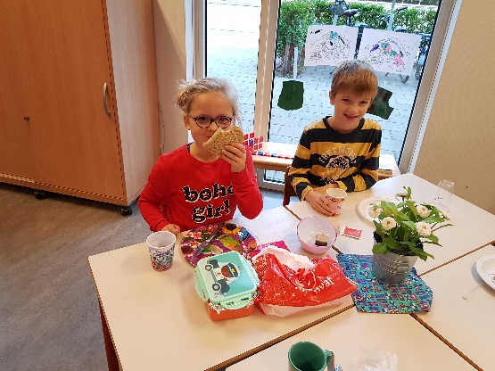

The doctor visited us
For the youngest pupils ”healthy food”has been part of the extended theme “Health”. So a real doctor visited us. Pupils prepared questions for the doctor. Then there was a consultation hour for sick “stuffed animals”. And the pupils talked with the doctor about the tools in the doctors’ suitcase.
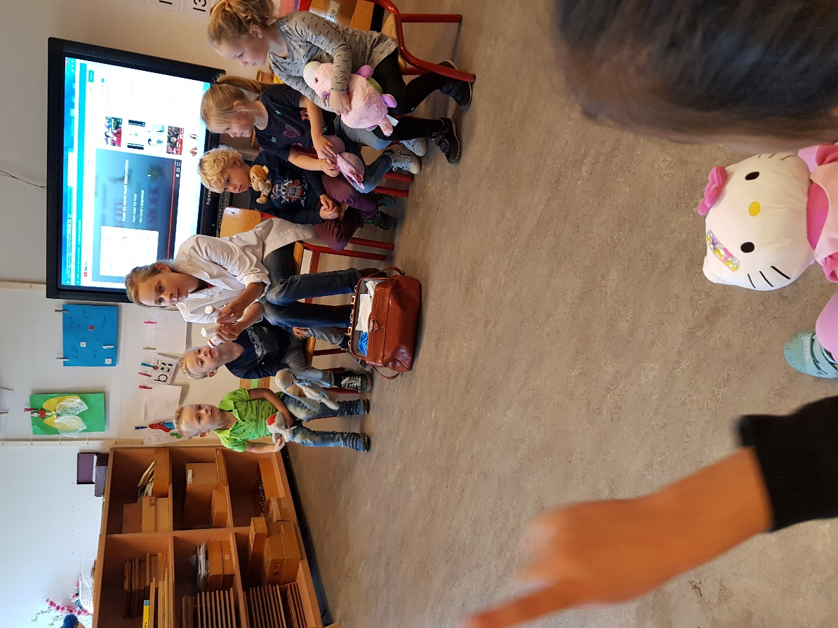

Fruit snacks
The youngest pupils eat their morning fruit or vegetable snacks at about 10 o’clock. They brought fruit and vegetables, putted these on bigger plates and cutted the stuff into peaces, with the help of parents. After cutting everything they could string some parts on the pricks and so they get acquainted with different kind of fruit and vegetables.
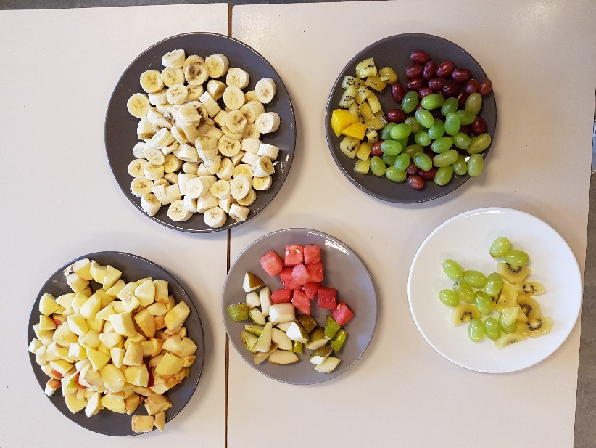

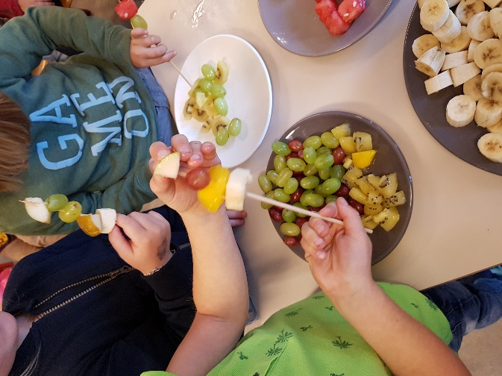

Preparing soup
The theme ‘healthy food’ has the focus on food. Nothing more interesting then preparing your own soup! Pupils invited special guests to tast their own soup. Great fun!
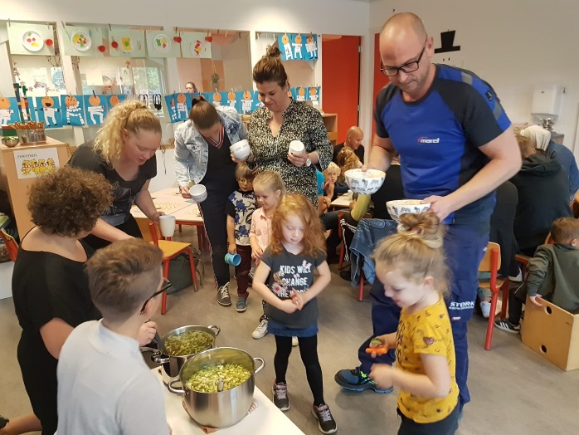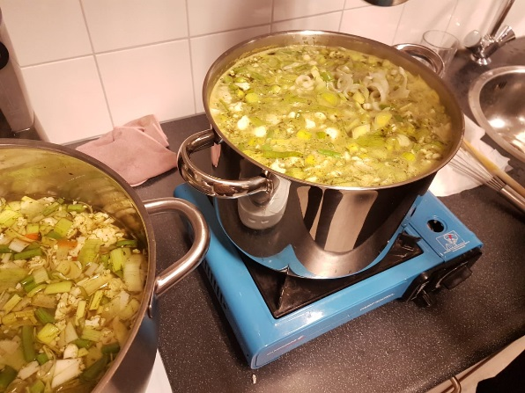
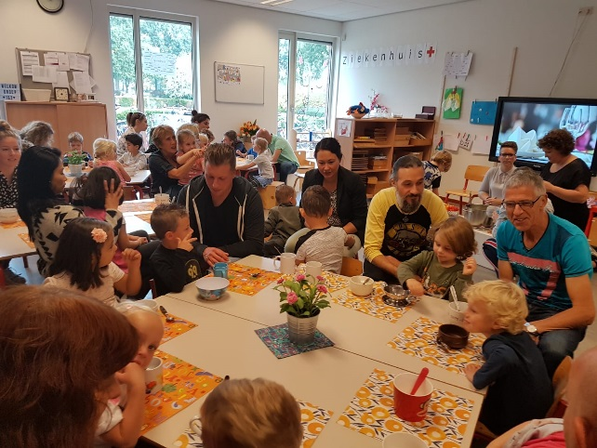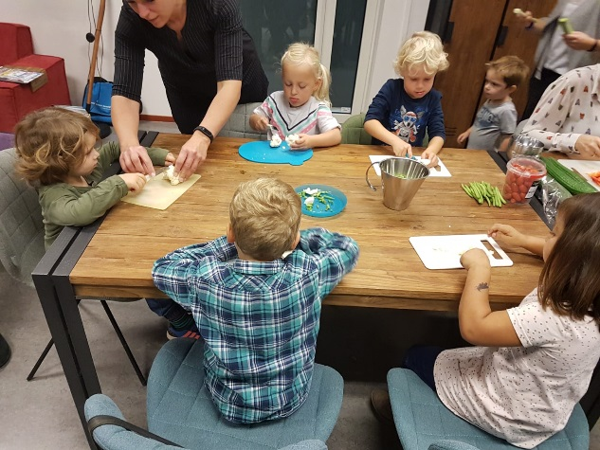

Creative lessons
We teached different kinds of lessons during these weeks. On the pictures you see pupils work: doctors and healthy sandwiches.
