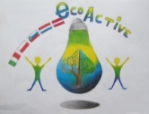 LESSON PLAN 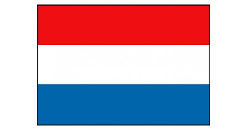
SCHOOL | Weijerwereld
THEMATIC AREA | ENERGY
TEACHER | Imke Kosman, Carin Overbeek
SUBJECT | Energy
AGE GROUP  (approximately) | 12
TIME REQUIRED | 60 minutes
PLACE | CLASSROOM
LESSON OBJECTIVES | What is energy?  What is windenergy?  Experiencing how windenergy works
REGULAR LESSONS YOU CAN USE | - Language, for translation in English of course the English lesson  - Nature knowledge and durability  - Physics
CLASS ORGANISATION | - Pupils work in pairs
MATERIALS | piece of sturdy cardboard 20x20 centimeters  piece of sturdy cardboard (size does not matter)  ruler  pencil  6 paper cups (preferable without print)  scissors  stick 25 centimeters  painters tape  piece of rope  hairdryer / ventilator (not needed for every 2 students)  paint  brushes
ICT TOOLS | IWB with sound
PROCEDURE | Introducing the teachers  Explaining todays goals  Watching a short movie about energy  Talking shortly about what we’ve seen  Watching a short movie about windenergy  Explanation of how to make a windmill, step by step  Working in pairs to built the windmill and to try it out  Cleaning the classroom together  Evaluation about what we learned and showing some examples ogf the made windmills.
EVALUATION
ATTACHEMENTS | PowerPoint  Foto’s of how to make the windmills.

