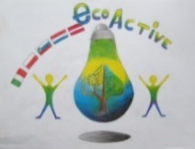 LESSON PLAN 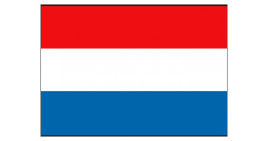
SCHOOL | De Weijerwereld
THEMATIC AREA | Health Workshop cooking
TEACHER | Hetty Bardoel, Thea Willems, Denise de Vlam, Gertjan Vrenken
SUBJECT | Workshops cooking
AGE GROUP  (approximately) | Form 3-4-5 (6-7-8 years)
TIME REQUIRED | ± 1,5 hour
PLACE | Classroom, play-an-learn-square and at home in mothers kitchen
LESSON OBJECTIVES
REGULAR LESSONS YOU CAN USE | - Mathematics (conversion of weights)  - Vocabulary  - Language  - Social skills
CLASS ORGANISATION | - Pupils work in groups
MATERIALS | Groceries from supermarket and cooking utensils
ICT TOOLS | --
PROCEDURE | Children are divided into groups and with the help of parents they prepare / cook a dish. They also carry out the preparatory work themselves and at the end they clean up everything too
EVALUATION | Children liked it very much and it was nice to make a dish yourself, to be allowed to eat. They did not like cleaning up everything!
ATTACHEMENTS | Pictures of the activity
