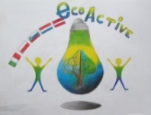 LESSON PLAN 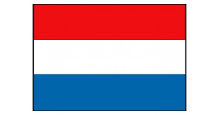
SCHOOL | De Weijerwereld
THEMATIC AREA | ENERGY
TEACHER | Denise
SUBJECT | Orientation on the world
AGE GROUP  (approximately) | 6-7 years
TIME REQUIRED | 5 x 30 minuts
PLACE | Classroom, circle activity
LESSON OBJECTIVES | - Children are introduced to different forms of energy and how they work  - Teaching children to deal with energy in a responsible manner  - Children become acquainted with the cycle of energy
REGULAR LESSONS YOU CAN USE | - Speaking language  - Citizenship
CLASS ORGANISATION | - Classical activity, all pupils involved active
MATERIALS | - https://eneco-energieles.podium.nl/thema/34/thema-1-5 (Dutch website, in Dutch)
ICT TOOLS | - Digiboard  - https://eneco-energieles.podium.nl/thema/34/thema-1-5 (Dutch website, in Dutch)
PROCEDURE | - First introduction movie  - After this discuss different types of energy: wind, solar energy, nuclear energy, but also human energy  - Information of batteries, how they work and collecting used batteries  - Energizer: transport chain, two groups try to whisper a message as quickly as possible
EVALUATION | - make a connection to practice by making a circuit for a nerve game.
ATTACHEMENTS | - picture of the nerve play  