Eco-Active, Weijerwereld, class 7
Friday 19-05
We started our art-project today. The children brouhgt waste from home to school. Stuf you normally throw away, now we use to create something beautiful. This way we produce less garbage. That’s good for the environment.
Together we looked at examples for our art-project. The children could choose one of the examples, or choose something they looked up for themselves.
Luckely the children came with verry creative ideas. We made a nice start today. In two weeks we will continue to work on this project. Now that the kids know what art-project they are going to make, they can collect the waste they need.
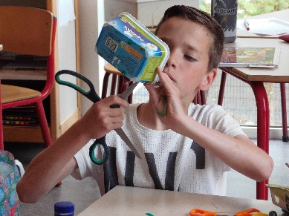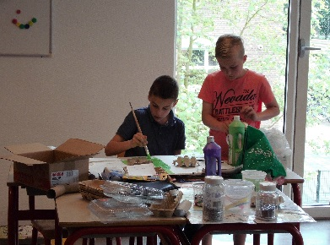
Monday 29-05
The start of out eco-active project was today. We listened to a story about plastic in the world. We had a substitute teacher in our class for three days, because our own teacher traveled to Polen this week for our international project.
Thursday 01-06
Today the entire day we worked at our “Eco-active”-project. We started the day on skype. We talked tot he teachers in Polen. The children asked some questions about the project in Polen and how the teachers are doing. The children also worked really hard at there art-projects!
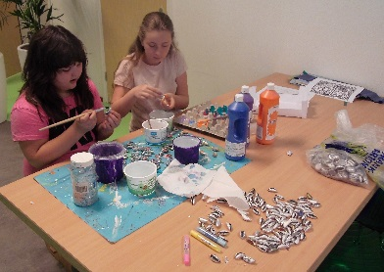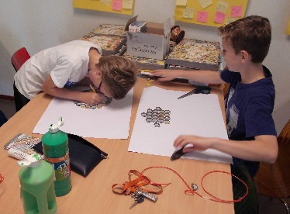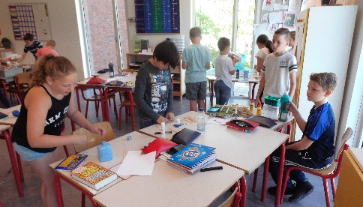
Friday 02-06
Today we had the last day of our project. We made a wordweb about “eco-Active”, what did we learn and talk about this week? We also finished our art-projects. We also watched “klokhuis”, a small documentary about garbage.
In the afternoon we made a museum in our classroom. The parents and children of our school went to see all the artworks made out of carbage this week. There were many parents and they were verry enthusiastic. It was verry nice!

