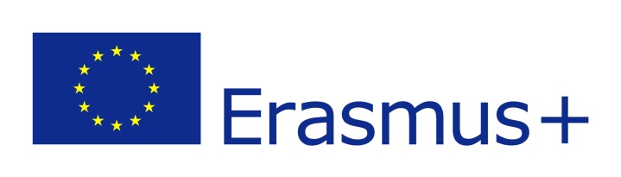

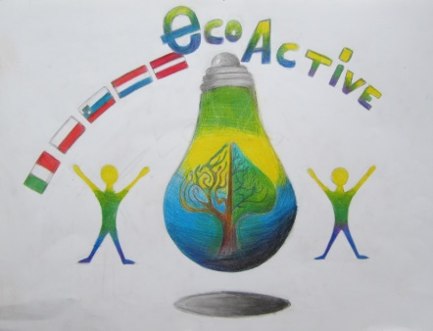
ECO-ACTIVE
Erasmus+ programme
newsletter 1.06.2018 – 31.08.2018

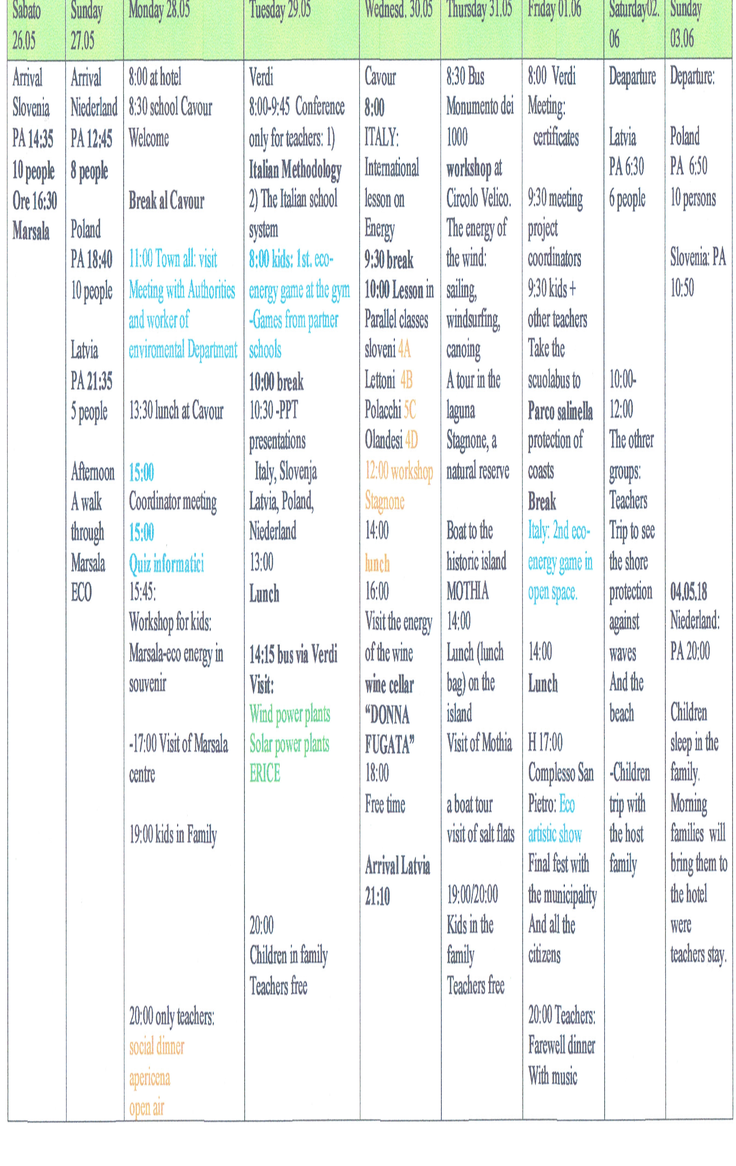
MEETING IN SICILY, ITALY 26th May-3rd June 2018

*)At the end of April there was an eco week in the school. Each day of the week was dedicated to a specific topic. On Monday, there was a market for self-made and unnecessary things.

WELCOMING AT SCHOOL IN MARSALA

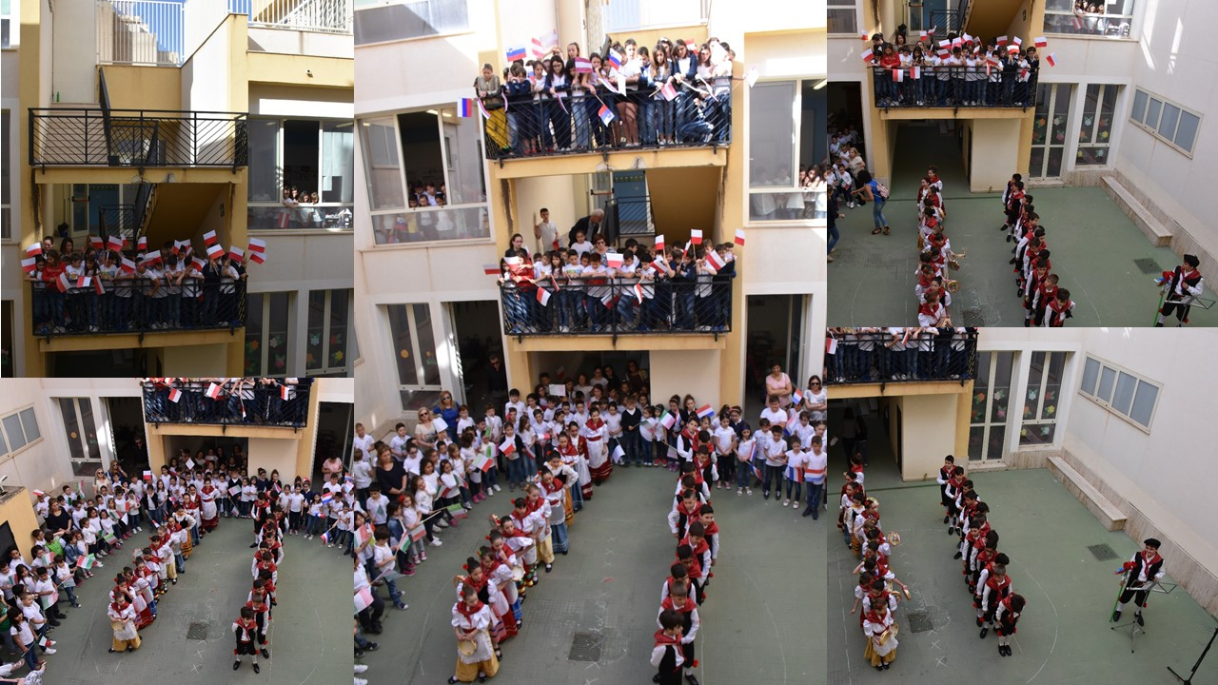

MEETING WITH LOCAL AUTHORITIES AND A MEMBER OF ENVIRONMENTAL DEPARTMENT OF MARSALA CITY

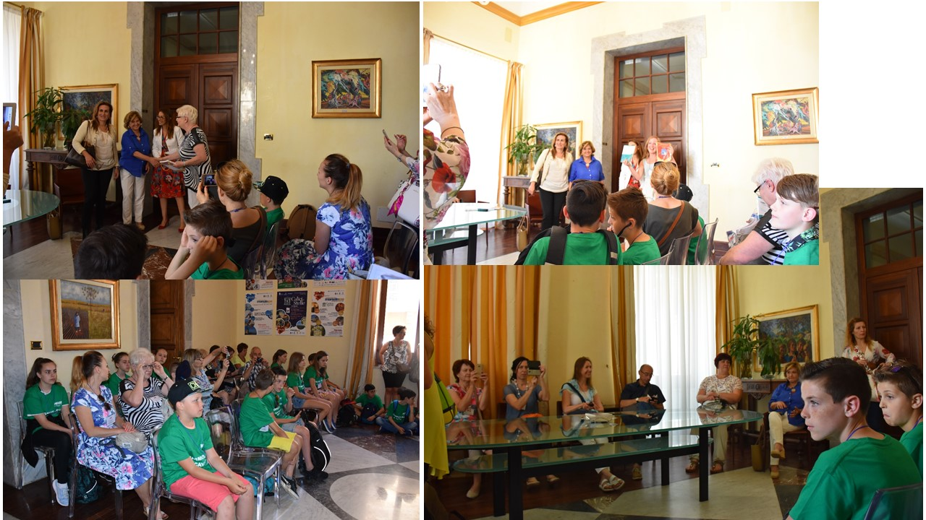
VISITING MARSALA OLD TOWN

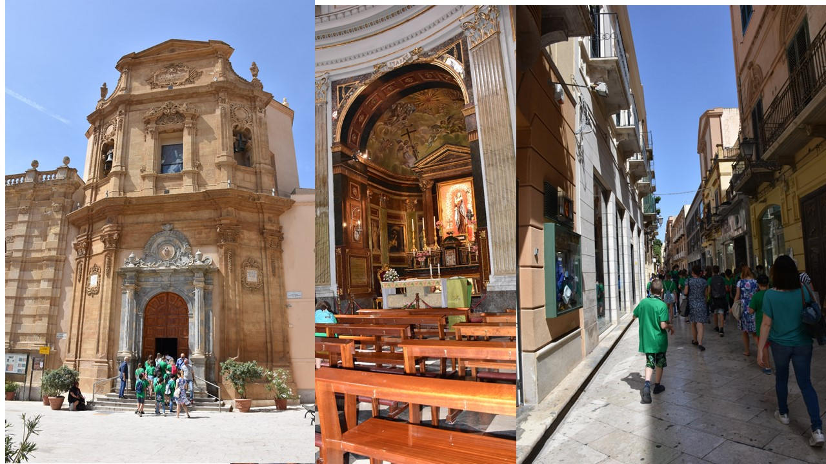

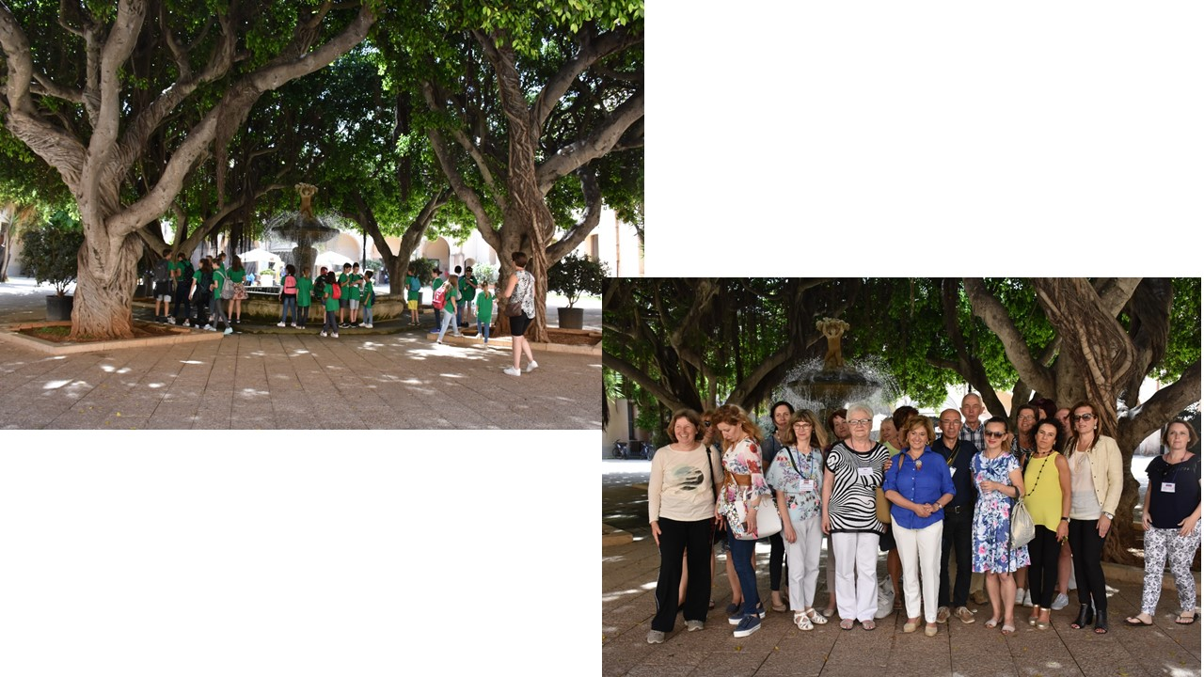

CONFERENCE FOR TEACHERS ON ITALIAN METHODOLOGY AND EDUCATIONAL SYSTEM

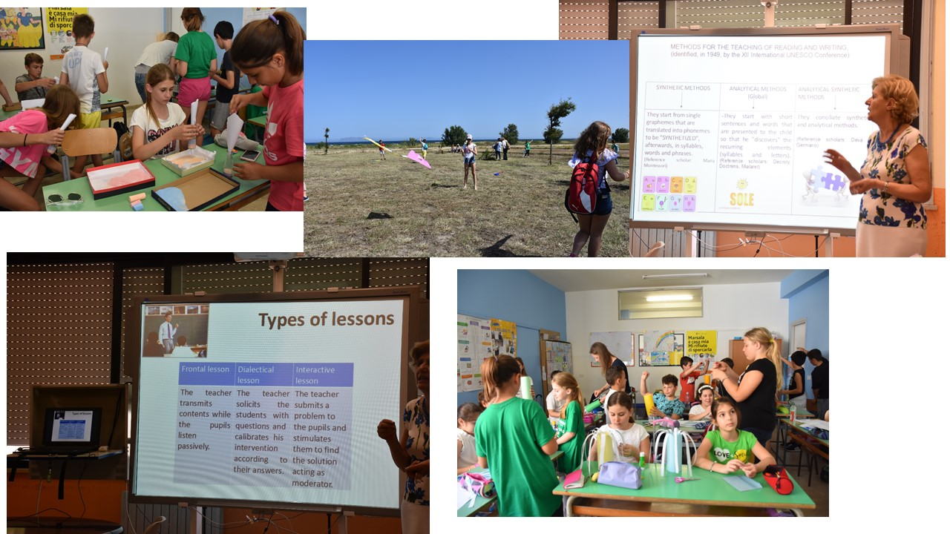

PRESENTATIONS AND GAMES ON ENERGY PRESENTED BY ALL PARTNER SCHOOLS IN SICILY, ITALY

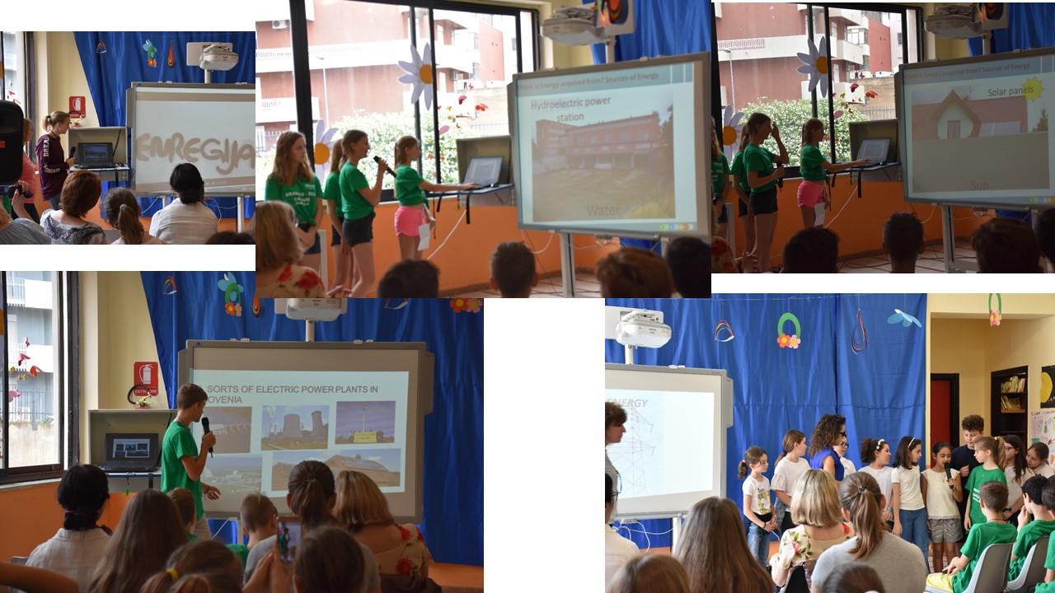

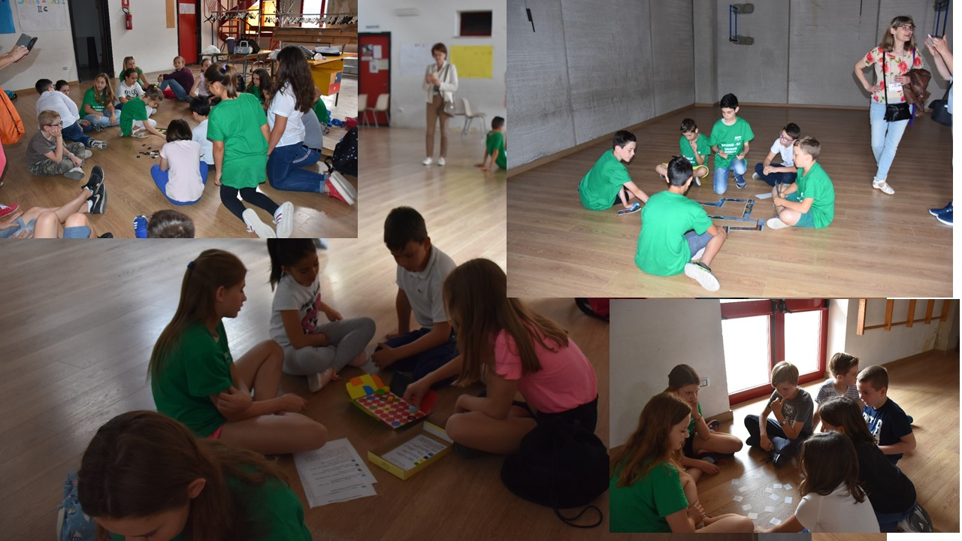

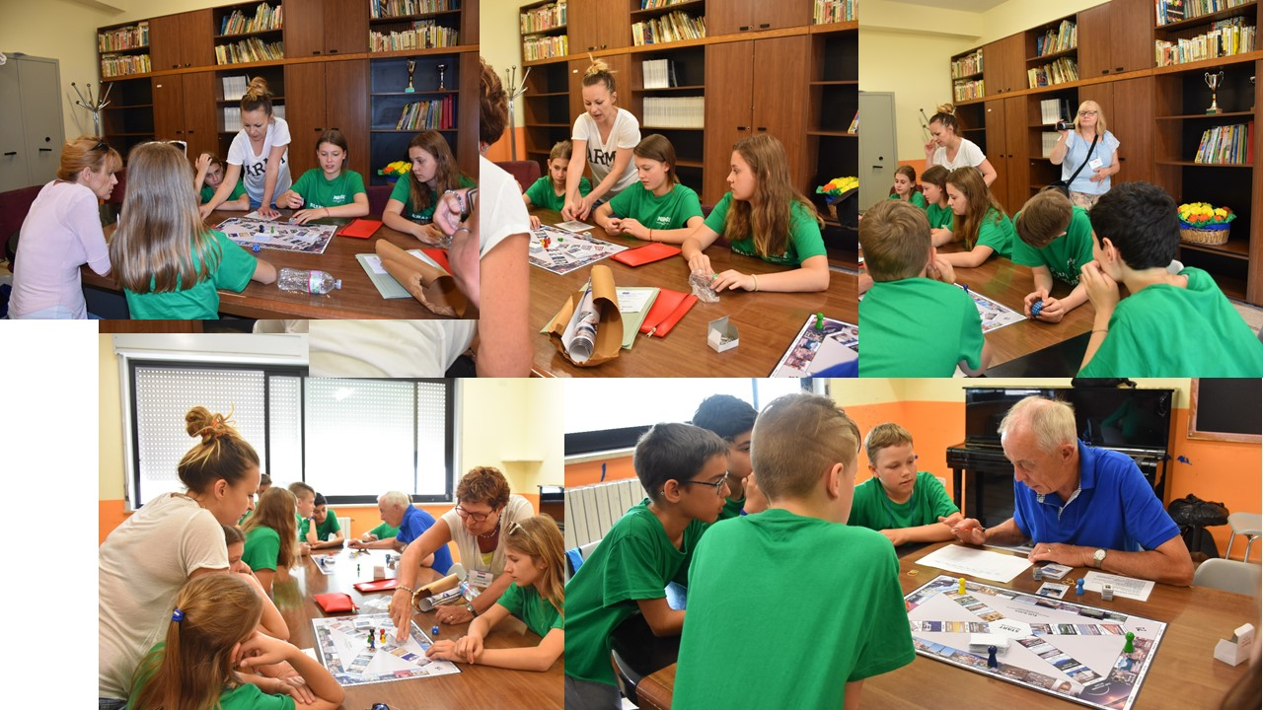
VISTING WIND AND SOLAR POWER PLANTS AND ERICE

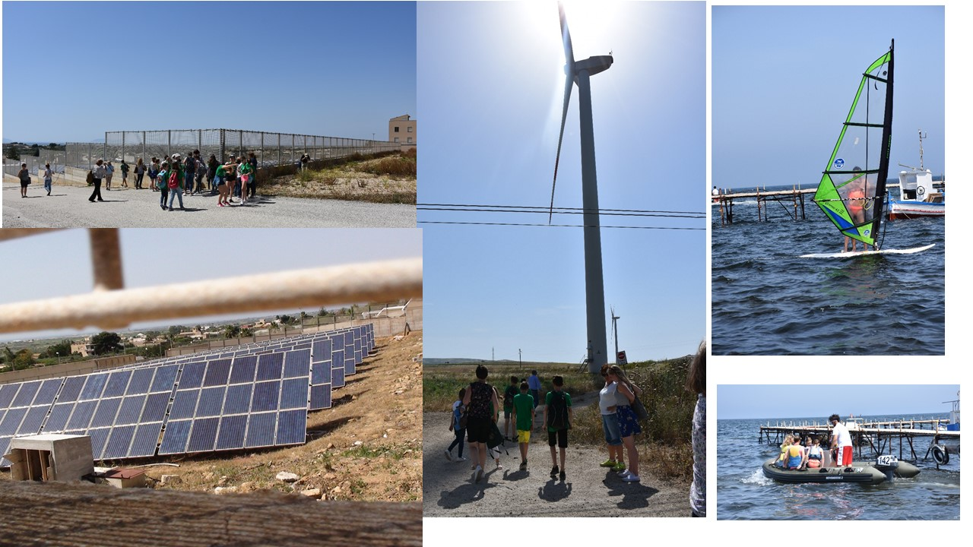
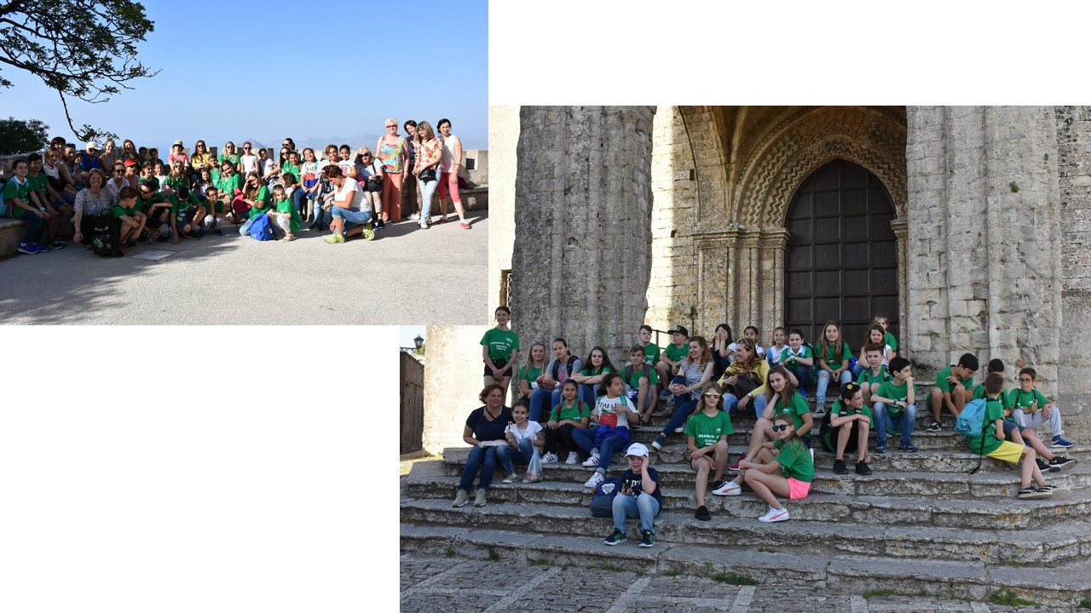

LESSONS IN INTERNATIONAL GROUPS OF STUDENTS

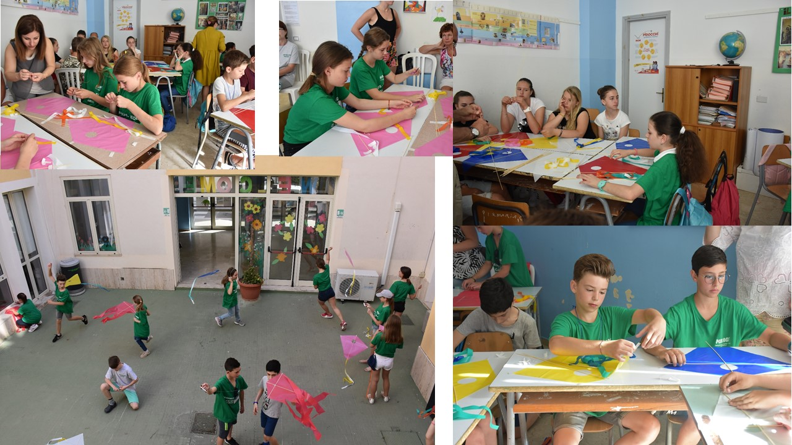

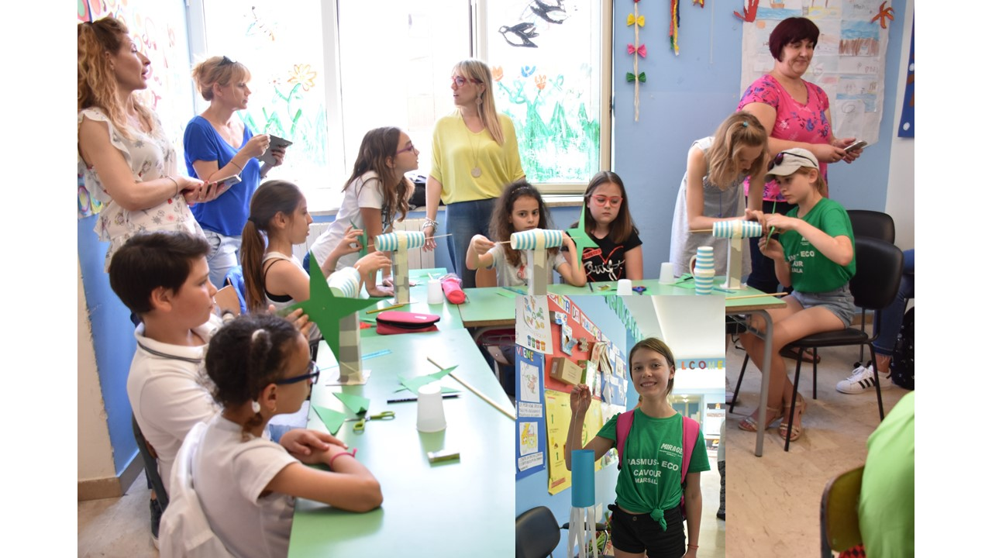
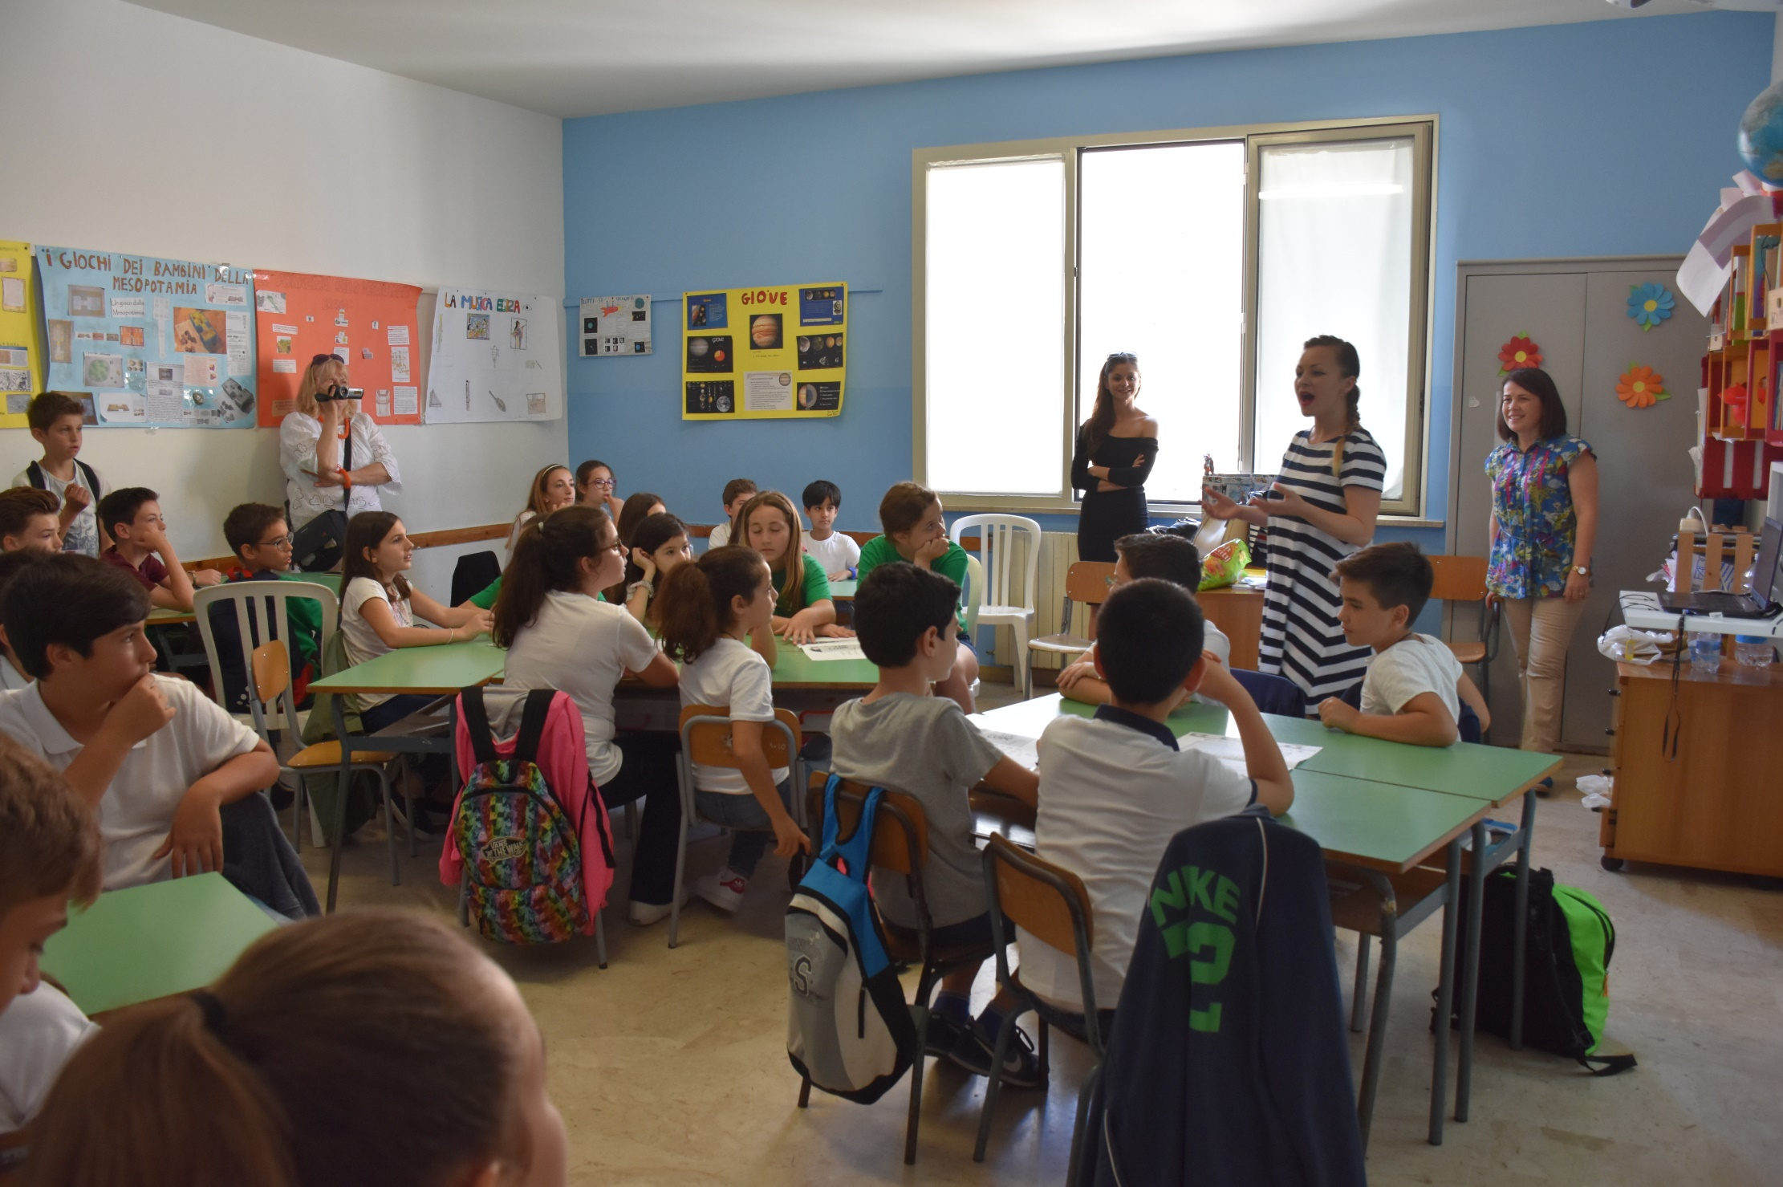

WE COULD EXPERIENCE THE ENERGY OF WIND BY TRYING WINDSURFING AND SAILING
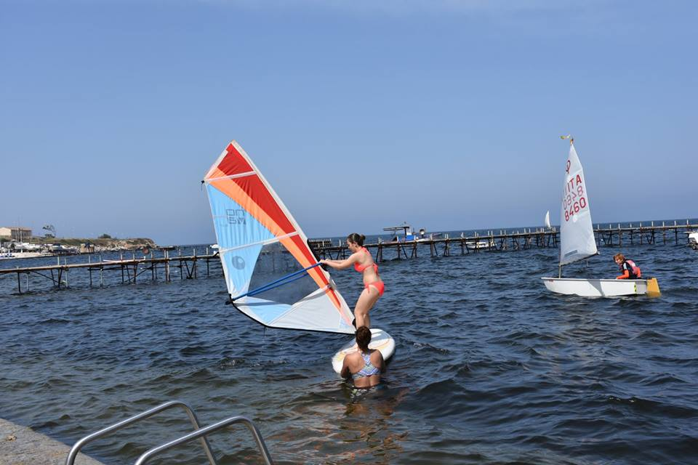

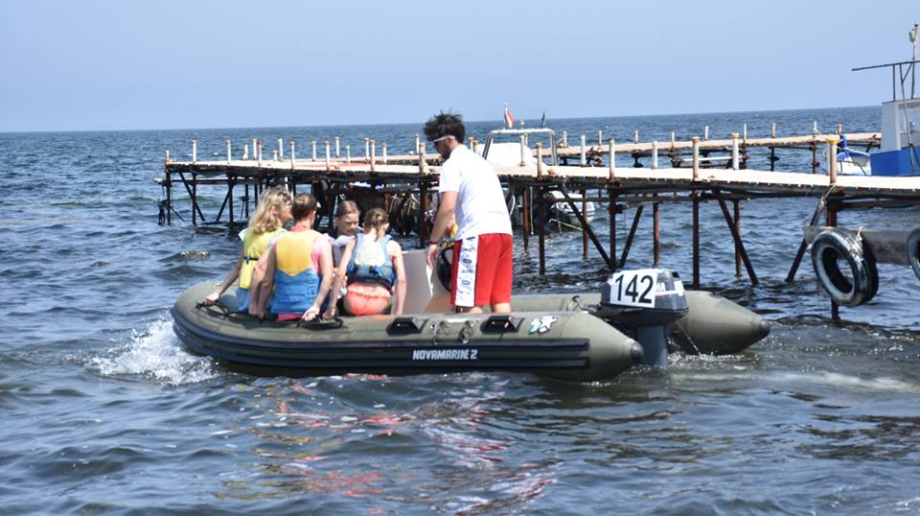
VISITING MOTHIA ISLAND AND SALT FLATS

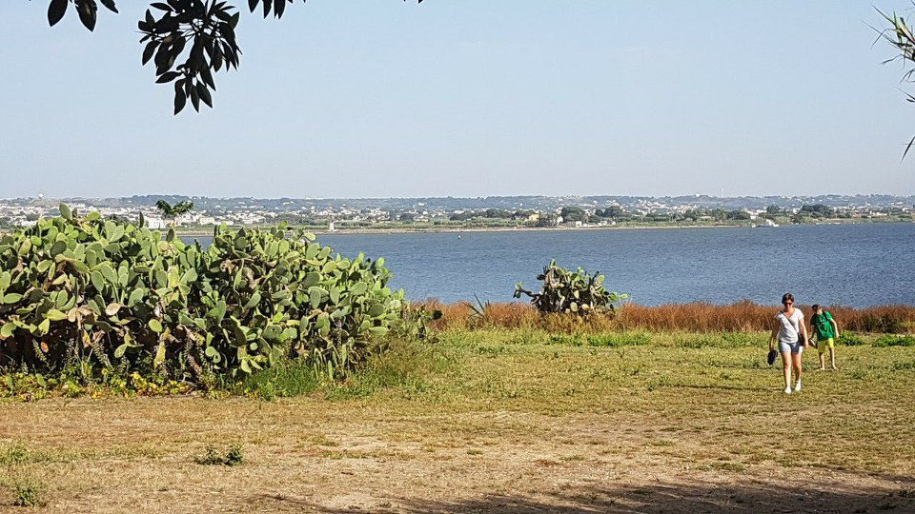

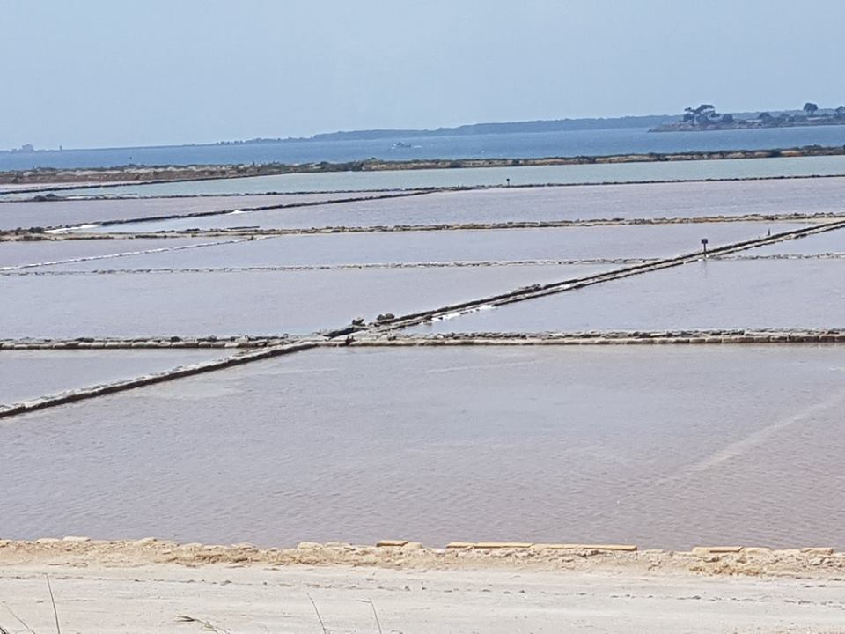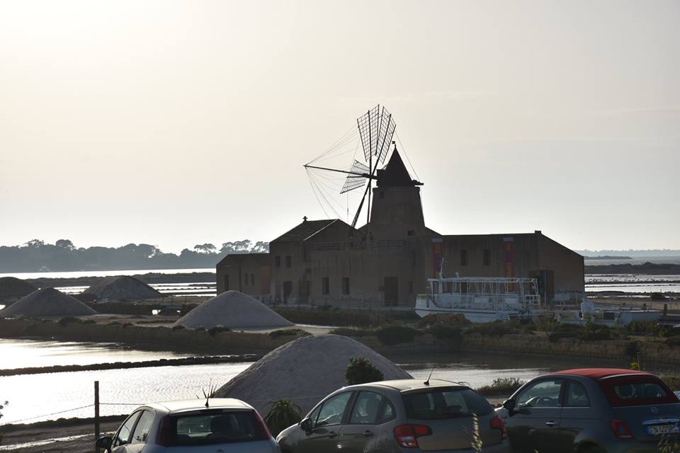

PARCO SALINELLO- THE PROTECTION OF COAST

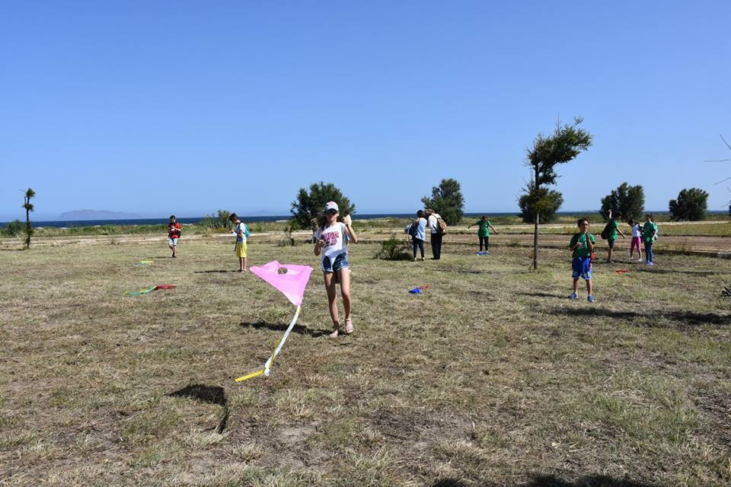

ECO-HAPPENING IN MARSALA

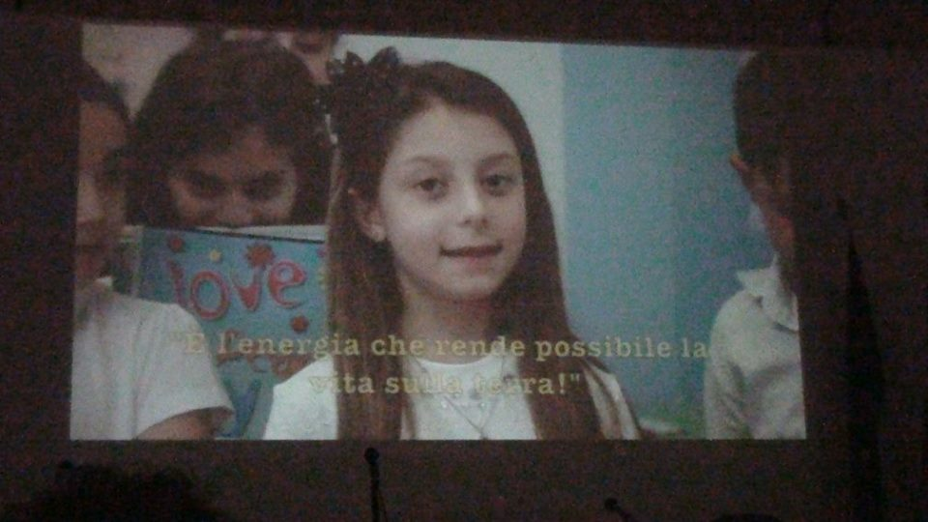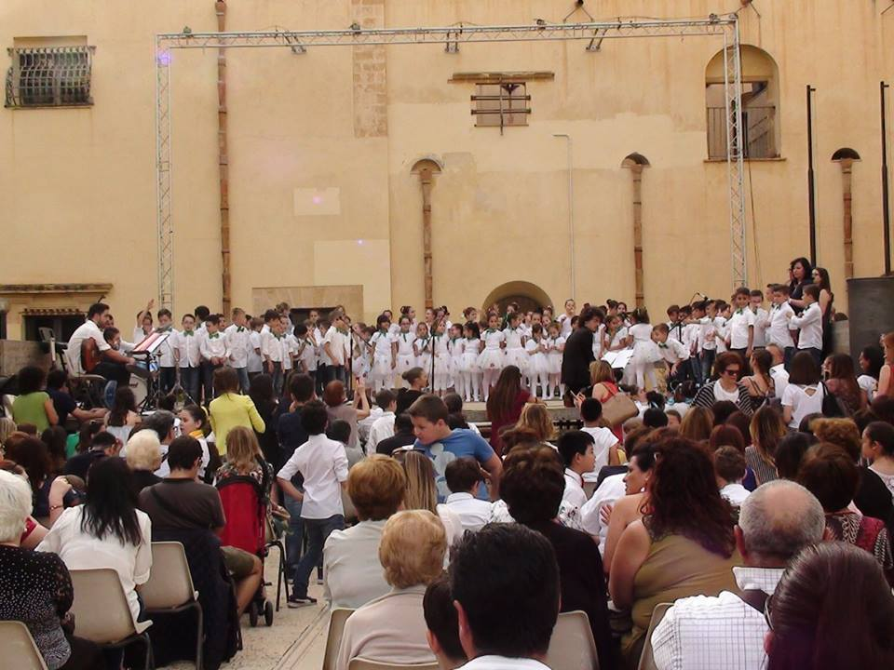

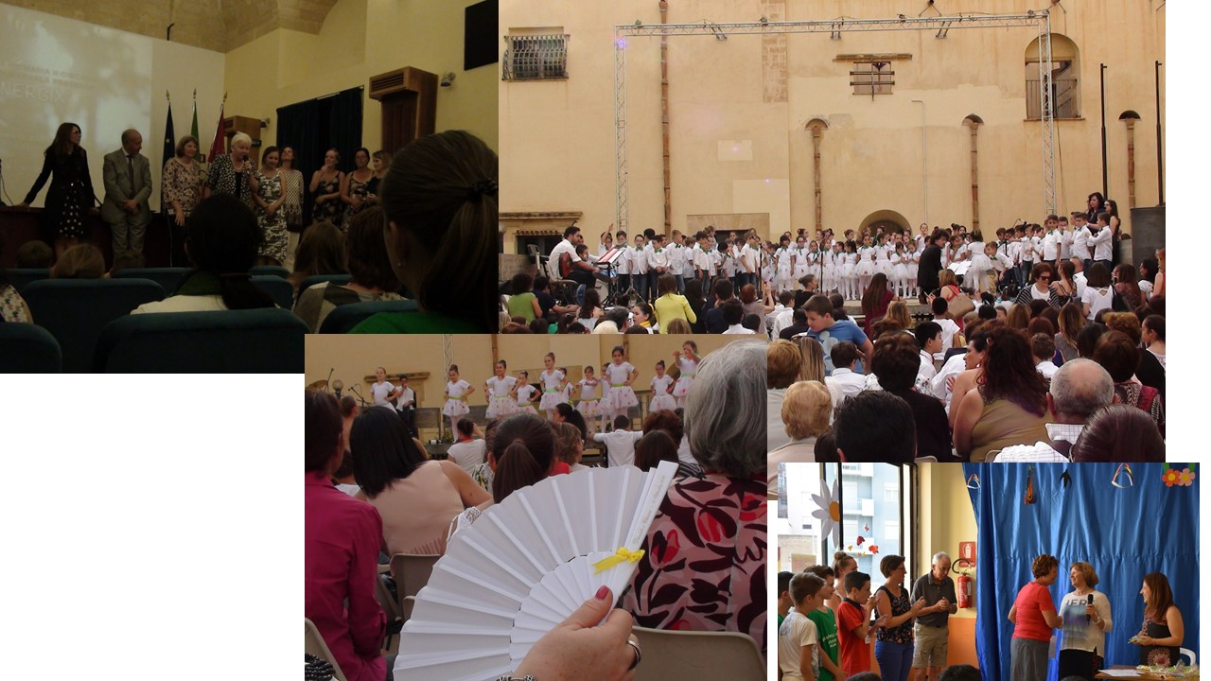

During the visit in Sicily, Italy the Polish coordinator presented the evaluation of the project after 2 years of its implementation. Here are the results:
Videoconferences were carried out throughout the second year of the project. The tabular summary shows the course of videoconferences.

Videoconferences | Italy | Latvia | Slovenia | The Netherlands | Poland
 | 7 | 7 | 6 | 4 | 7

4 (Polish, Italian,Dutch and Latvian partner schools) collected a total of 4539,624 kg of used batteries. Slovenian school was collecting batteries and counted them. They have collected 10901 batteries in units. We have selected the best 3 eco-classes and the best 3 eco-students and we calculated the average amount of collected batteries in kg per student. The figures are presented in the following chart

 | School results in the amount of collected batteries in kilograms by May 21st 2018. | Average amount per student (number of batteries collected at school in kg divided by the number of students at school) | Three best classes in the collection of batteries (specify the amount of collected batteries in kg and class) | Three best students (give the number of collected batteries in kg per each of them and the class)
The Netherlands | 173,5kg |  | No competition | No competition
Slovenia | We were counting the batteries.  The students collected 10901; | We were counting the batteries.  The students collected 10901; there are 296.  36 pieces per student | - A  3. B  4. A
Latvia | 370,515 kg | 3,062 kg | I -3 class – 200,735 kg  II – 6 class – 78,245 kg  III -4 class – 50,163 kg | I –LINARDS ŠTRAUSS – 80,290 kg  II – AMANDA ŠTRAUSA – 78,245 kg  III – RALFS EMĪLS SKADIŅŠ – 40,191 kg
Italy | 430kg | 1,43kg | Class 4a, 100 kg  Class 4b, 60 Kg  Class 4c, 49 Kg | Aguglitta Alice-Class 4a Kg 60  Milazzo Sharon-Class 4c Kg 30  Accardi Viola –Class 4B Kg 28
Poland | 3690,109 | 7,669 | I 3c – 728,400  II 4c – 423,798  III 5a – 365,530 | B.Gieras – 650,000 kg kl. 3c  F. Pokropski – 331,090 kg kl. 5a  K. Majchrzak – 268,608 kg kl. 4c

The students of Polish school collected the biggest amount of batteries.
Polish school became Eco-school, second place. Latvian school and third place Dutch school
Eco-classes:
I place - 3c Polish school
II place 4c Polish school
III place 5a Polish school

Eco-student
1 place: B. Gieras (650,00kg ) Poland
2 place: F. Pokropski ( 331,09 kg ) Poland
3 place: K. Majchrzak (268,61 kg) Poland
The thematic areas in the second year of the project were Water and Energy. On the initiative of students, more than planned videoconferences were carried out. Pupils also showed great initiative in organizing various types of ecological competitions in schools thematically related to the project.

 | Number of lessons about ecology carried out by teachers during educational hour by 05.25.2018 | Number of eco-actions  by 25.05.2018
The Netherlands | 63 | 24
Slovenia | 45 | 12
Latvia | 190 | 37
Italy | 100 | 50
Poland | 481 | 392

Until 25th May 2018 all partner schools provided 879 lessons about ecology and 515 eco-actions.
Lesson plans developed by teachers are placed by all partners on e-Twinning. The summary shows the current number of lesson plans placed at the end of the second year of the project.
 | THE NETHERLANDS | ITALY | LATVIA | SLOVENIA | POLAND
RESOURCES | 3 | 4 | 2 | 2 | 3
WATER | 4 | 2 | 2 | 2 | 2
ENERGY | 2 |  |  | 1 | 3
HEALTH | 3 |  | 1 | 1
In the second year of the project, all schools organized Eco-weeks:
Netherlands 3.10-13.10.2017 . /24.05 – 8.06.2018
Latvia 23-27.04.2018
Slovenia 08/10 - 14/04/2017
Italy 27.05 - 02/06/2018.
Poland 04.06 - 08.06.2018.

ECO-WEEK IN POLAND 4th-8th JUNE 2018

Eco-week in Poland started on Monday 4th June 2018 with the Eco-Happening.

Students tried healthy food and drinks such as joghurt, water, fruits etc.
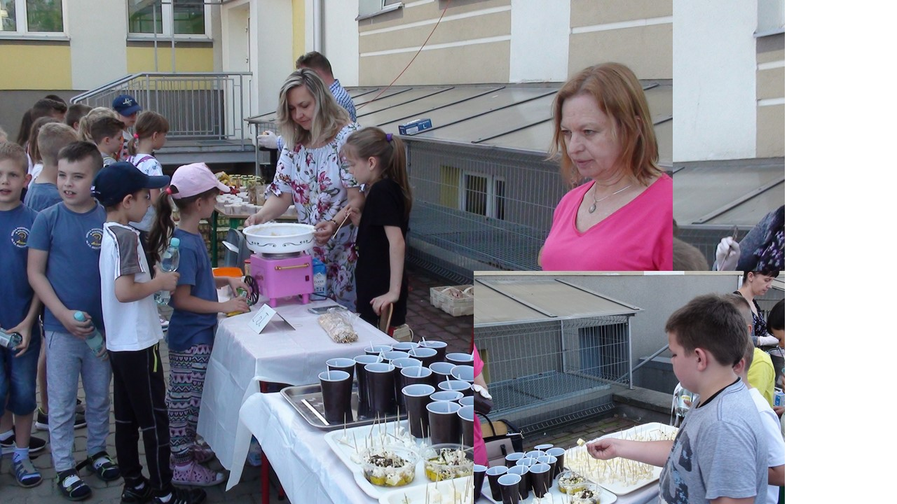

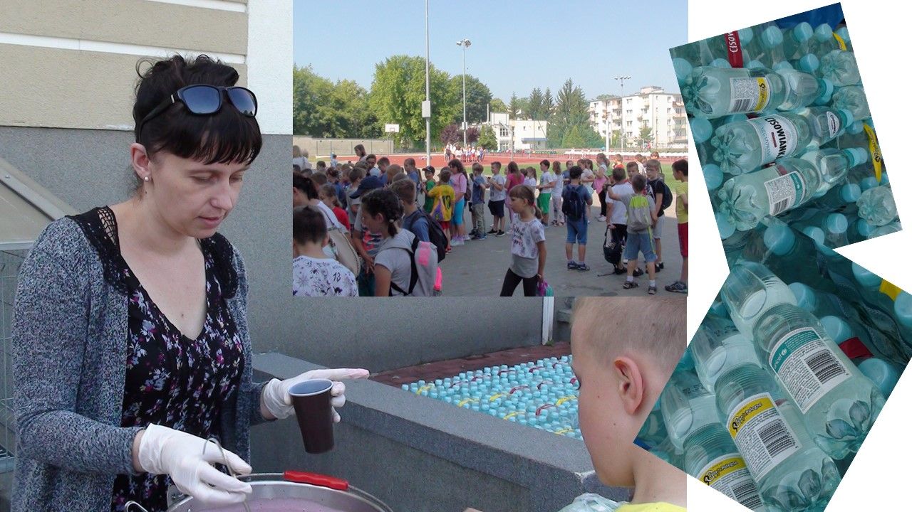

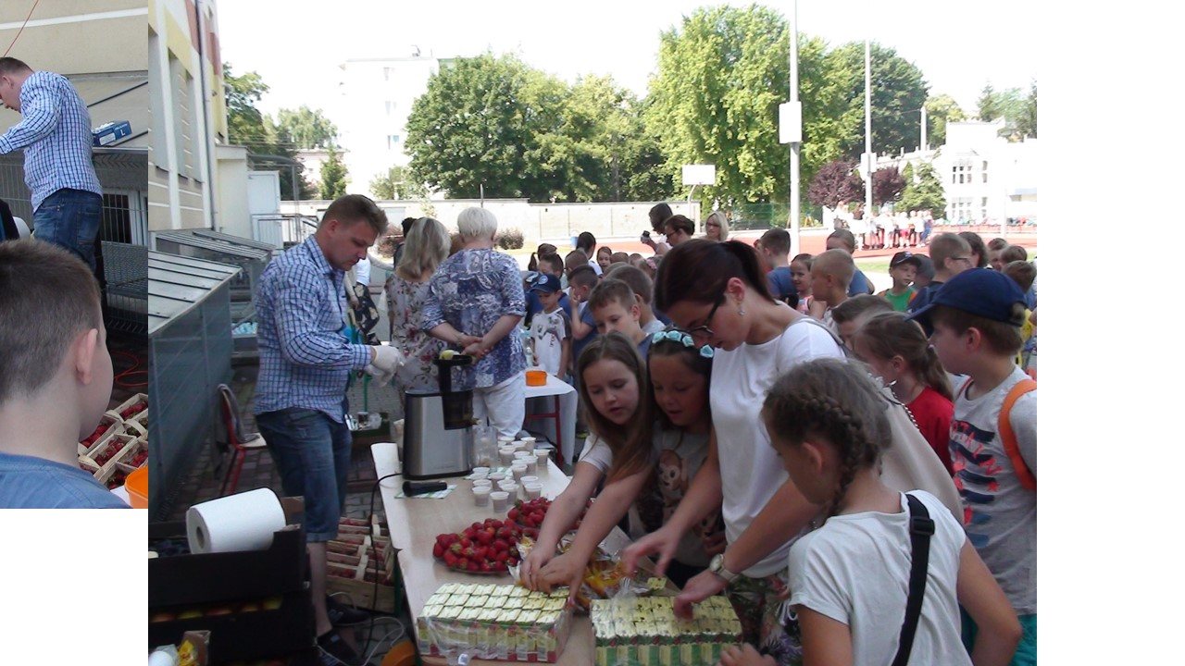

Students took part in sport games and activities

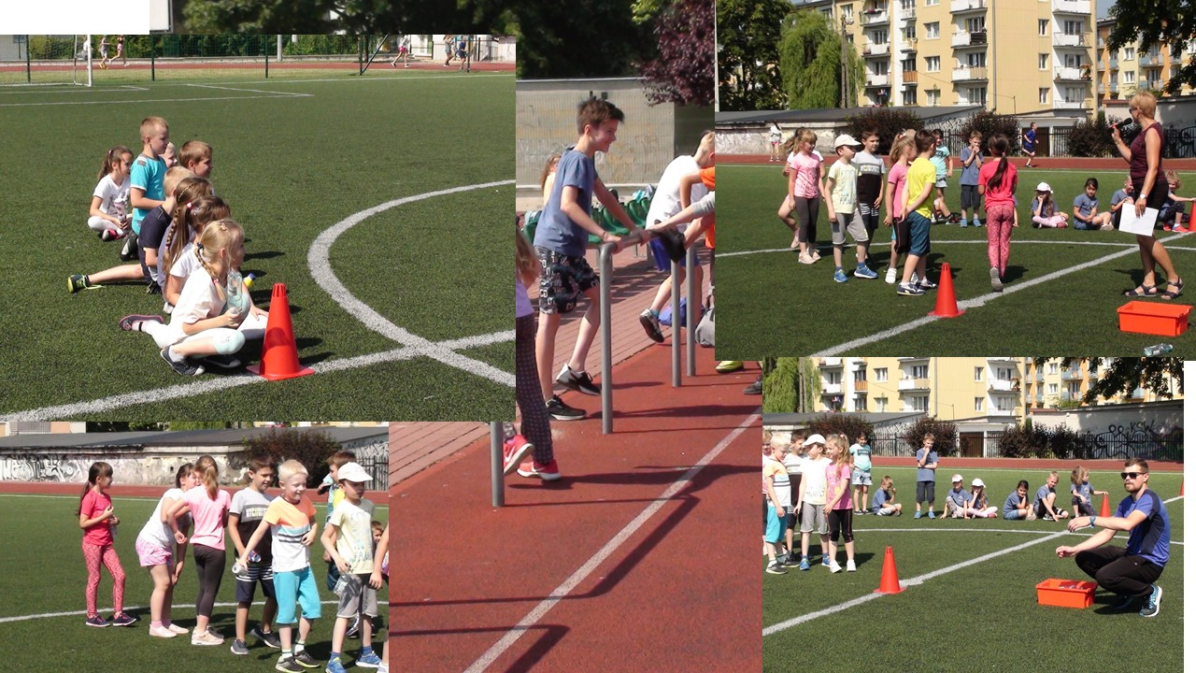
Students from class 3d and 1a took part in culinary workshops “ We eat healthy and colourful”- how to eat healthy ? Fruit shashliks.
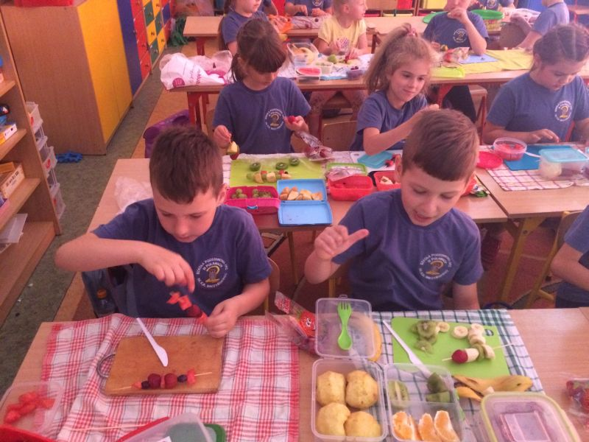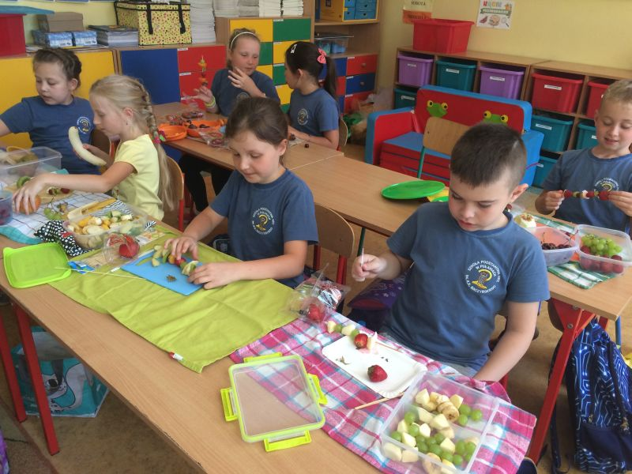
Tuesday 5th June
Polish kids took part in a picnic in the park
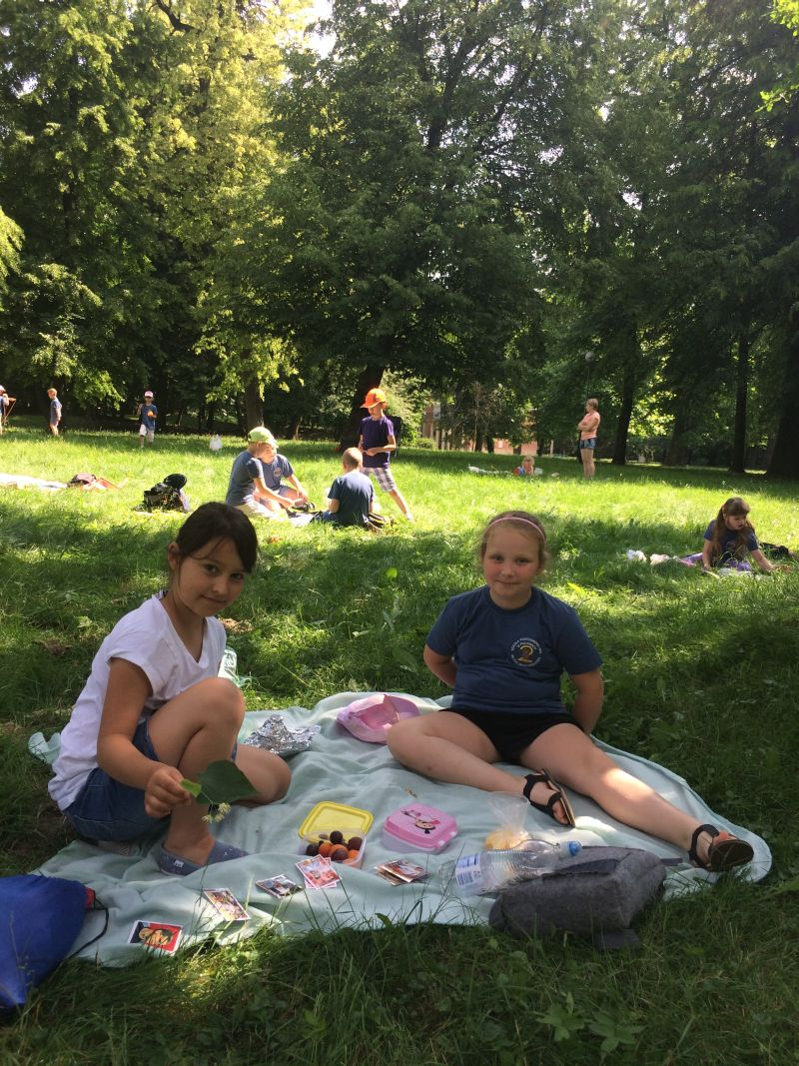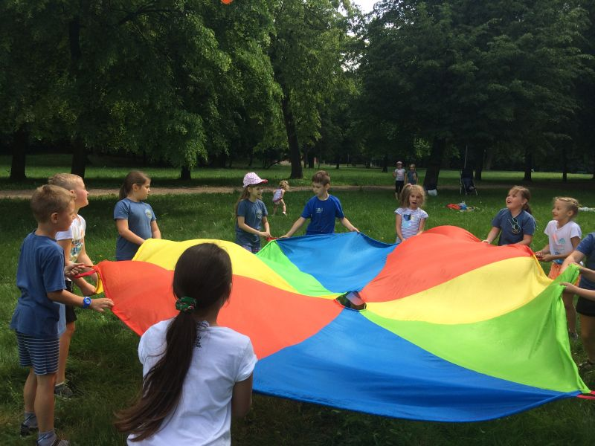

Students played eco-games on Resources, Water and Energy
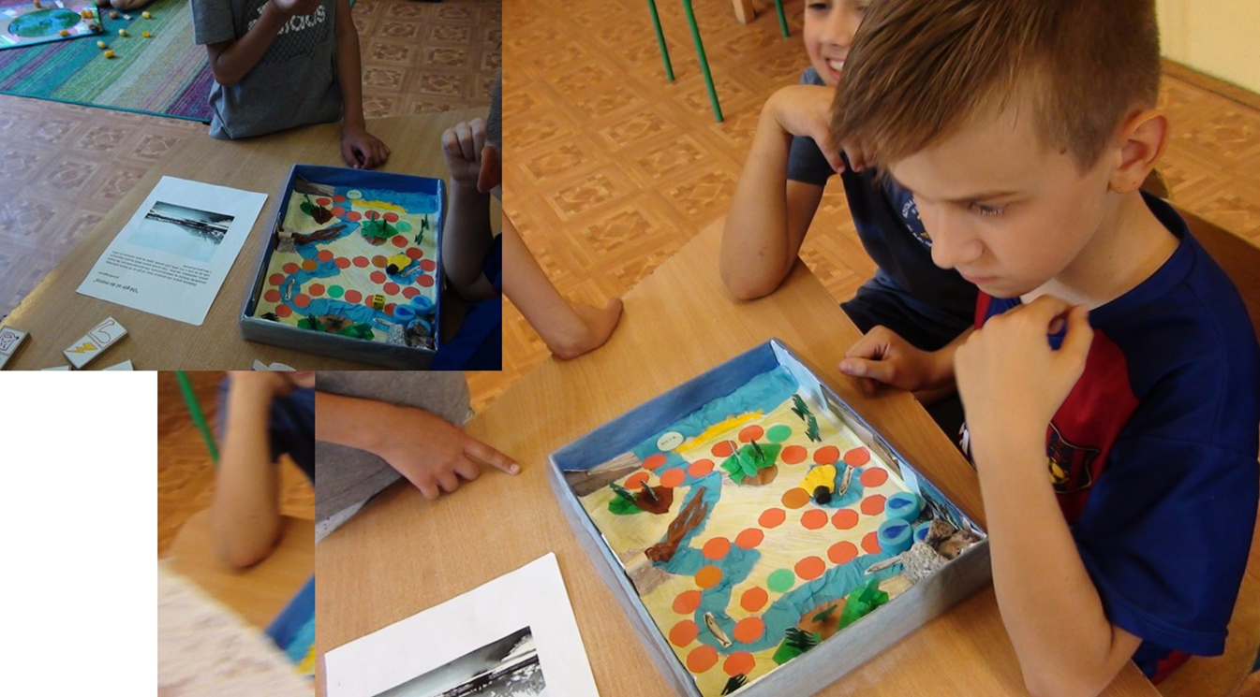

- Class 3a - visit to the IUNG of the State Research Institute based in Puławy, a research and development unit subordinate to the Ministry of Agriculture and Rural Development
- Class 3a took part in ecological classes in Leroy Merlin.
- Class 3d and 3c had a trip to the park and they met with the employer of IUNG (Recognition and naming of conifers and deciduous trees. Forms of nature protection)
- Class 3b,3d and 2a took part in the lesson developed by an employee of a doctoral student at the University of Life Sciences in Lublin “Life of bees and their significance for humans"
- Class 6c went to Kazimierz Dolny – Eco-Kazimierz
- “We care about our environment and segregate waste" - a discussion conducted by employees of the Environmental Protection Department of the Municipal Office in Puławy for the students

Younger students took part in an ecological picnic in the park

Wednesday 6th June
In the school gym there was a summary of the competitions and a presentation of rewards for the collection of waste batteries. Eco-classes and Eco-pupils were selected and prizes were awarded for all other competitions
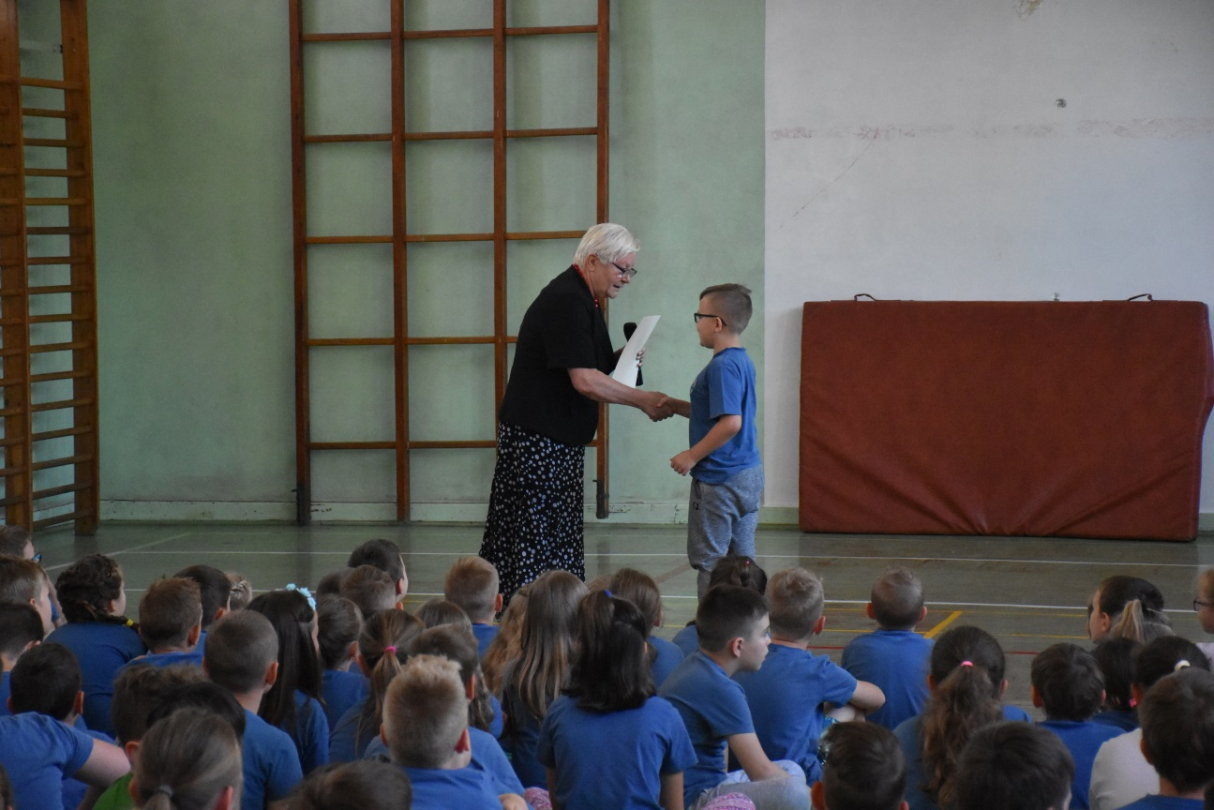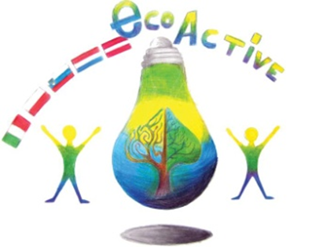

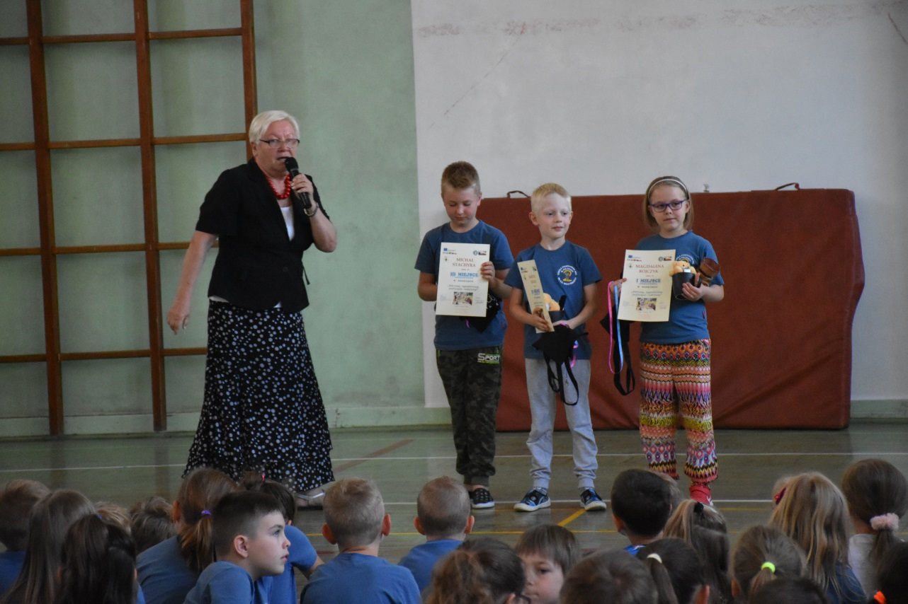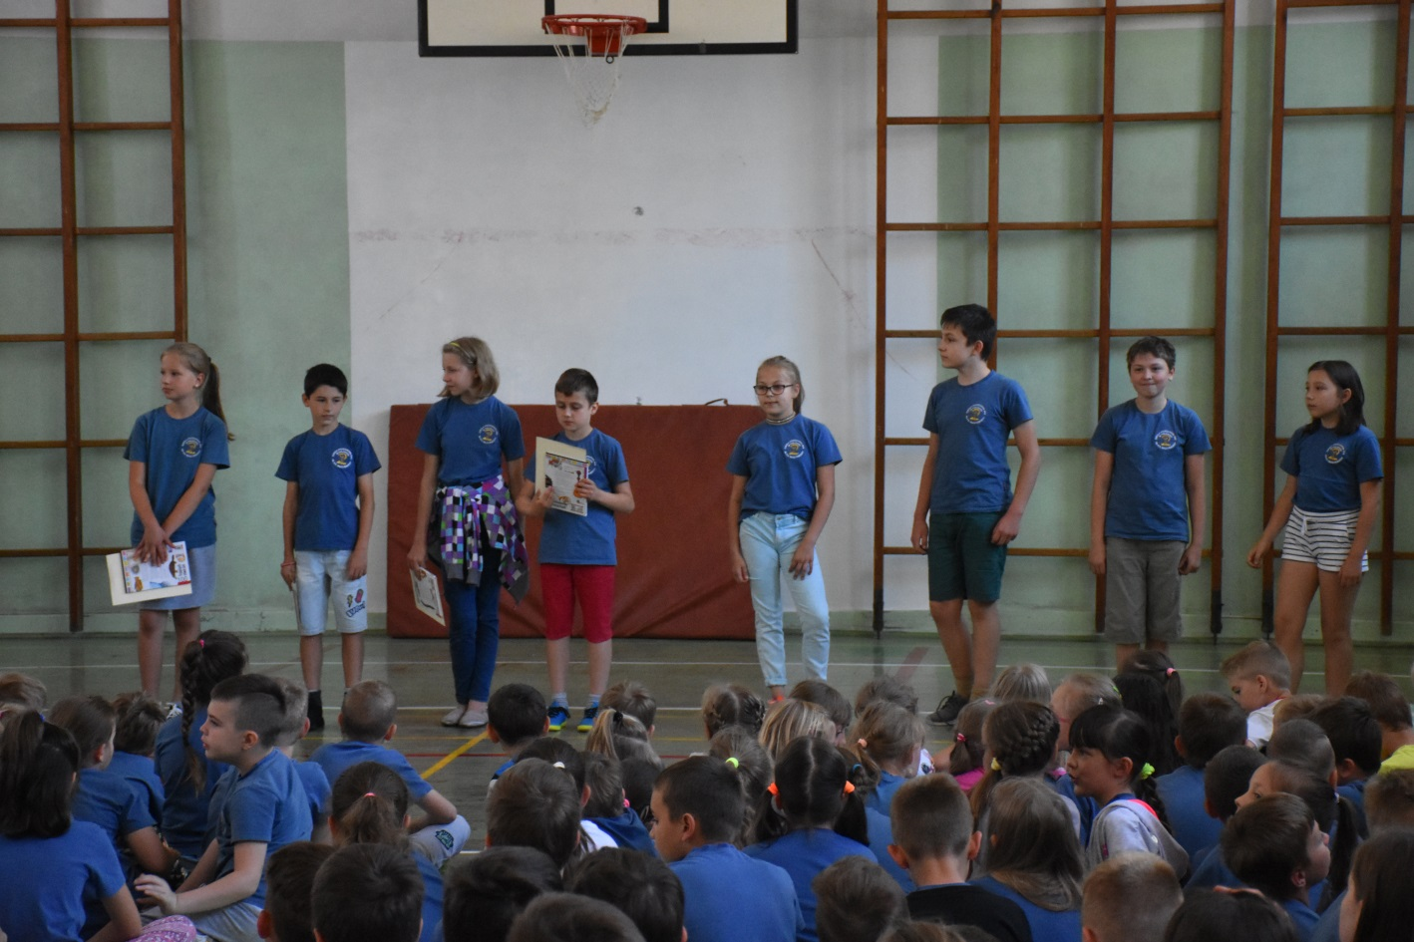

- Classes 5b and 5a went on a trip through loess gorge from Bochotnica to Kazimierz Dolny
- Classes 3c and 3d –"National Parks in Poland" ecological quiz, completion of the map, matching the park designation with its name - memo
- Class 4d- A trip „Energy of the sun” – the use of solar panels on farms household
Thursday 7th June
- Teachers used presentations and eco-games during their lessons, and the lesson plans they have previously received on the disc
- On 5th lesson from 11. 30 am to 1. 30 pm Eco-examinations - Cycling card exam for classes 4
- Bicycle rally for class 5e to Kazimierz Dolny
- Creation of a photo frame made of environmentally friendly 3d materials
- Class"0" - educational activities Ecoactive - nature protection
- Children played ecological games made by the students in the scope of the three thematic areas of the project: Raw materials, water, energy
- "Why should plants and animals be protected? Joint editing of notes on on the basis of the information prepared. Protected plants - ecological game. Class 3d
- Class 3c and 3b - "National parks in Poland". - children make advertising posters the selected park
Friday 8th June
- Quizzes and competitions at the school for students of grades 1-7 on environmental issues
- Unit "0": Workshops at the "We meet Pu³awy birds" school conducted by an employee of the Natural History Museum in Kazimierz Dolny
- Day care center - children played ecological games made by students in competitions with the scope of the project's three thematic areas: Raw materials, water, energy. Teachers of the day-room conducted an environmental knowledge test for children attending the day-room
An ornithological lesson conducted by the employees of the Environmental Department from The Vistula Museum in Kazimierz Dolny - classes 1a and 1b,2a
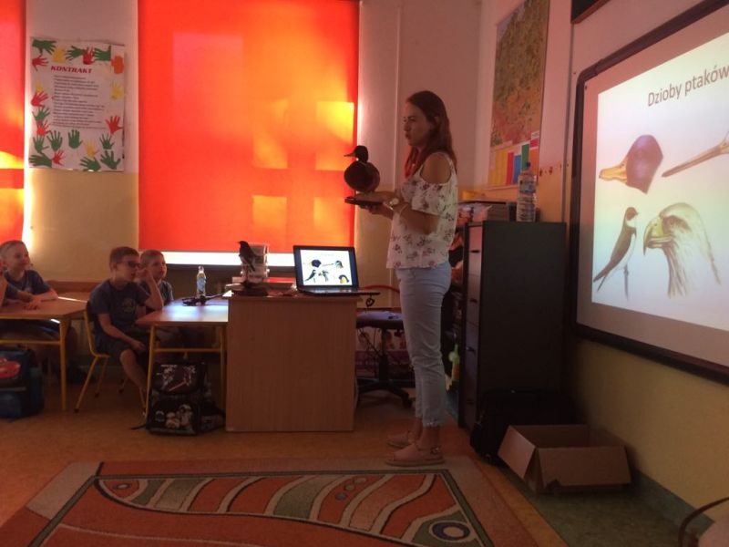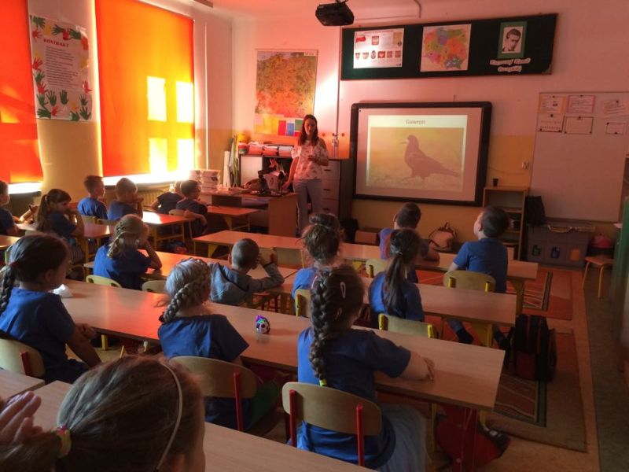
- Class 1ab - quizzes, rebuses, ecological riddles
- A theatrical performance on the ecological theme "Children and rubbish", prepared by children from class 1b in cooperation with the Youth Culture Centre in Puławy
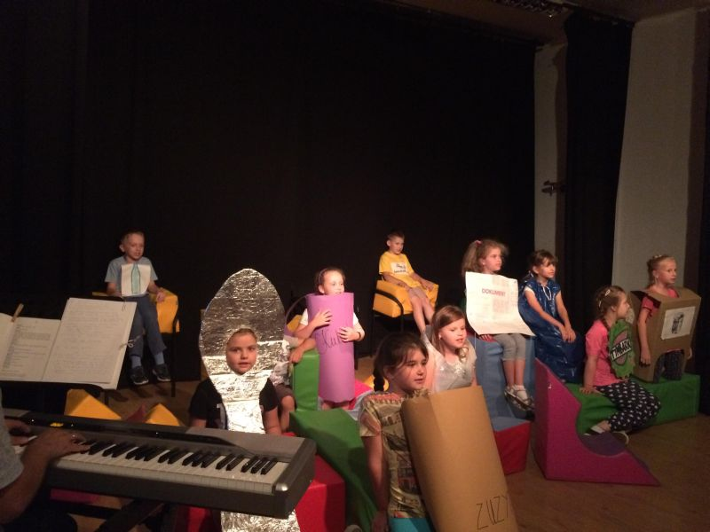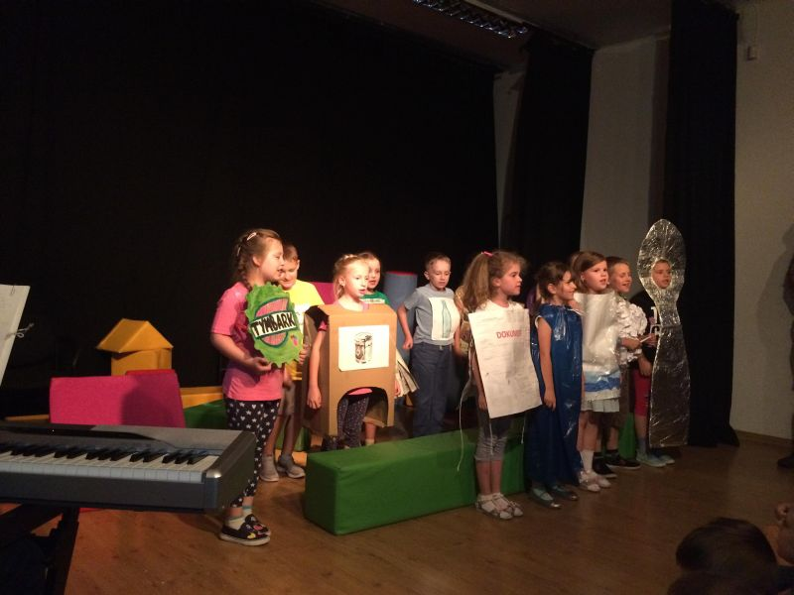

- Music Club 2 - Eco-picnic with the participation of the band members, their parents, teachers and the school principal in the port of Marina
Class 3a, 3b, 3c and 3d excursion to the "Chamomile Land" in the village of Hołowno. Class 3c took
part in creative recycling workshops. Class 3d and 3a took part in the workshops of making glycerine soaps. Grade 3b took part in the workshop "From fibre to textiles'. An ecological game with the participation of residents of the village of Hołowno. During the game, children could recognize herbs, built a tower of stones, minted coins, made pendants of amber, soaked an "artificial cow", a bonfire, old flax processing – tools

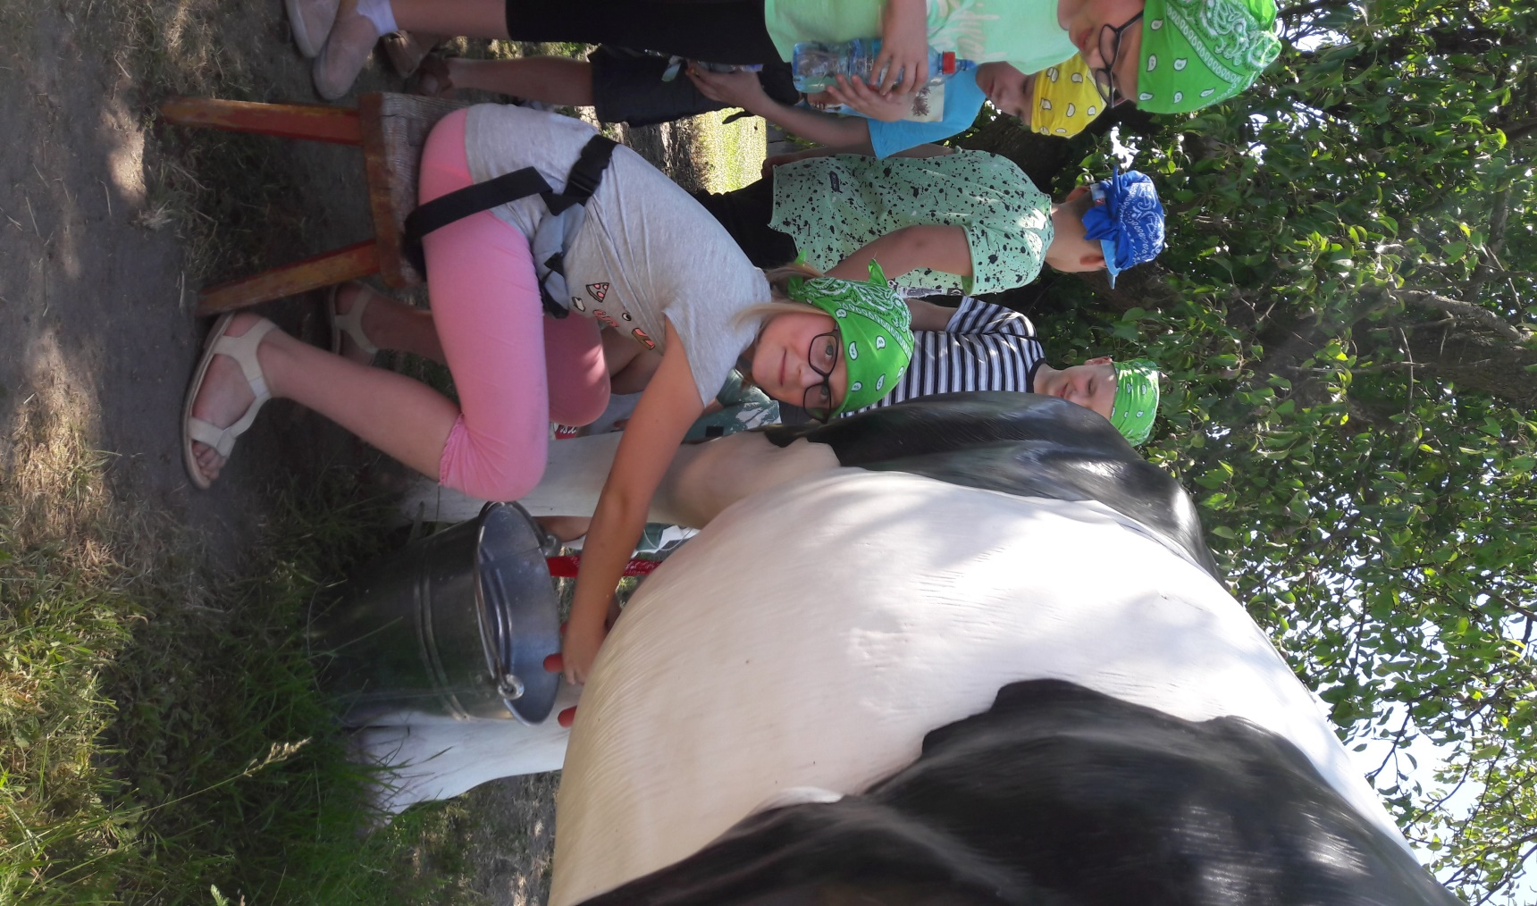

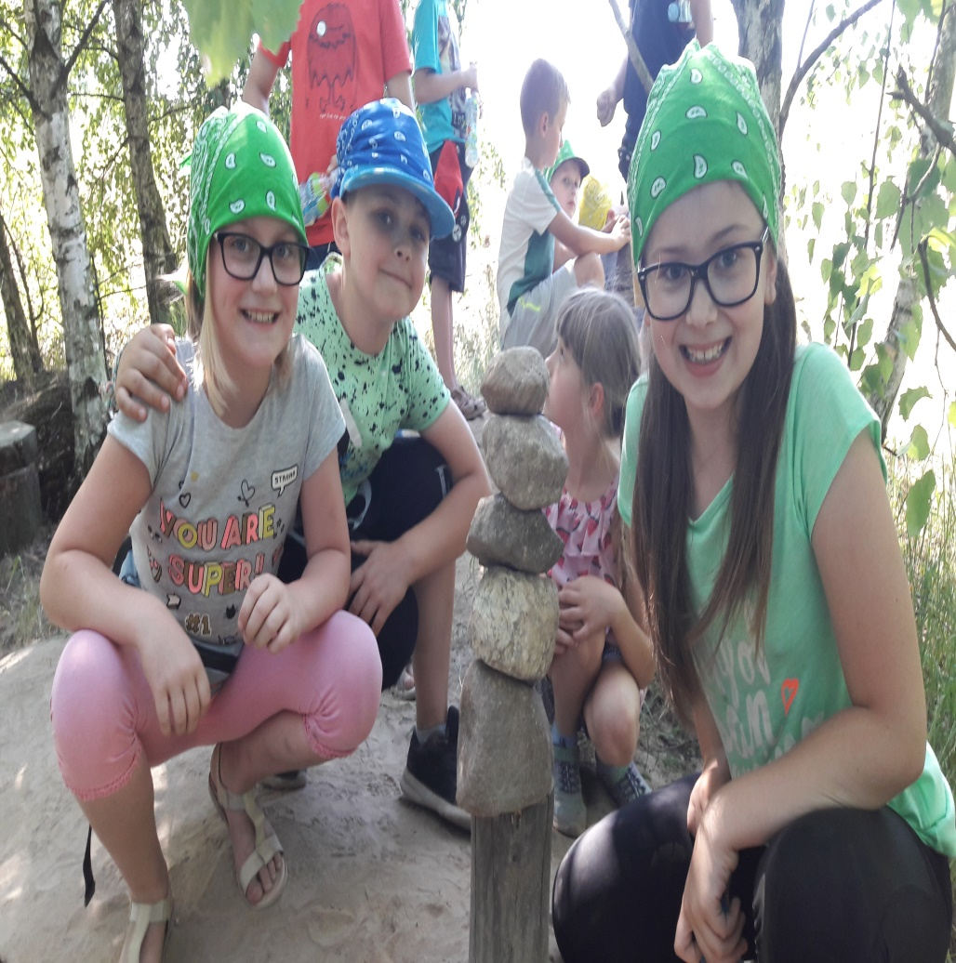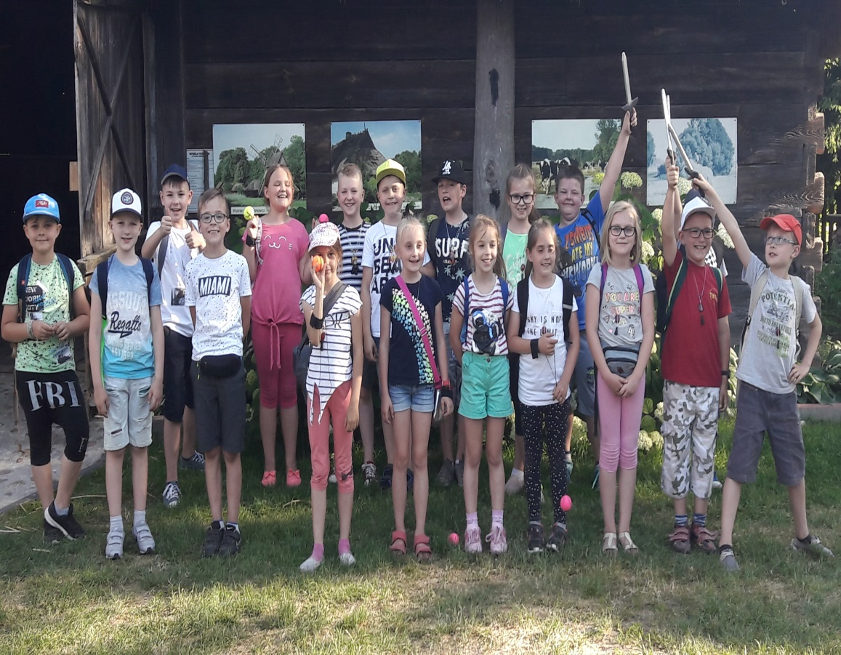

Classes in the Science and Technology Park. Chemical workshops. After Workshops students took part in sports games
