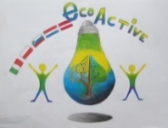 LESSON PLAN 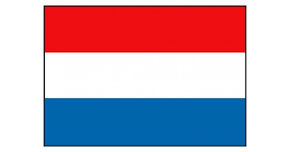
SCHOOL | Bs De Weijerwereld
THEMATIC AREA | Eco Active Healthy Food.
TEACHER | Thea Willems, Hetty Bardoel, Denise de Vlam, Gertjan Vrenken
SUBJECT | Healthy Food
AGE GROUP  (approximately) | 6-7-8 years
TIME REQUIRED | 80 minutes,
PLACE | In school: classroom,
LESSON OBJECTIVES | Manual skills: making fruit or vegetables from salty bread-dough
REGULAR LESSONS YOU CAN USE | - Language: how to name the vegetables and fruits  - Reading lessons  - Biology: what your body needs to stay healthy  - Nature knowledge: how fruits and vegetables grow  - Cooking skills. Reading and preparing recipes.
CLASS ORGANISATION | - Pupils work in groups, mixed up the pupils from the 3-4-5th class
MATERIALS | - Some movies about healthy food (Dutch school TV and News from the nature)  - In the vegetable garden: various vegetables harvest for vegetable soup  - Handy crafts: ingredients for salty bread dough: flour and salt
ICT TOOLS | Digibord:  - Schooltv)  - Schoolbordportal  - News from the nature  - Powerpoint presentation making bread dough.
PROCEDURE | - The introduction meetings on the theme Healthy Food take place in the own group.  - For the creative part the pupils of the forms 3-4-5 are mixed up, every group has 6 members, they can/will help eachother
EVALUATION | Children have experienced in a playful way that a healthy diet is important for health, growth and development.  Very important here is starting with a healthy breakfast in the morning for enough energy to learn and play  They have also learned that vegetables and fruit are grown outside in nature and grow. Each season has its own harvest moments.  In closing, they have created fruit and vegetables from bread dough
ATTACHEMENTS | Report Project eco-active form 4

