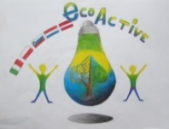 LESSON PLAN
SCHOOL | De Weijerwereld
THEMATIC AREA | ENERGY
TEACHER | Denise
SUBJECT | Crafts
AGE GROUP  (approximately) | 6-7 years
TIME REQUIRED | 45 minuts
PLACE | Classroom and outside
LESSON OBJECTIVES | - Students learn that you can move objects by means of wind  - Pupils learn different techniques with regard to manual skills: cutting, pasting, measuring
REGULAR LESSONS YOU CAN USE | - Crafts  - Language, speaking  - Technics  - Fine motor skills
CLASS ORGANISATION | - Pupils work individualy  - Pupils support to eachother.
MATERIALS | - milk carton or yoghurt pack  - coloured paper  - cork  - the satay stick  - iron wire  - glue  - scissors  - example sailboat
ICT TOOLS | None
PROCEDURE | - The teacher has cut a piece in all cartons and then has them cut the cartons in two.  - Teacher shows the example of the sail boat  - Pupils cut the milk carton in two parts.  - The tip of the carton is, when necessary, tied together with iron wire.  - The pupils attach the cork with a lot of glue to the bottom of the carton  - The children make a sail from coloured paper and attach it to the satay stick.  - The children attach the satay stick in the cork.  - The children add their own creativity to the sailing boat.  - The teacher and children admire each other's sailboat and experience whether the sailboat gets moving by letting it sail out in a puddle (what does the amount of wind do, how should you sail).  - The pupils adapt their sailboat when it is not sufficiently advanced
EVALUATION | - When does a sailboat sail better ?  - What influences are involved?  - What can you add to make your sailing boat sail even faster?  - What does a sailboat have to do with sustainable energy?
ATTACHEMENTS | 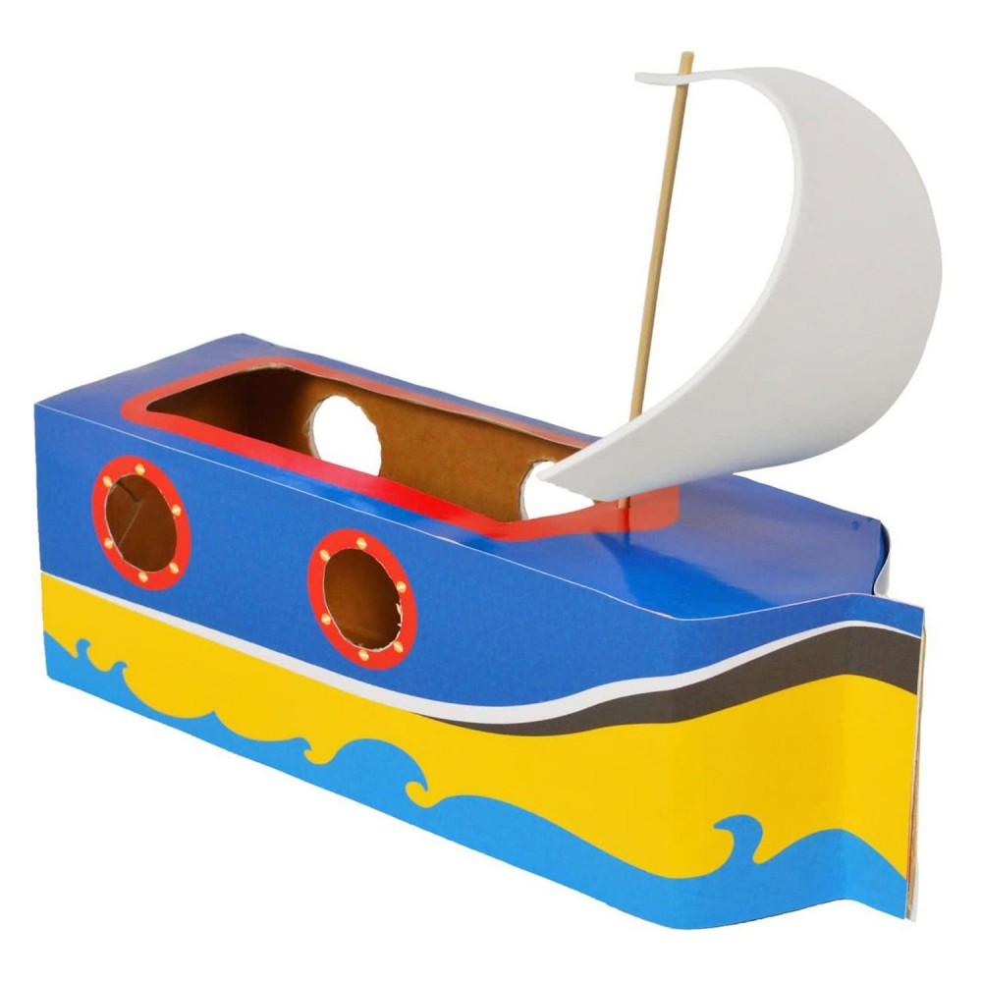
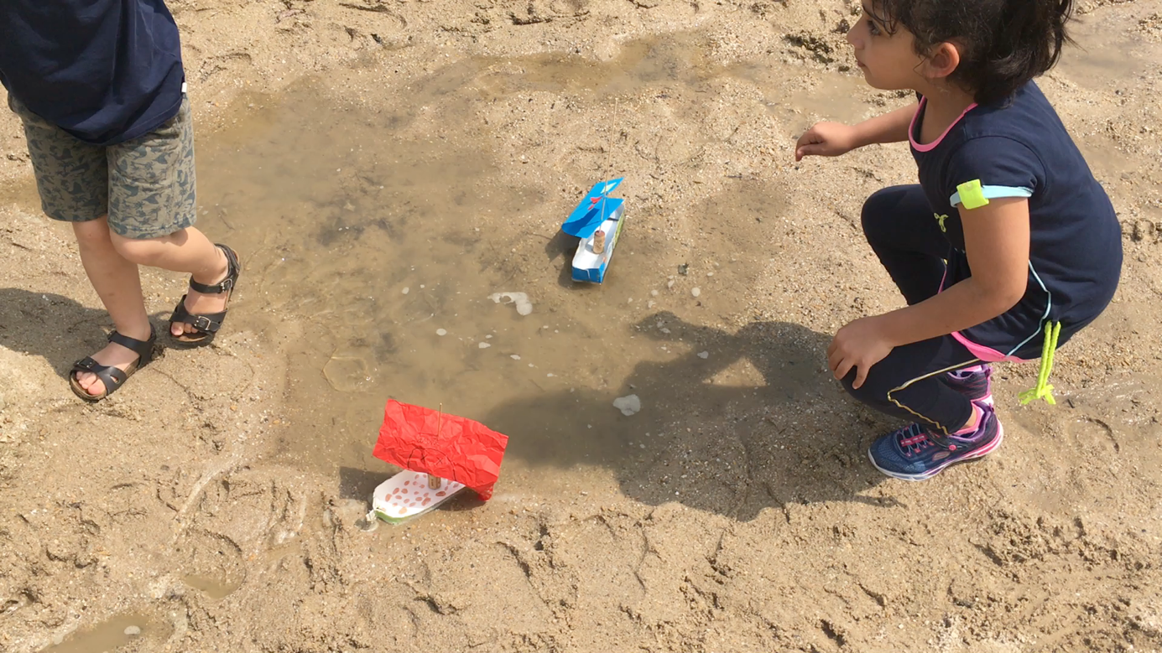
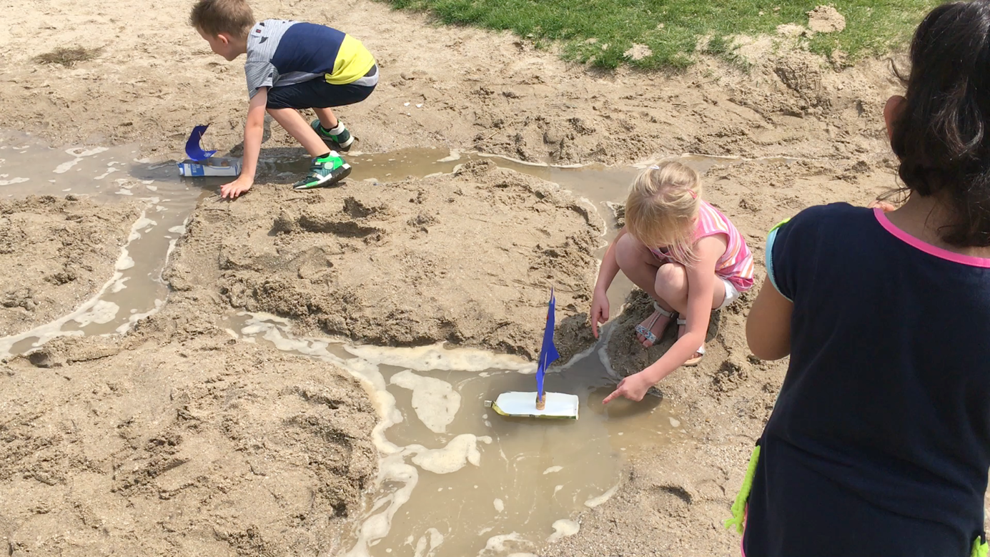
Movie:

