**Water: physics**

* **Liquid**
* **Vapour**
* **Solid**
* **All three together**

[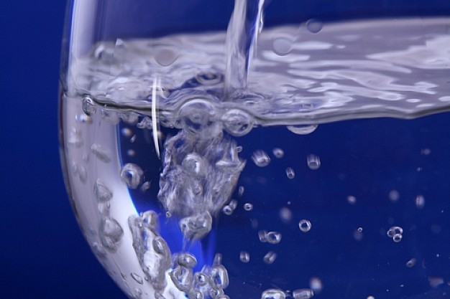](http://www.google.nl/url?sa=i&rct=j&q=&esrc=s&source=images&cd=&cad=rja&uact=8&ved=0ahUKEwiRgvWYv5DWAhWHaFAKHedoCPMQjRwIBw&url=http://www.imagui.com/a/imagenes-gratis-fondos-de-liquidos-iX8ayaG47&psig=AFQjCNFgqVl8UUP7bMoNY_8lCII3C1kpZw&ust=1504785023374010)

**Water: physics**

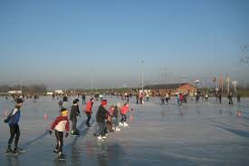

* **Liquid**
* **Vapour**
* **Solid**
* **All three together**

**Water: physics**

* **Liquid**
* **Vapour**
* **Solid**
* **All three together**

**Water: physics**

[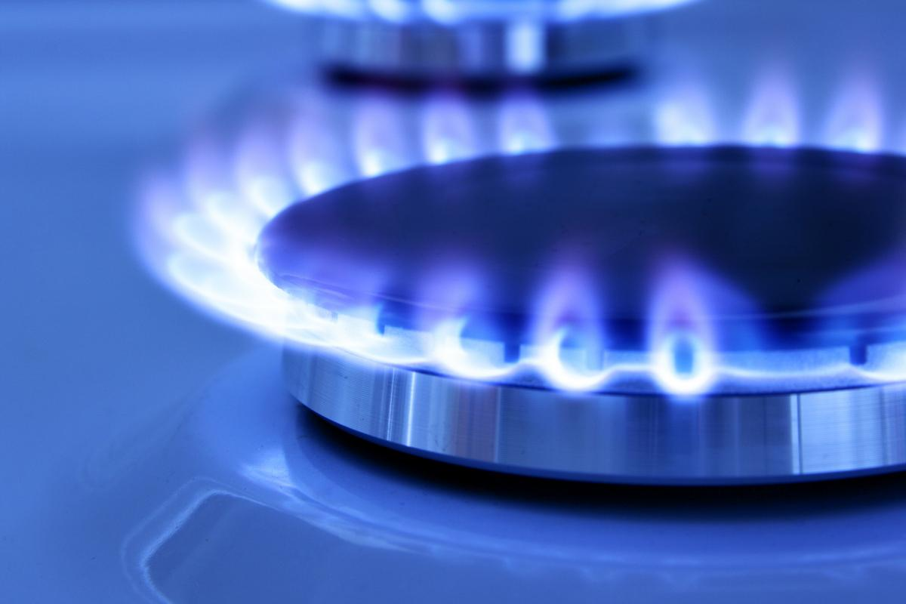](http://www.google.nl/url?sa=i&rct=j&q=&esrc=s&source=images&cd=&cad=rja&uact=8&ved=0ahUKEwjZ2_nPv5DWAhVDPFAKHaZ_BgYQjRwIBw&url=http://radagaz.ru/articles/kakoi_gaz_ispolzuetsya/&psig=AFQjCNGgBCPAlyF7gwJVLRtX3PREMOUQlg&ust=1504785135463782)

* **Liquid**
* **Vapour**
* **Solid**
* **All three together**

**Water consumption**

* **Toilet**
* **Shower**
* **Coocking**
* **Dishes**

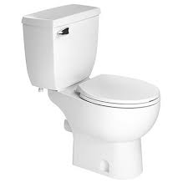

**Water consumption**

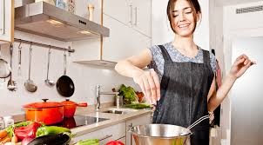

* **Toilet**
* **Shower**
* **Coocking**
* **Dishes**

**Water consumption**

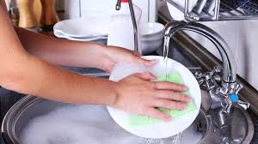

* **Toilet**
* **Shower**
* **Coocking**
* **Dishes**

**Water consumption**

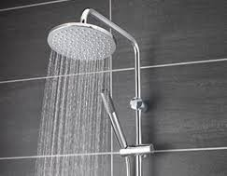

* **Toilet**
* **Shower**
* **Coocking**
* **Dishes**