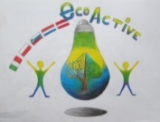 LESSON PLAN 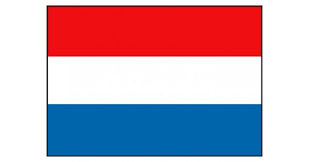
SCHOOL | Bs De Weijerwereld
THEMATIC AREA | Eco Active Healthy Food.
TEACHER | Thea Willems, Hetty Bardoel, Denise de Vlam, Gertjan Vrenken
SUBJECT | Healthy Food
AGE GROUP  (approximately) | 6-7-8 years
TIME REQUIRED | 60-80 minutes, each part of lessons (5)
PLACE | In school: classroom,  Out of the school: vegetable garden, workshops
LESSON OBJECTIVES | - Healthy breakfast  - Lesson: the need of healthy food  - How and where grow the healthy vegetables (visit vegetables garden)  - Workshops: create recipes for healthy food  - Manual skills: making fruit or vegetables from salty bread-dough
REGULAR LESSONS YOU CAN USE | - Language: how to name the vegetables and fruits  - Reading lessons  - Biology: what your body needs to stay healthy  - Nature knowledge: how fruits and vegetables grow  - Cooking skills. Reading and preparing recipes.
CLASS ORGANISATION | - Pupils work in groups, mixed up the pupils from the 3-4-5th class  - Visiting a fruit-vegetable garden (out of the school)  - Workshops with parents (in and outside the school)
MATERIALS | - Various movies about healthy food(School TV, news from nature etc.)  - In the garden: harvest various vegetables for vegetable soup  - Workshops: Ingredients for receipts  - Handy crafts: ingredients for slaty bread dough: flou rand salt
ICT TOOLS | Digibord:  - School TV  - Schoolbordportal  - News from nature  - Powerpoint presentation how to make bread dough.
PROCEDURE | - The introduction meetings on the theme Healthy Food take place in the own group.  - For the creative assignment the groups 3-4-5 are mixed and divided into groups of 6 children  - They can make their own choice for the cooking workshops, but there are also 6 children in a group here
EVALUATION | Children have experienced in a playful way that a healthy diet is important for health, growth and development. Very important here is starting a healthy breakfast in the morning for enough energy to learn and play. They have also learned that vegetables and fruit are grown outside in nature and grow. Each season has its own harvest moments.
ATTACHEMENTS | See report Project eco-active form 4

