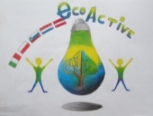 LESSON PLAN 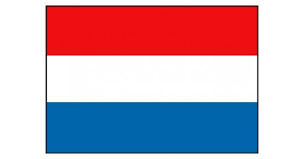
SCHOOL | De Weijerwereld
THEMATIC AREA | ENERGY
TEACHER | Teachers oldest pupils 11-12 years old
SUBJECT | Crafts: How to make an electro-game
AGE GROUP  (approximately) | 10-12 years
TIME REQUIRED | 2x 1 hour
PLACE | CLASSROOM
LESSON OBJECTIVES
REGULAR LESSONS YOU CAN USE | - technics  - Biology  - Nature knowledge
CLASS ORGANISATION | - Pupils work individually  - Pupils work in pairs
MATERIALS | - Electricity wires  - Pictures  - Sturdy cardboard  - Split pens  - Bateries  - Littlelight  - Elastic  - Glue  - Pliers to strip the wires  - Small paperclips.
ICT TOOLS
PROCEDURE | (what happens, what we do step by step)  - We search for images with corresponding answers / pictures, for example Pictures from music starts and the corresponding name, football player and the club logo.  - The pictures are stuck on the English cardboard and underneath these plates the split pins are attached.  - At the rear, the wires (which have been stripped a bit, because only the copper transmits electrical power) of the matching plates are connected to each other via the split pins  - Then we test with a battery and a light whether the power wires are well connected.  - If they are properly connected, the light will come on  - At the end of the wires we can attach a paperclip  The whole is glued to the thick cardboard and the battery is attached to the top.
EVALUATION
ATTACHEMENTS | https://youtu.be/bmGmJhutcyw (6 minutes, without words!!!)

