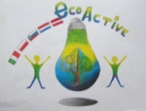 LESSON PLAN 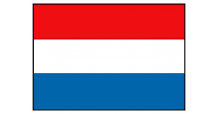
SCHOOL | Primary School “De Weijerwereld” Boxmeer The Netherlands
THEMATIC AREA | Drawing lesson: how to create a sticker about “Saving water” and/or “saving energy”
TEACHER
SUBJECT | How to develop an advertising sticker
AGE GROUP  (approximately) | 4-12 years: can be used for every age of pupils, just adapt the words you use
TIME REQUIRED | Two lessons, about two hours overall
PLACE | Classroom
LESSON OBJECTIVES | - Environmental education  - Changing behaviour concerning use of “water” and “energy”  - Improving drawing skills  Aspects of drawing lessons:  - What colours do we use?  - What kind of font style?  - Surface division?
REGULAR LESSONS YOU CAN USE | - Drawing lessons
CLASS ORGANISATION | - Discussion in groups  - Pupils work individually
MATERIALS | Paper, pencils, colour markers, paint
ICT TOOLS | Internet: search for good practice/examples of usable stickers
PROCEDURE | - Announce the subject of the drawing lesson.  - What are we going to do?  - What should we achieve?  - What should be the result at the end?  Discussion:  - Why is it necessary to reduce the use of water or energy?  - How can we make people (pupils) mindful on the need of redusing the use of water and energy? What do we need? What can we use?  - (TV commercial, radio, magazine, newspaper, sticker)  We are going to create a sticker.  - What are the characteristics of a usable sticker? Think about:  - Form  - Colour(s), signal colours  - Size  - Text  - Now start developing and drawing your sticker.  - Make your choice for:  - Subject  - Form  - Colours  - Text
EVALUATION | Halfway through:  - Admire each others creations: what are the ideas?  - Tell each other. What is the form you used? Why this form?  - And what about the colours?  - The text?  At the end:  Feedback to the pupils by:  - The teacher  - The pupils between themselves  The stickers:  - Will be printed on plasticized paper.  - Used on different places in school:  - Next to electricity swichtes  - Water taps
ATTACHEMENTS

