A healthy week menu, by the pupils of form 8.
Smakelijk eten – buno appetito - smaczne jedzenie - okusna hrana - garšīgs ēdiens!!!
 | Monday | Tuesday | Wednesday | Thursday | Friday | Saturday | Sunday
Breakfast | Fresh pancakes | yogurt with berries | Breakfast pizza with egg and bacon | oatmeal with rye bread special  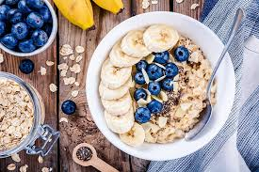 | Dutch bouncer  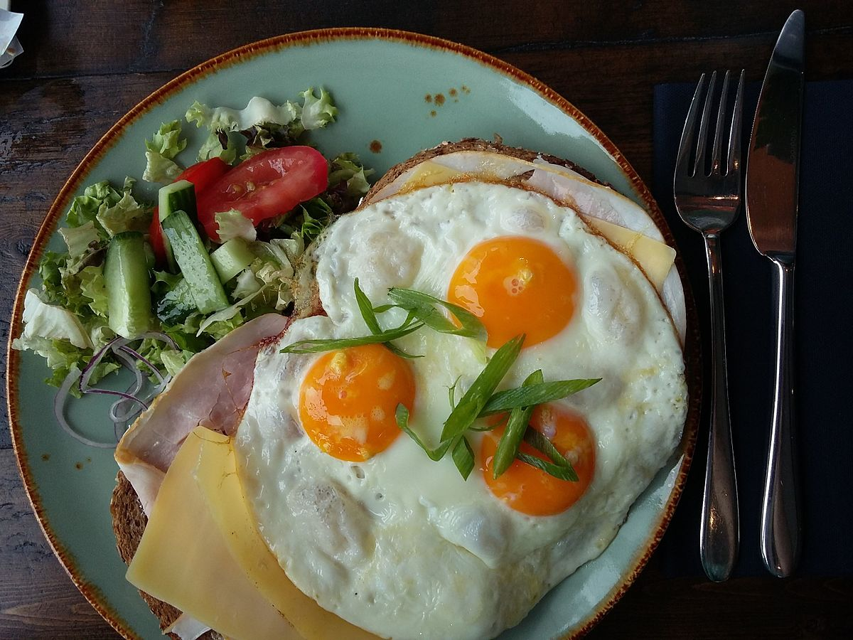 | Yogurt Granola + cracker + Cheese and cucumber | We sleep in and have brunch!  dutch pea soup with rye bread and bacon  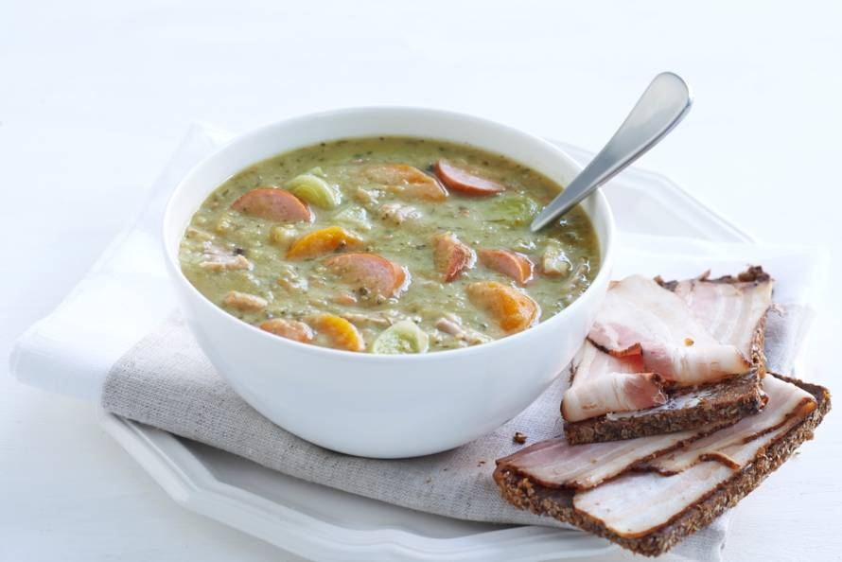  pumpkin soup  salad with pear brie, ice with warm cherries  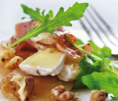
Lucnh | tasty and healthy salade | pancakes with raspberries  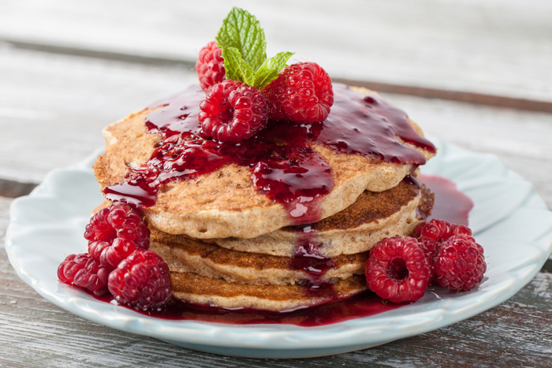 | fish wrabs  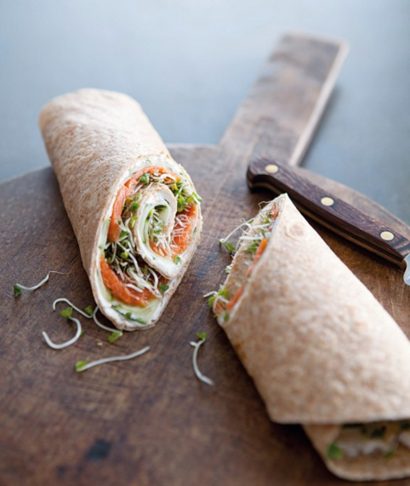 | soup and salade  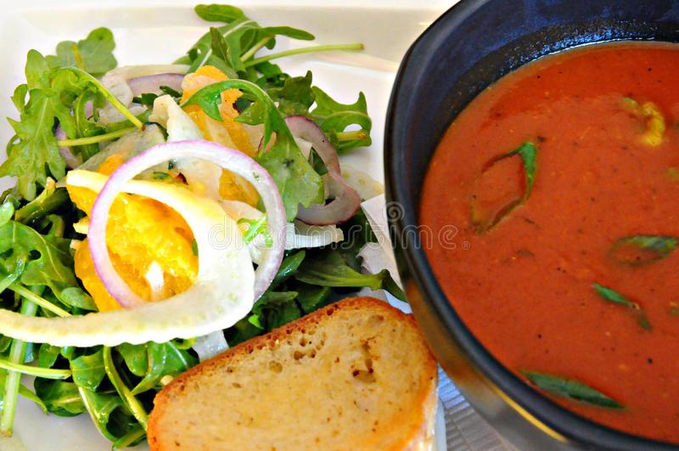 | Egg Muffins  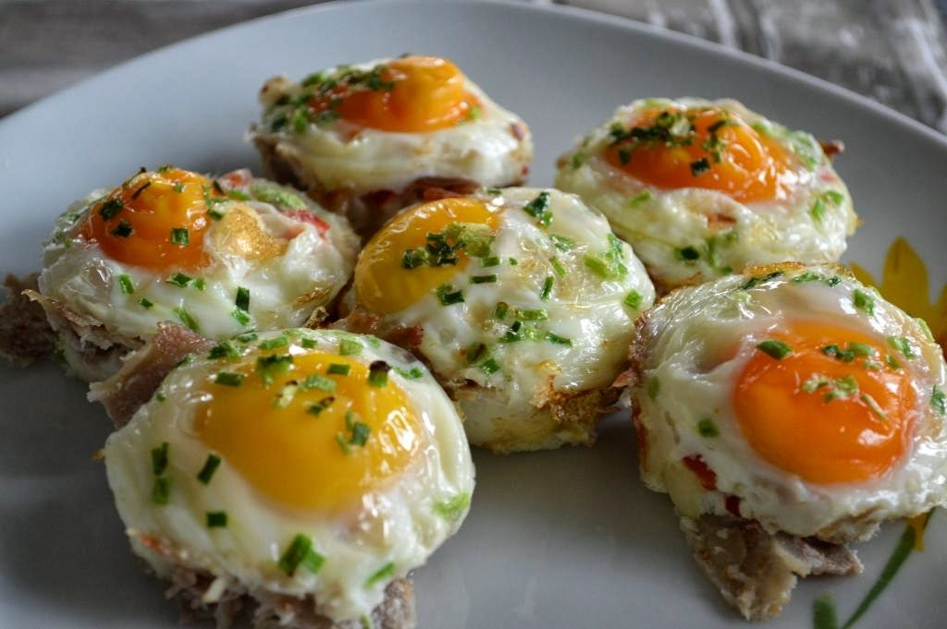 | tosti “hairdressers”  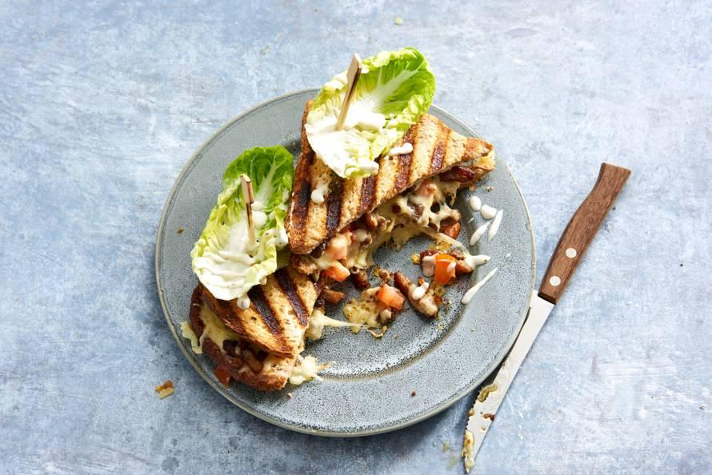
Diner | nasi with a cabbage fried egg  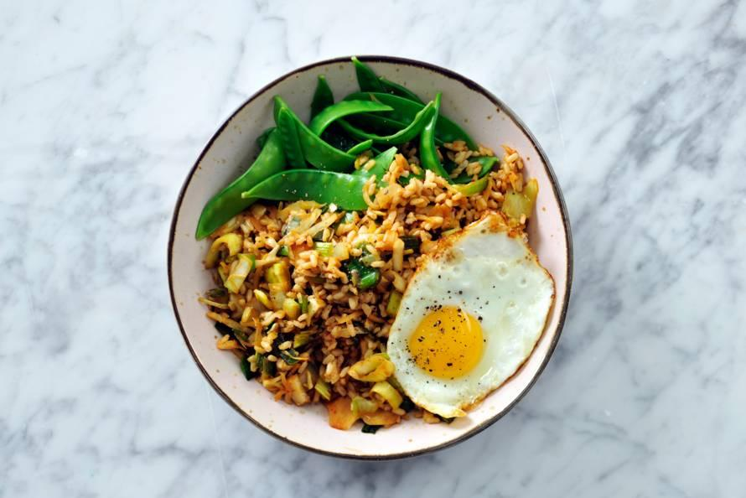 | Stuffed peppers  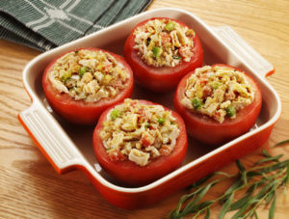 | pasta salad  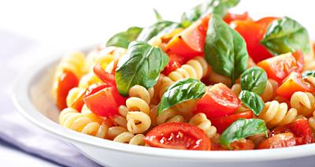 | Hotchpot  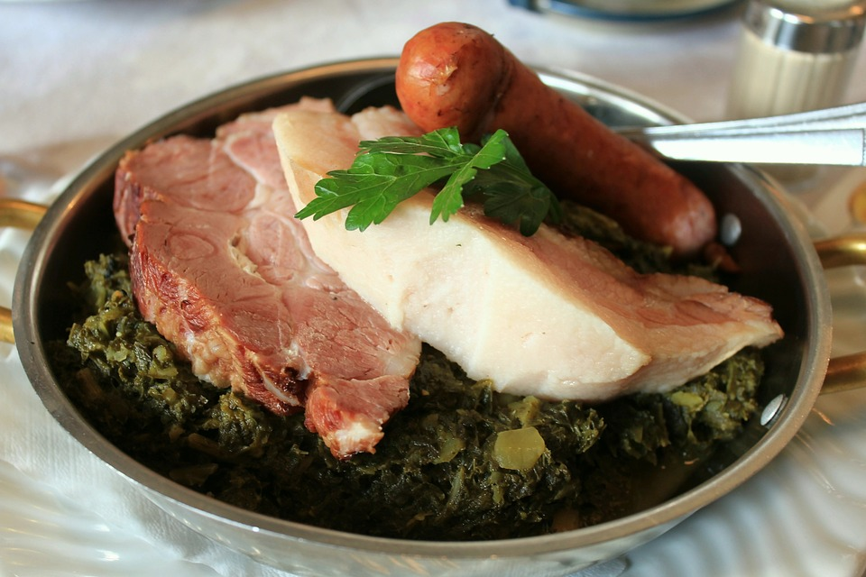 | vegetable soup | lasagne special  