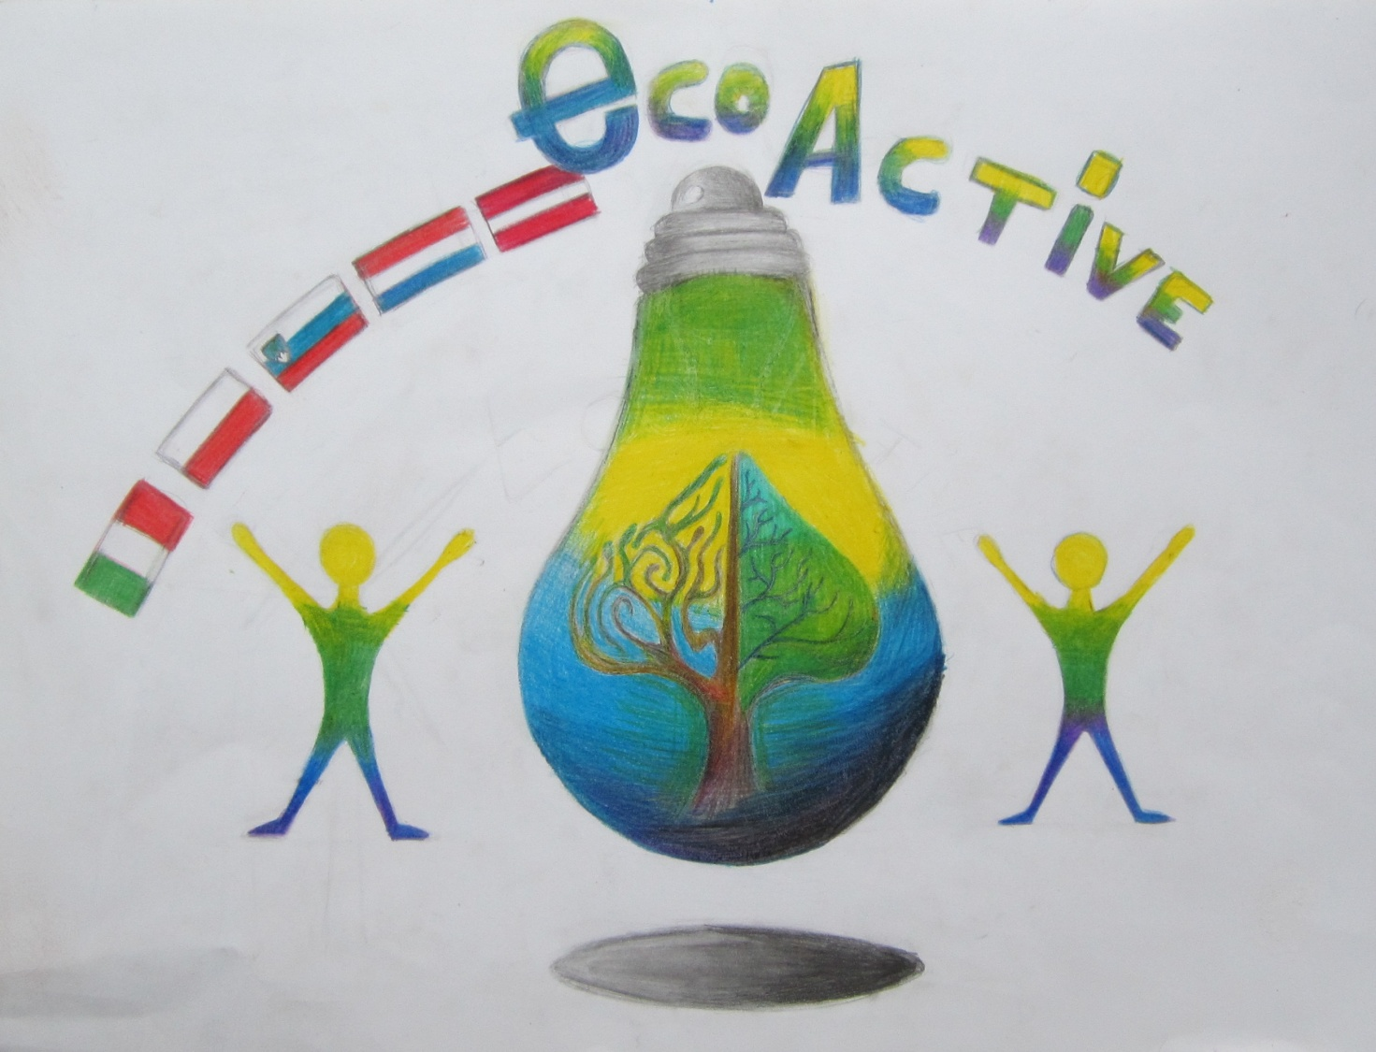
LESSON PLAN
SCHOOL | Annas Brigaderes primary school
THEMATIC AREA | ENERGY
TEACHER | Svetlana Kursina, Sandra Geislere, Maija Klāsupa
SUBJECT | Wind energy
AGE GROUP  (approximately) | 10 -14 grades
TIME REQUIRED | 60 min
PLACE | CLASSROOM
LESSON OBJECTIVES | To use wind power in practical work
LESSONS YOU CAN USE | - Language, for translation in English of course the English lesson  - Nature knowledge  - Handicrafts
CLASS ORGANISATION | - Pupils work individually  - Pupils work in pairs  Pupils work in groups
MATERIALS | required materials:  string or rope  scissors  tape  two sticks 40 cm and 60 cm  little plastic bags  7 needles with big needle eye  stickers to decorate
ICT TOOLS | https://www.youtube.com/watch?v=Ts1XZNG6wpU
PROCEDURE | Together we will remind all kinds of energy :  wind energy  water energy  electric energy  heat energy  chemical energy  solar energy  geothermal energy  kinetic energy  Today we will talk about wind energy and we will make a kite.  1. With the string or rope we tie up two sticks in a cross.  2. With the tape glue two sticks to plastic film, some cm we have to leave from the edge.  3. Fold plastic film to the sticks  4. Cut off the unnecessary part, few cm from the fold place.  5. Fold up and glue with the tape every edge.  6. Glue the kite’s bottom side from both sides.  7. Glue the kite’s upper side from both sides.  8. In the middle of the kite glue the tape crosswise.  9. Cutt off the string or a rope in the lenght of the kite  10. Sew the string to the kites in the middle through the tape.  11. Tie up three knots.  12. The other bottom side sew to the kites top.  13.Place the string in the stright angle to the kite.  14. Make a small loop, it will strengthen string for flying kite  15. Cut off a string or rope into 4 kite lenghs.  16. Make a tale for the kite  17. Make the plastic bags bouquets  18. At least six bouquets.  19. sew the tail to the kites bottom.  20.Put the string or rope to the kite for launch and decorate.
EVALUATION | Selfevaluation
ATTACHMENTS | -

Darba lapa
KROŅAUCES HES
PASE

- Kroņauces HES dzimšanas diena: ___________________________
- Adrese : _______________________________________________
(Atzīmēt kartē!)
- Pozitīvais Kroņauces HES darbībā:
- ___________________________________________________
- ___________________________________________________
- __________________________________________________
- Kroņauces HES negatīvā ietekme uz vidi:
- ___________________________________________________
- ___________________________________________________
