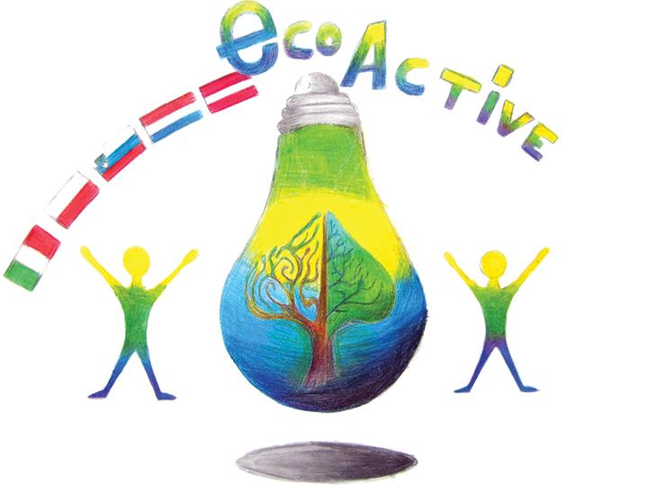 LESSON PLAN 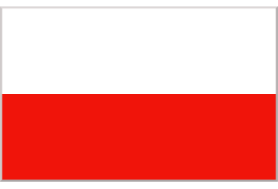
SCHOOL | Szkoła Podstawowa nr 2 im. K.K.Baczyńskiego w Puławach
THEMATIC AREA | ENERGY
TEACHER | Katarzyna Jurak
SUBJECT | Power engineering in Poland.
AGE GROUP  (approximately) | 13-15
TIME REQUIRED | 45 minutes
PLACE | CLASSROOM
LESSON OBJECTIVES | - The student knows renewable and non-renewable energy sources and knows what types of renewable energy can be used in Poland.  • lists energy sources  • characterizes the structure of electricity production in Poland  by type of power plant and sources compared to selected European countries  • lists types of power plants  • locates the largest power plants in Poland on the map  • discusses the use of renewable energy sources in Poland
LESSONS YOU CAN USE | - Biology  - Science  - Nature knowledge
CLASS ORGANISATION | - Pupils work individually  - Pupils work in pairs  Pupils work in groups
MATERIALS | Handbook, exercise book, map, film.
ICT TOOLS | Interactive board
PROCEDURE | Introduction:  1. Organizational activities.  2. Objective of the lesson.  3. Writing the keyword "Sources of energy" on the board. Students give examples of energy sources. Question for students:  Can all types of renewable energy sources be used in Poland?  Implementation:  1. Brainstorming - students give associations with the word "alternative".  2. Explanation, summary by the teacher of the term "alternative energy"  3. Questions to students: "why are people looking for alternative energy sources?" And "what distinguishes alternative energy from traditional energy sources?"  4. Graph analysis: Structure of electricity production in Poland and Europe and maps. Power plants in Poland.  Questions for students: which energy sources do we use the most in Poland? Are the power plants evenly distributed? What factor caused such a diverse distribution of power plants in Poland? - can be compared with the map of the distribution of energy resources  5. The class is divided into pairs (two questions per pair) - Individual teams are to answer questions about a given alternative energy source (attachments). To do this, they choose the appropriate fragments from the text. (pp. 138-141) nuclear power - receives a fragment from another book.  6. The representative of each pair shares with the class the answer to the questions about the energy source assigned to the pair.  7. Can Poland develop all types of renewable energy? The film lasts about 3 minutes. (Conditions for energy production from various sources in the Pomeranian Voivodeship(POLAND).
EVALUATION | Summary:  1. Infographics - assess whether the natural conditions occurring in the province in which you live are conducive to the development of wind and solar energy.  2. Assessment of students' work  3. Evaluation  Questions true / false:  The largest power plant in Poland is in Bełchatów  Energy in Poland comes mainly from RES(Renewable energy sources)  A nuclear power plant has been located in Poland  The most favorable conditions for the development of wind energy are found in Pomerania Voivodship  Renewable energy sources include wind, water, sun and fossil fuels
ATTACHEMENTS | Group work:  Annex 1.  GROUP I - wind energy  - what is the main barrier to using wind in energy production?  - what is the main condition for the wind farm development?  - where are the most wind farms?  - indicate the location of this type of power plant  Annex 2.  GROUP II - geothermal energy (104 - 105) + manual  - what is geothermal energy  - what is it used for in Poland?  - where do these types of plants are?  Annex 3.  GROUP III - solar energy (104- 105) + manual  - what types of power plants are connected with solar energy?  - what is the main difference between these types of power plant?  - are there other options for using solar energy?  - where are solar power plants mainly located?  - what type of energy is most often obtained in solar power plants?  - give an example location of such a power plant  Annex 4.  GROUP IV - biomass energy  - what is biomass?  - what sources can biomass come from, what can we use in such a plant?  - for the production of which energy is biomass usually used?  - give an example of a location  Annex 5.  - GROUP V - Biogas energy  - What is the most popular biogas called?  - Where is it created? What products can be used to obtain biogas?  - Give an example of the location  GROUP VI - energy of flowing waters  - How do we call plants of this type?  - Where are the largest hydropower plants located in Poland?  - Give an example of the location  Annex 6.  GROUP VII - tidal energy  - what elements of the natural environment are necessary for the tides to be used for energy production?  - where are power plants based on tidal energy?  - give an example of the location  Group VIII - nuclear energy  - what factor must be met for a nuclear power plant to be created?  - have scientists ever worked on the construction of this type of power plant in Poland?  - Give an example of the location  Group IX - thermal energy  - what fuels do we use in thermal power plants?  - what factor determines the location of the plant in a warmer area?  - where is the largest power plant of this type in Poland?

