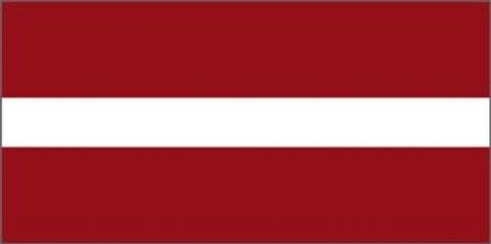
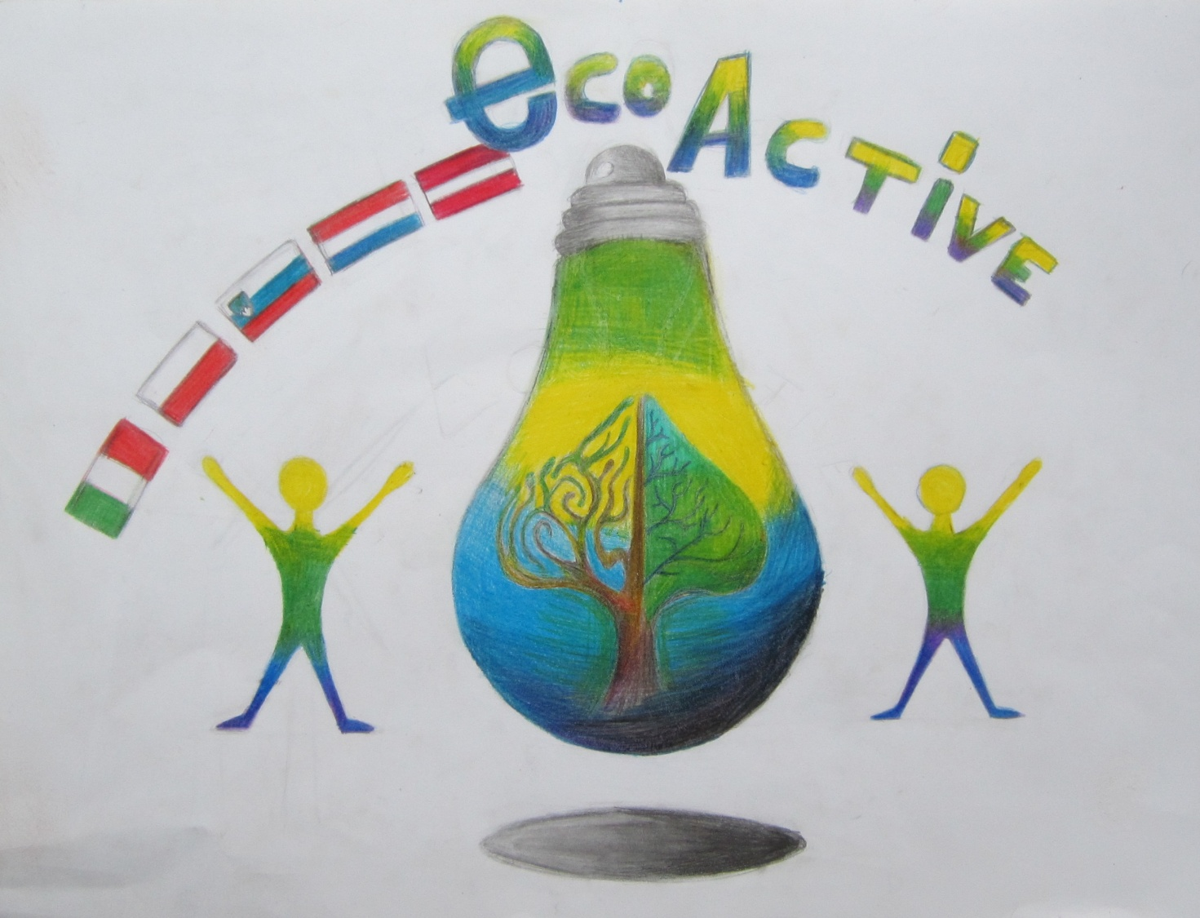
LESSON PLAN
School | Annas Brigaderes pamatskola
Thematic area | Healthy food
Time | 40 – 45 min
Age group | for Grades 4-6 (9-12 year - olds)
Teacher | Maija Klāsupa
Lesson plan | *At the beginning of the lesson the teacher gives each student colorful sheet of paper, they should write down some foods they believe are healthy  *)There is a sheet of paper on the blackboard with drawn dish on it, students come and stick their clorful paper sheets on the dish  *)The teacher reads the answers aloud and discuss if students' answers conform healthy eating patterns  *)The teacher talks about the food pyramid and explain that in order to be healthy children should be eating more of certain foods and less of others  *)Group work – students get food flashcards  - the Task: make a healthy food – salad, soup etc. - breafast, lunch, dinner. Each groap represents, what they have made.  *)Each student get a worksheet „My family's recipe” and writes down her or his favorite family's recipe. When students have finished they present their recipes and discuss what are the most popular foods in their families.
Forms | - Individual work;  - collective work;  - group work.
Materials and tools | Post-it Super Sticky notes, worksheets
Evaluation | Selfevaluation
Attachements | Sets of flashcards

www.google.lv/search?q=uztura+piramīda&biw=1047&bih=481&source=lnms&tbm=isch&s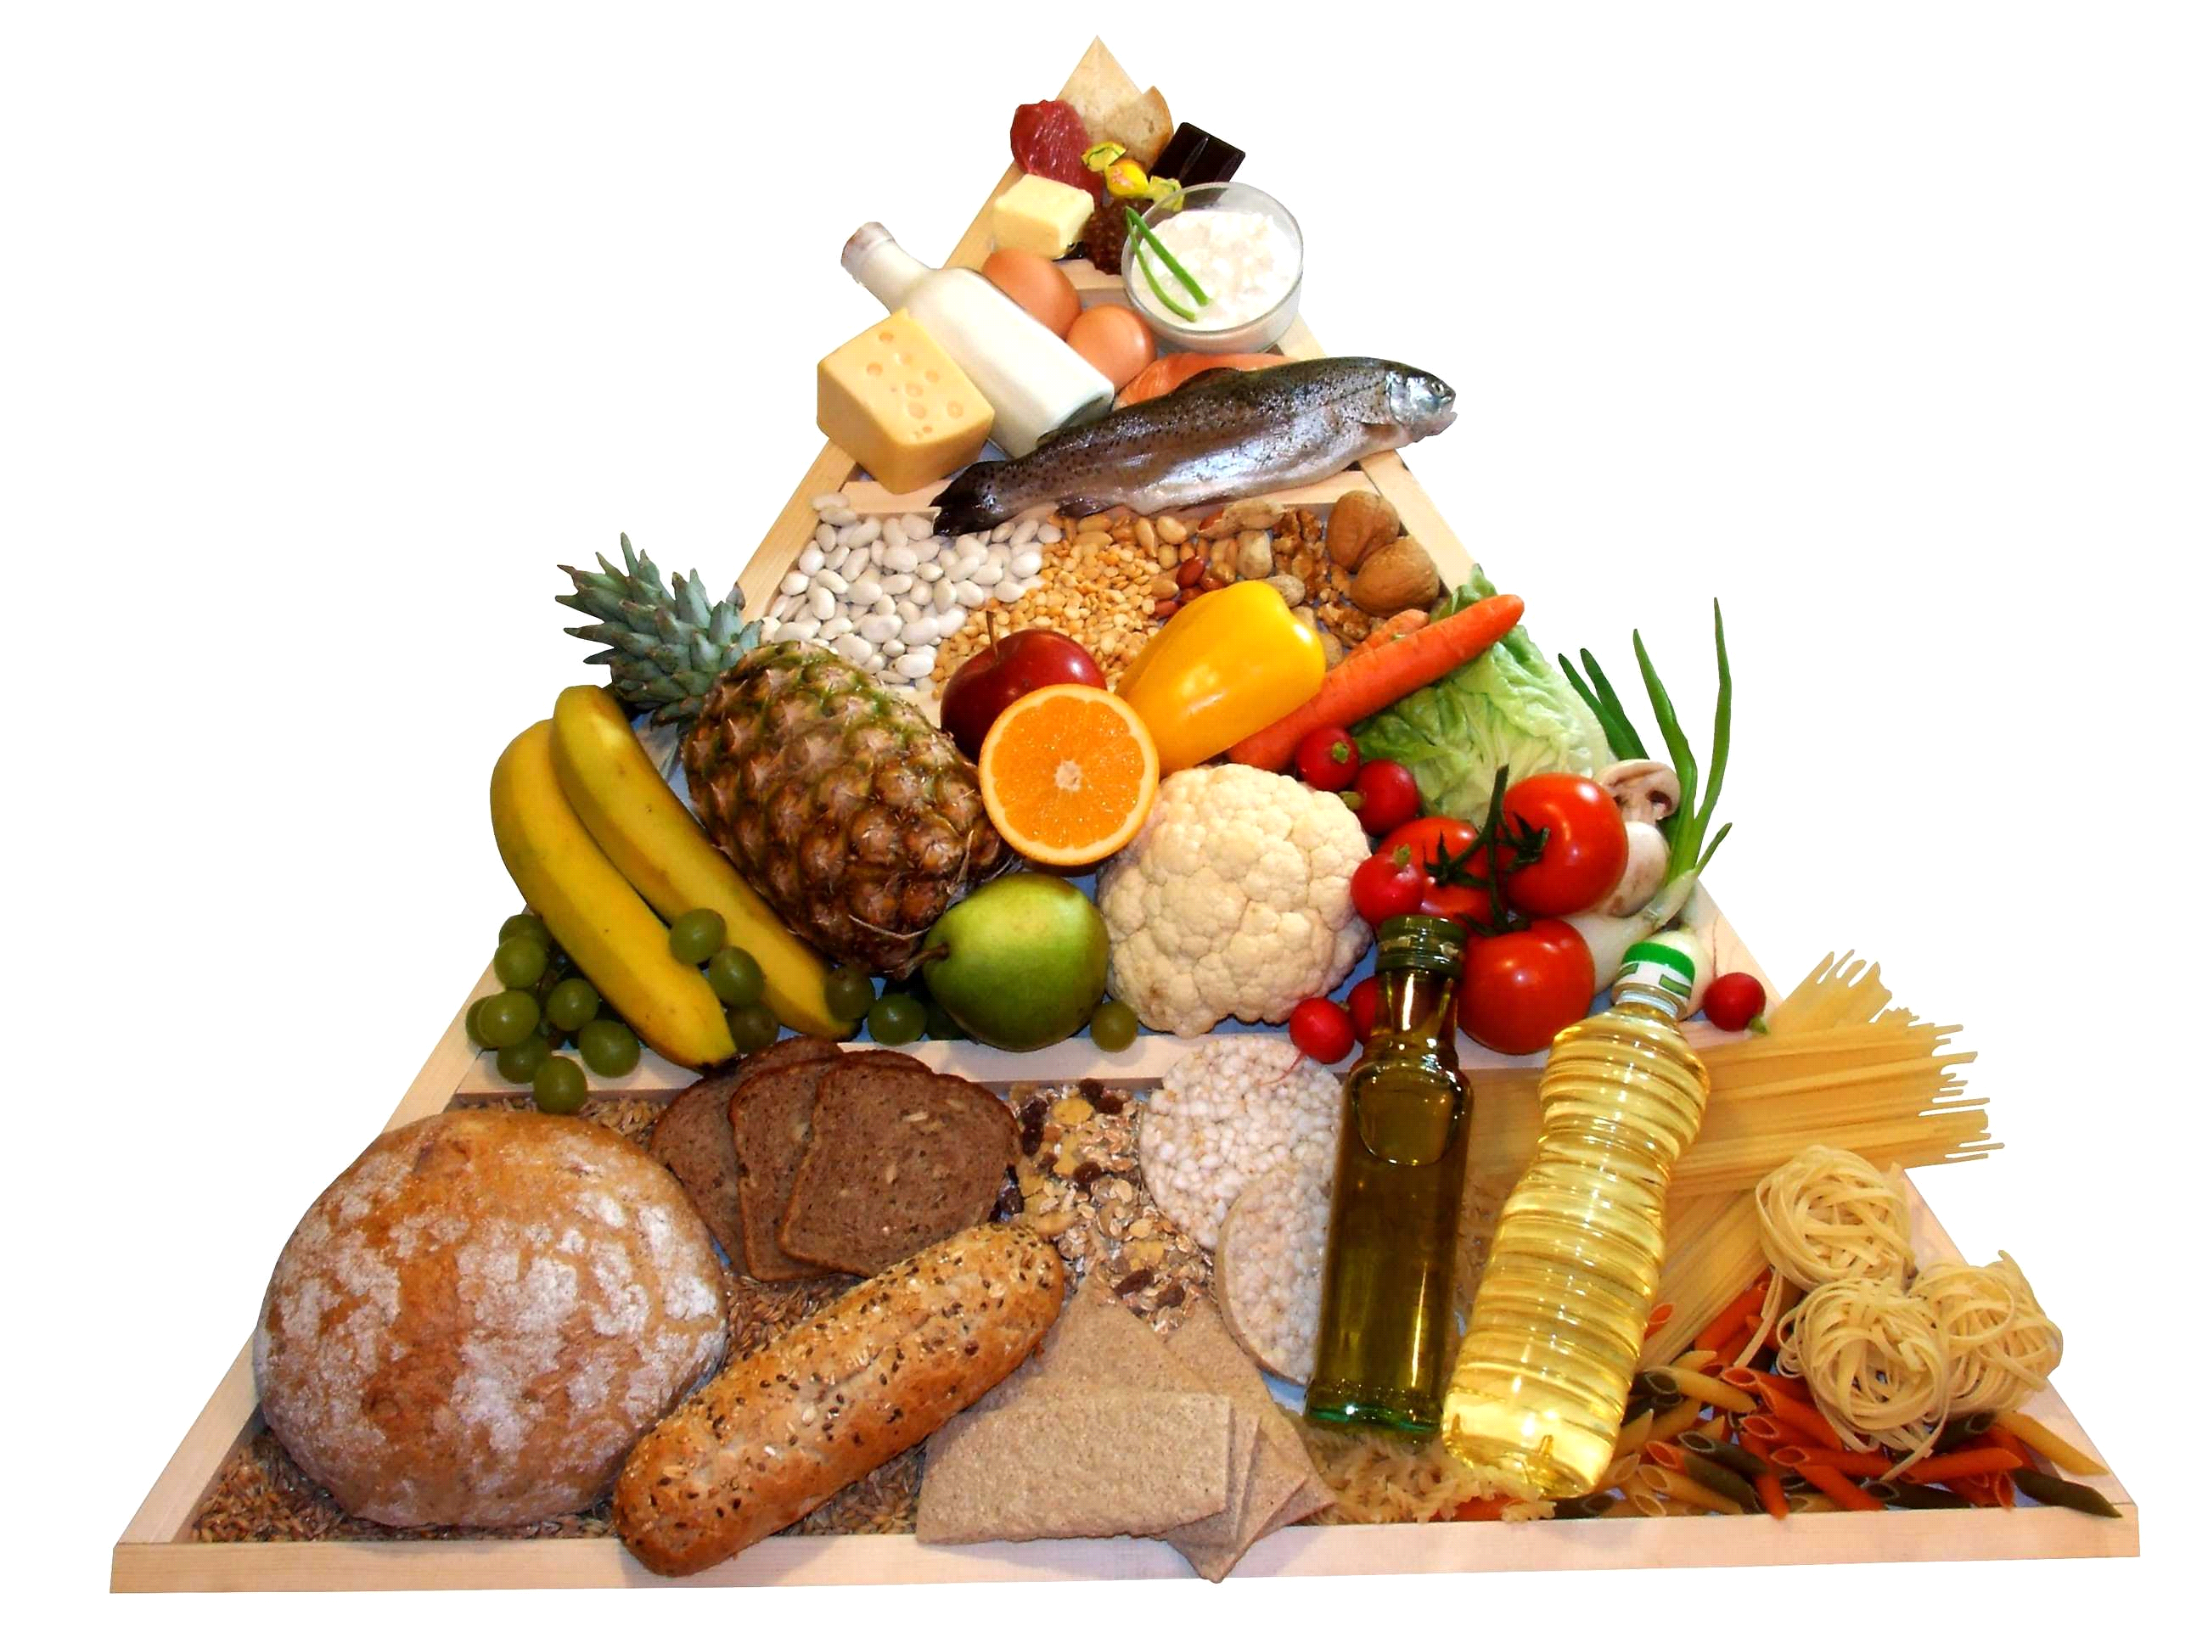
My Family's recipe

