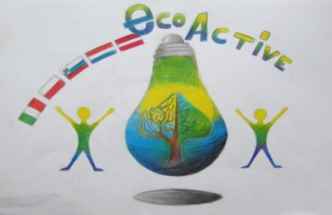
LESSON PLAN

SCHOOL | Annas Brigaderes primary school
THEMATIC AREA | ENERGY
TEACHER | Svetlana Kursina
SUBJECT | Wind energy
AGE GROUP  (approximately) | 9-11
TIME REQUIRED | 40 min
PLACE | CLASSROOM
LESSON OBJECTIVES | 1. Create an understanding of wind and wind energy.  2. Find out the possibilities of using wind energy in the past and nowadays.  3. Teach students to measure wind speed with self-made anemometer.
LESSONS YOU CAN USE | - Language, for translation in English, of course the English lesson  - Science  - Nature knowledge  Integrative learning connecting skills and knowledge from multiple sources and experiences CLIL Content and Language Integrated Learning
CLASS ORGANISATION | Pairs/groups and individuals
MATERIALS | Two cardboard strips, glue, 4 plastic or paper cups, adhesive tape (or needle with thread), hairdryer for teacher
ICT TOOLS

PROCEDURE | - Introduction task (On the screen - images showing strong winds - in the appendix). During the discussion students make conclusion that all the images depict the wind. The teacher notifies the theme and tasks of the lesson.  - The teacher suggests modeling the wind in the classroom (blowing, ventilating, using a hairdryer). It is concluded that the wind is the movement of the air in the horizontal direction. Observation: The hair dryer puts the ball rolling, flinging the flag. Conclusion: The wind has energy!  - Discuss: What are the characteristics of the wind (strength - speed). Speed can be measured. This is done with a device called an anemometer. Practical work: production of an anemometer  - Two thick strips of cardboard are glued in shape of the cross. Attach the plastic or paper cups to the end of each strip  - Put the construction on the pencil or pen tip (making the hole)  - Test the costruction by blowing and using the hair dryer using different operating modes. Working in pairs / groups: How do people use wind energy? (students draw and tell how people used the wind in the past and use it nowadays)
EVALUATION | Selfevaluation (What I found out in the lesson and what I liked the most)
ATTACHEMENTS | Pictures

