Lunch for Monday (by Guus)
tasty and healthy salade

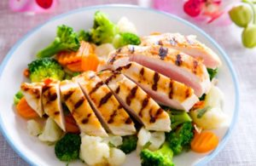

Ingredients:

- Tofu salade.

description
first you smoke the tofu
next you get 100 grams chicken and tro it in the pan
then you can eat the diner
- salmin with advocad
- spicy chicken salad
- couliflower salad feta
- omelette with salmon
- Thai tuna salad
- Avocado with egg
- Vegetarian suchi

Lunch for Tuesday (by Ika)
pancakes with raspberries

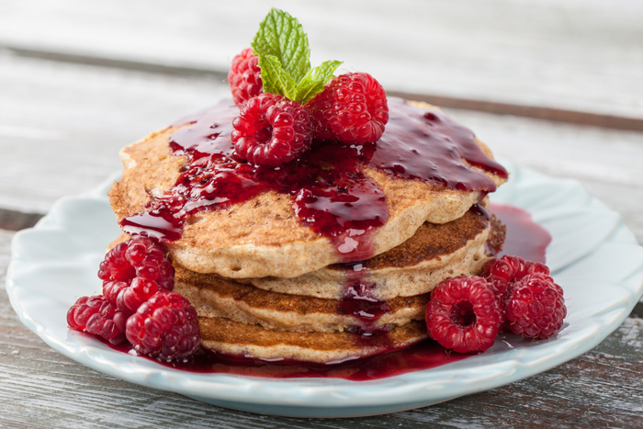
description
1 mix all the ingredients in a bowl with a mixer
2 put a pan on the fire
3 and fry the pancakes
4 and then eat tasty

ingredients:
- 160 grams selfraising flour
- 0,5 teaspoon of salt
- 300 ml of water
- raspberries

Lunch for Wednesday (by Ilse)

fish wrabs

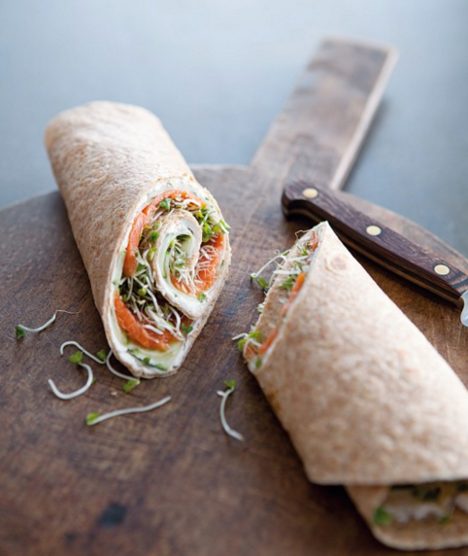

Ingredients:
0.5 of bergine 1 large tomato tuna
wheat made herb cheese pepper and salt
pepper 1 iceberg lettuce

1 was eggplant, peppers, tomatoes and lettuce.
2 cut vegetables washed except iceberg lettuce into cubes.
3 pack wrap and add a layer of herb cheese.
4 herb dressing and cheese wrap fish.
5 add the sliced vegetables and cream cheese wrap with fish.
6 put salt and pepper to taste.
7 to finally lettuce on ice.
8 roll wrap and cut through the wrap and eat him.

lunch for Thursday (by Jannik)
Afternoon healthy food: soup and salad
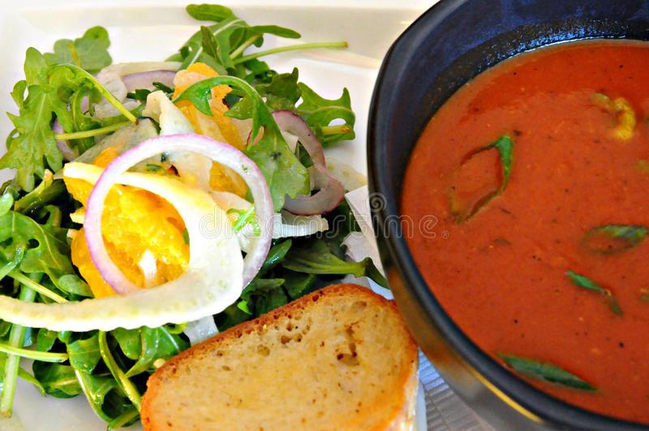

ingredients
- Bag of soup
- slices 2
- ham and
- chees
- lettuce
- boiling water
- 1 egg

- allow the water to boil for
- do it in bowl and add the contents of the sachet into the
- insert the ham on the sandwich and then the cheese over one, add the slice of bread on it
- do the sandwich the sandwich iron [there get him if he smokes
- put the pan on the fire
- break the egg through the middle and put it in the pan
- put the salad on a plate and cut the egg into pieces do it by lettuce

Lunch for Friday (by Jermaine)
Egg Muffins
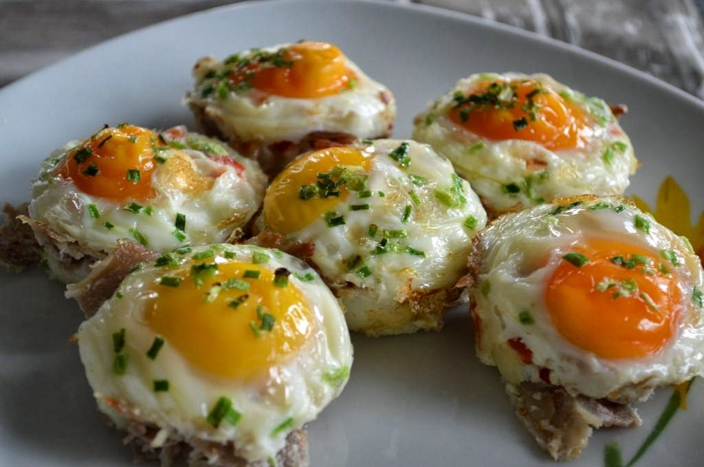
description
1 Preheat the oven to 180 degrees
2 fat 3 cupcake tins with butter,
3 spreads the molds with slices of bacon 2 a form
4-knock the eggs with grated cheese,
5 pour the egg-mixture into the wells of bacon
6 place it in the oven for 15 minutes

Ingredients:
- 1 large teaspoon powdered herbs make broth
- 2 handfuls fresh spinach
- to taste salt pepper
- unsweetened
- coconut
- egg
- muffin form
- 12 small tomatoes

Lunch for Saturday (by Karlijn)
tosti “hairdressers”

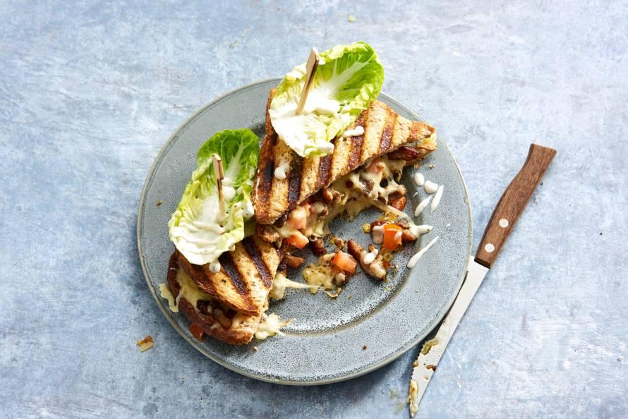

Ingrediënten:
- 18 pieces of shoarma bars
- 3 tomatoes
- 6 tps sambal
- 12 slices of bread ( all variations possible )
- 18 el grated cheese
- 18 leaves of lettuce
- 6 tbps garlic sauce

How do you make the dish ?
- first you heat some oil in a frying pan and fry the shoarma strips for about 8 minutes.
- meanwhile, the tomatoes cut intro small pieces. treat the slices of bread with sambal.
- seige the slices of bread with the shoarma and some pieces of tomato.
- sprinkle some grated cheese over it.
- put the sandwich in the sandwich maker until it has grill marks.
- prick a leaf of lettuce on top and serve with garlic sauce!
Lunch for Sunday
Dutch pea soup with rye bread and bacon (by Max)

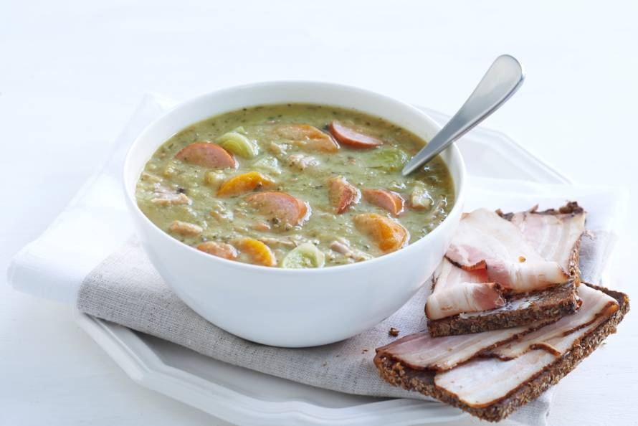
Wash the split peas. Peel the celeriac and the winter carrot. Cut the celeriac into cubes and the winter carrot into pieces. Cut the celery fine. Cut the leek into rings and the smoked sausage into slices.
In a large soup pan, bring the split peas with celeriac, winter carrot, shoulder chops and the sauerkraut bacon to the boil. Turn down the heat and boil the soup for about 45 minutes, or until the split peas are tender and begin to fall apart. Occasionally scoop the foam off the soup with a slotted spoon and stir with a spatula over the bottom of the pan to prevent burning.
Remove the pork chops and sauerkraut bacon from the pan and cut the meat into pieces. Discard the bone from the pork chops. Put the meat back in the pan with the leek, the celery and the smoked sausage. Heat the soup for another 15-20 minutes on very low heat.
Season the soup with pepper and salt. If you find the soup too thick, dilute it with some water or broth. Spoon the soup into bowls and add rye bread with cat bacon.

Ingrediënts:
- 500 grams of split peas
- 1 celeriac
- 1 winter carrot
- 40 grams of celery
- 2 pears
- 350 grams of smoked sausages
- 2 shoulderchops (360 grams)
- 200 grams of sauerkraut bacon
- 2 liters of beef broth from tablet
- 8 slices of Frisian rye bread (pack of 350 g)
- 100 g of cat bacon (slices)

