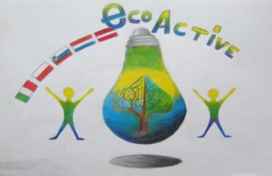
LESSON PLAN

SCHOOL | Annas Brigaderes primary school
THEMATIC AREA | RESOURCES
TEACHER | Evita Deičmane, Maija Klāsupa
SUBJECT | Project week
AGE GROUP  (approximately) | 10 -13
TIME REQUIRED | 40 min
PLACE | CLASSROOM
LESSON OBJECTIVES | - • With the help of allegoric performance sketch to draw attention to environmental problems and human activities in it. The goal - to play eco sketch about resources and saving the environment.  - Learn to save environment, to sort our waste  - Learn the basics of green thinking
LESSONS YOU CAN USE | - Language, for translation in English, of course the English lesson  - Science  - Nature knowledge  Integrative learning connecting skills and knowledge from multiple sources and experiences CLIL Content and Language Integrated Learning
CLASS ORGANISATION | Pupils work in groups
MATERIALS | carton boxes (2-3), desk lamp, white silk paper, used carton, glue, scissors, cocktail straws, adhesive tack (masa mocujaca) , scotch tape, worksheets
ICT TOOLS | https://www.youtube.com/watch?v=dpcWKg2vqJA
PROCEDURE | Greetings, introduction  In the introduction – lesson starts with Shadow Theatre, during the lesson pupils prepare similar performances  Students are divided into groups of three, using coloured buttons.  Each group toss up a ready sketch, which is prepared by Annas Brigaderes primary school, pupils can offer their own original etudes about lesson theme . There are previously prepared folders with the necessary images.  Two groups prepare stage for shadow theatre – cardboard boxes.For this exercise pupils can involve international project teachers.  Preparing time – 10-15minutes.  Pupils show their performances.  At the end of the lesson pupils value their job, they can discuss, what they liked and what they found out.
EVALUATION | Pupils get 2 colourful post-it note sheets, on the one note sheet they write, what they liked and on the other sheet they write, what they found out.
ATTACHEMENTS | Eco -performances

