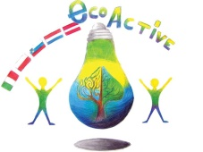 LESSON PLAN
SCHOOL | Primary School number 2 in Puławy
THEMATIC AREA | WATER
TEACHER | Jolanta Ciesielska
SUBJECT | Water – nature’s treasure – let’s save it every day!
AGE GROUP  (approximately) | 7 – 10 year olds ( younger pupils)
TIME REQUIRED | 60 minutes
PLACE | classroom
LESSON OBJECTIVES | Pupil:  - knows the importance of water in the life of man, plants and animals,  - understands why water is a treasure,  - speaks about the water and the actions to be taken to save it,  - understands why saving water is so important  - indicates the possibilities of limiting waste of water,  - is aware that excessive water consumption may cause shortages in the future,  - cooperates with peers while performing tasks,  - decrypts words,  - puts words in the correct order to make a sentence,  - multiplies in the range of 50,
LESSONS YOU CAN USE | • Ecology  • Nature knowledge  • Mathematical knowledge
CLASS ORGANISATION | - Individual  - Group work
MATERIALS | world map, globe, one liter bottle of water, water, laboratory glassware, 100 cm long paper strip, interactive whiteboard charts, individualized work cards, group work materials
ICT TOOLS | multimedia devices - interactive whiteboard, ActivInspire computer programme, Task Magic, movie "Saving water" - YouTube
PROCEDURE | 1. Welcome.  2. Reminding of the rules of the class.  - What are the rules of working in class?  3. Getting to know the subject of the lesson.  Calculate. Interactive exercise.  25 s 32 s 15  36 s 12 s 28  24 42 16  40 30 50  5 ∙ 5 = 25 box 4 ∙ 8 = 32 box 3 ∙ 5 = 15  6 ∙ 6 = 36 box 4 ∙ 3 = 12 box 4 ∙ 7 = 28  3 ∙ 8 = 24 6 ∙ 7 = 42 2 ∙ 8 = 16  5 ∙ 8 = 40 5 ∙ 6 = 30 5 ∙ 10 = 50  - What is this?  - What can be a treasure?  - In today's lesson, we will answer the question: why is water a treasure?  Getting to know the objectives of the lesson.  * During today's lesson you will learn why water should be saved.  * You will learn how to save water  5. Success criteria.  * After today's classes you will be able to enumerate at least 5 ways to save water.  In today's classes the teacher will pay attention to:  - pupils’ being active,  - using full sentences while speaking,  - work in a group, correct performance of tasks,  - behaviour.  I remind you that everyone has the right to make a mistake.  We do not laugh at the mistakes of children, it is important not to repeat them.  6. Curiosities about water.  - What is the color of water? (is transparent)  - Where does the blue color of water in the water reservoir come from? (From the color reflection of the sky).  - What shape does the water have?  - Pour water into dishes of various shapes. Watch what its shape is.  The liquid takes the shape of the container in which it is located.  - Conclusion: Water is a liquid.  [Most countries in the world suffer from a water deficit, only a dozen have so-called surplus. This is, for example, Norway, which due to its relatively low population and moderate climate has plenty of water in abundance. The worst situation prevails in Africa and some Asian countries. Poland is not doing well in this context - it is one of the poorest countries in Europe as it comes to water and water consumption is constantly growing. On average, in Europe there is 5100 m³ of life-giving fluid per person, while in Poland only 1,700 m³.]  - Looking at the globe, say what is more, water or land?  - To visualize how much water is useful for us on our planet, you can do a simple demonstration:  A 100 cm long paper strip constitutes 100% of the Earth's water resources.  The seas and oceans represent 97% of water on our planet. However, it is salt water, unsuitable for use - measure out and cut 97 cm from a long strip.  It has been 3 cm, or 3% which is fresh water. Unfortunately, 2% is stored in glaciers - cut a 2 cm long strip.  The water available to us is 1% of water resources. That's a lot?  - And what is the water needed for? (for drinking, washing, cleaning, cooking, washing, watering plants, for animals ...)  - Water occurs in all living organisms,  For example, the body of jellyfish is 95% water.  In humans, water is about 65% of body weight. It is a component of blood and all body fluids, it occurs in such organs as the liver, heart, brain and muscles.  Every day, we lose about 2.5 liters of water from the body (through the skin - sweat, along with breathing, through the urinary and digestive systems). It is therefore necessary to remember to refill this liquid.  - How many days can a man survive without drinking? (Without water, humans can survive from 4 to a maximum of 7 days. Long-term dehydration leads to loss of strength, weakening of the body's immunity, loss of consciousness, damage to internal organs and death.)  - There is not enough of water, but the needs are greater. In that case, what should be done in such a situation?  (Water should be saved.  That is why it is important to realize how important it is to manage water properly.)  - How can we save water?  7. Watching a film. „Saving water”  - Why should you save water?  • To pay smaller bills and have more money.  • Africa has a water shortage.  • Scientists say that in 2050, 7 billion people in 60 countries can  suffer from shortages of drinking water.  - List the actions you can take to save water.  • Turn off the faucet while brushing your teeth.  • You should take a shower instead of a bath.  • The tap must be leak-proof.  • Water the garden once a week for 20 minutes in the evening, because the water evaporates less at night.  • Do not wash dishes under constantly running water.  • It is good to use the dishwasher.  8. Solution to the text task.  If you do not turn the tap when brushing your teeth, you will lose 15 liters of water with a medium stream within 3 minutes.  How much water will you lose when brushing your teeth twice a day (morning and evening)?  (Answer: 30 liters of water.)  How many liters of water will be lost with a family of four while brushing in the morning and evening?  (Answer:. 120 liters of water.)  9. Conversation - What other actions can be taken to save water?  * Do not open the tap completely when washing your hands. To clean the face and hands, the water does not have to spurt; it is enough as it flows in a calm stream. If you collect water in the wash basin during washing, you can use it to soak stained clothing before washing.  * Change all taps to ones that save water. In the old tap you can install the aerator - a kind of fine mesh sieve that aerates the outflowing water, making the stream stronger. However, if you do not want to stop at half measures, the best solution will be installing a Roca Atlas battery which, thanks to an innovative aerator, reduces water consumption to 1.32 liters per minute.  * Only run the washing machine and the dishwasher when it is full. If you follow this rule, you will get a lot of savings compared to washing or handwashing. If you buy new household appliances, pay attention not only to the energy class of the device, but also to whether it has ECO programmes to shorten the washing or washing process, and to reduce water consumption.  * Collect water from rainwater and use it to water the gardens. (This water is usually soft, so it's even better for watering plants.)  10. The song "Four Elements". Movement improvisation.  11. Group work.  Reminding the rules of a group work.  - Read the task. Put these sentences, which talk about saving water in the column "I save water", and those that point to wasting water in the column "I waste water".  "I save water", "I waste water".  I turn off the tap while brushing my teeth. In the evening I take a quick shower. I collect rainwater and use it to water the plants in the garden. I only switch on the washing machine and the dishwasher when they are full. While taking a shower, I turn off the water while soaping. I repair a leaking faucet. I wash the dishes in the dishwasher. I do not fix a leaking tap. I bathe every day in a tub full of water. I wash dishes under constantly running water. I do not turn the tap off while brushing my teeth.  12. Self-assessment on the interactive board.  13. Independent work at the tables.  Individualized work card:  Here is the magic square that encrypts words.  A B C D E  1 ć o i ż e  2 a w l b ó  3 n ą k s m  4 ł ę r t c  5 z y j d e  Decrypt a password:  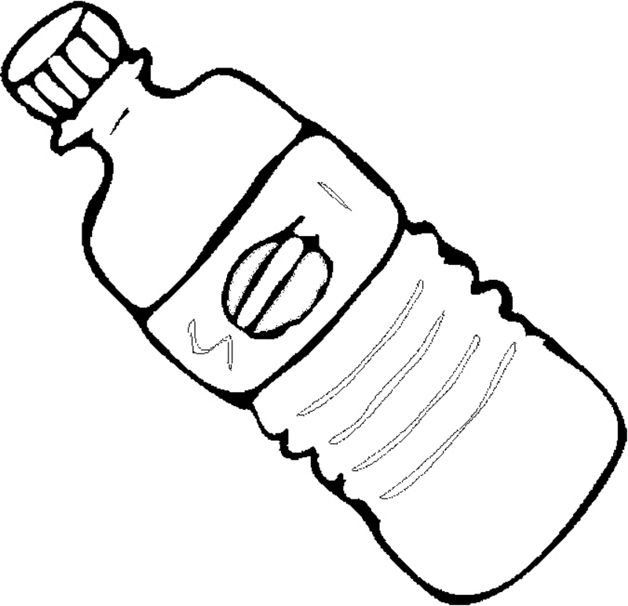  2B 1B 5D 2A 4D 1B  W o d a t o  3D 3C 2A 4C 2D  s k a r b  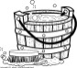  2B 1C 4B 4E 3A 2A 2C 1E 1D 5B  w i ę c n a l e ż y  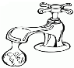  5C 3B 3D 5A 2A 3A 1B 2B 2A 1A  j ą s z a n o w a ć  Password:  Water is a treasure, so it should be respected.  - Why is water a trasure?
EVALUATION | 14. Summary of classes  Evaluation.  Interactive task: TRUE - FALSE.  Water is needed for people, plants and animals. (TRUE)  Bathing in a bathtub is more economical than showering. (FALSE)  Excessive water consumption can cause shortages in the future. (TRUE)  Garden should be watered in the evening, because the water evaporates less. (TRUE)  By saving water, you pay smaller bills. (TRUE)  Rainwater can not be used to water plants in the garden. (FALSE)  You do not need to turn off the water when brushing your teeth. (FALSE)  15. Assessment.  - You have achieved the goal of today's activities. You can enumerate at least 5 ways to save water.  - HOW TO USE YOUR KNOWLEDGE IN EVERYDAY LIFE?  - Which advice, which we talked about during the lesson, will you use at home?  - Finally, we can ask ourselves: Why is it worth to save water?  - By saving water - we save money that we can spend on something else.
ATTACHEMENTS

