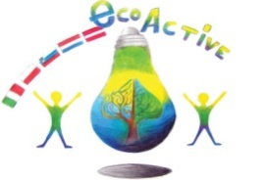
LESSON PLAN
SCHOOL | SECONDO CIRCOLO DIDATTICO “CAVOUR”MARSALA-SICILY-ITALY
THEMATIC AREA | RESOURCES
TEACHER | Silvana li volsi, Graziella Pellegrino
SUBJECT | Recycling and reusing materials to create a mini “Dinosaur Park”
AGE GROUP  (approximately) | 8-9
TIME REQUIRED | 10 hours
PLACE | classroom
LESSON OBJECTIVES | Recycle paper, plastic  Reuse the recycled material  Build new objects from recycled things
LESSONS YOU CAN USE | - Geography  - History  - art  - Italian  - english
CLASS ORGANISATION | - Pupils work individually  And in groups
MATERIALS | For the park: Pizza cardboard boxes, waste paper and coloured cardboard, moss  For the dinosaurs: knife  scissors, glue, a sheet of cardboard, colors, markers and tempera
ICT TOOLS | Computer, interactive white board
PROCEDURE | Pupils recycle all the materials  pupils build the dinosaurs:  use a cork as base. Draw a dinosaur on cardboard, decorate it with waste paper and other recycled materials  Prepare a miniature park with pizza boxes and moss, stick a miniature volcano and palms and e river. Build on it a very big Dinosaur with a balloon covered of wastepaper and paint it. Stick the other small dinosaur.
EVALUATION | Children worked with enthusiasm, motivation, they build a very amazing miniature dinosaur park.
ATTACHEMENTS | photos

