Dinner for Monday (by Camiel)
nasi with a cabbage fried egg

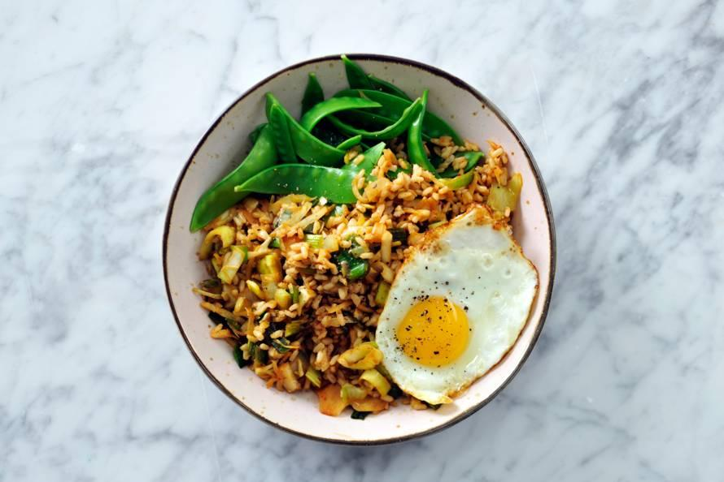

Ingrediënten:
1.Cook the rice according to the instructions on the package. Slice the garlic. Heat the oil in a skillet and add the garlic and sambal. Put the cabbage together with the leek with the garlic. Stir fry 5 min.
2.Rouve the cooked rice with a fork and scoop the vegetables with the soy sauce. Heat put the oil in a frying pan and fry the eggs. Meanwhile, cook the snow peas for snow peas
3.Rouve the cooked rice with a fork and scoop the vegetables with the soy sauce. Heat
put the oil in a frying pan and fry the eggs. Meanwhile, cook the snow peas for snow peas

● 200 g of unpolished rice
● 2 cloves of garlic
● 3 tbsp sunflower oil
● 2 tsp sambal oelek
● 300 g of biologically cut
white cabbage
● 300 g of sliced ​​leeks
● 4 eggs
200 g snow peas

Dinner for Tuesday (by Geske)
stuffed peppers

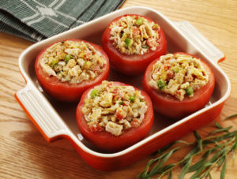

ingredients for 6 people
- Preheat the oven to 180 to 200 ° C.
- Cut the top of the peppers and remove the seeds.
- Pour the olive oil into a pan for the filling and heat over a medium heat. Stew the onions and add the minced meat.
- Bake the minced meat until it looks brown.
- Pour in the sifted tomatoes and 1 liter of water. Season with salt and pepper, the oregano and the bay leaf.
- Add the rice and stir well. If you see that the filling is too firm, you add some water.
- Cook for 15 minutes and stir regularly so that the rice does not stick to the bottom. Turn off the heat and let rest for 5 minutes.
- Fill the peppers with the mince filling. Place the peppers in an oven dish. Drizzle with olive oil. Season with a pinch of oregano, pepper and salt.
- Put the dish in the oven for 45 minutes.

6 red peppers
olive oil
oregano
for the filling
4 tablespoons of olive oil
1 small onion, chopped
500 g half-to-half minced
1 liter sieved tomatoes
1½ tablespoon of oregano
1 bay leaf
200 g of rice

Dinner for Wednesday (by Lindi)
pasta salad
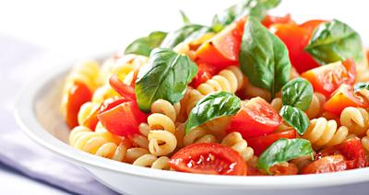

ingredients: ( for 4 persons )
- you have to put water in a pan.
- and then let it boil ( first on stand 6)
- wait about 10 minutes
- Add a little salt.
- Is not it still cooking? set the position higher.
- When is boils, add the pasta then wait another 5 minutes.
- Meanwhile cut the vegetables. ( is in the ingredients)
- Pick up a colander put the pasta in and let the water run out.
- Pick up a bowl where you put the pasta in with the vegetables and the lettuce
- when the paste is cooked, mix it with the lettuce and vegetables.
- 350 grams of penne (or other types of pasta)
- 60 ml of (olive)oil
- 1 bunch of spring onion
- 1 clove of garlic
- 150 grams of cherry tomatoes (cut into quarters)
- salt and pepper
- 140 grams mozzerella
- 40 grams grated parmesan cheese
- 100 grams of fresh basilicum
- 12 large olives (cut in two )
- lettuce optionally

Dinner for Thursday (by Luc and Gabriel)

hotchpot
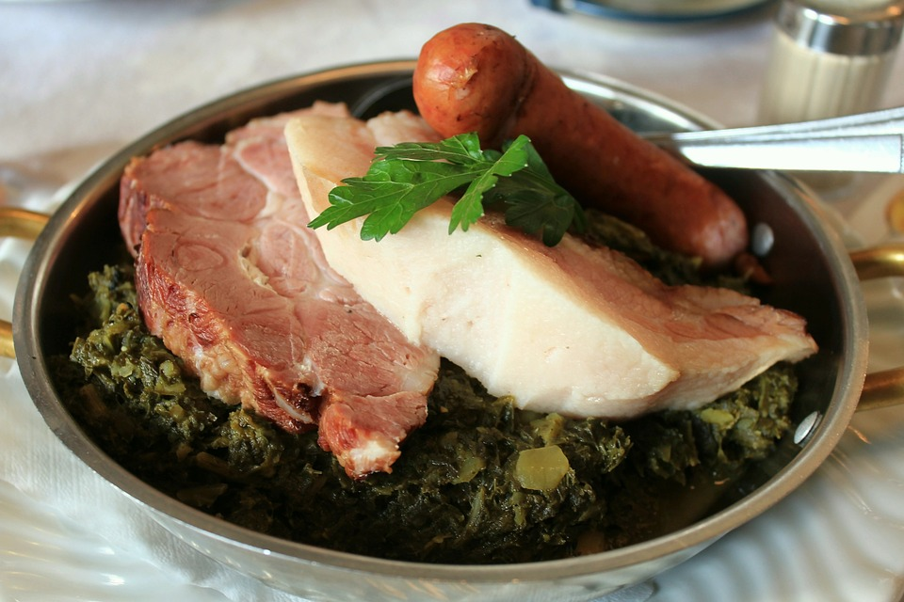

Ingrediënten:
Preparation
Boil the peeled potatoes and make a puree.
Cook the Brussels sprouts until done.
Heat the smoked sausage in hot water for 20 minutes.
Chop the onion and press the cloves of garlic.
Cut the mushrooms into cubes the chicken fillet into small pieces.
Preparation method
Fry the bacon strips in the wok until crispy.
Add the onion and garlic, fry them glassy.
Add the chicken fillet and stir-fry a bit.
Add the mushrooms, the cooked sprouts and the
smoked sausage cut into half slices.
Stir fry this a while.
Spat the puree through the wok dish, so that it remains a coarse character and is not crushed.

- 1 200 gr of kale
- 500 gr of crumbly potatoes
- 1 smoked sausage
- 10-15 grams of butter
- 100 grams of bacon cubes / bars
- pinch of salt and pepper
- possibly a touch of vinegar

Dinner for Friday (by Noa)
vegetable soup

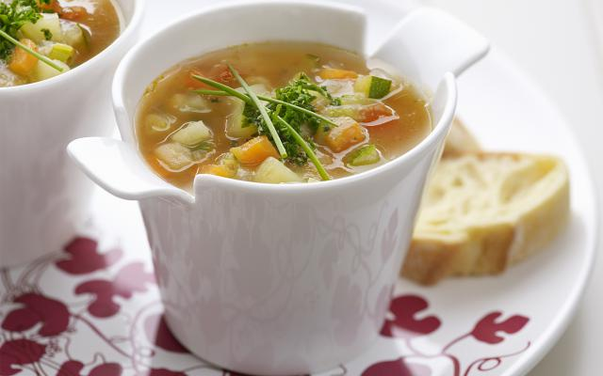

Ingredients for 4 people:
1.peel the root, tomato, potato and turnip. Peel the onion and rinse zucchini, leek and celery. Chop the vegetables into small pieces.
2.stew the vegetables for 10 minutes in a pan with some oil. stir occasionally to make the greens do not stick to the bottom. add the hot vegetable stock in. bring to a boil and let simmer for 20 minutes on low heat.
3. shovel 1 ladle vegetables in a bowl. mix them finely in a blender. add the mixed vegetables in the soup and let it boil so that the soup binds a bit. add the soy sauce and season to taste with salt and pepper.
4. Serve the soup into bowls and garnish with parsley and chives.
- 1 carrot 1 turnip
- 1 onion 1 potato
- 1 leek
- 1 zucchini
- 1.5l vegetable stock (cubes)
- 3 chives
- 2 tablespoons oil
- salt
- 4 stalks celery
- 1 tomato
- 2 tbsp Petr Elie chopped
- 1 tbsp soy sauce
- pepper

Dinner for Saturday (by Tom)
lasagne speciaal

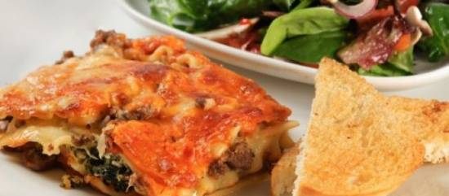

Ingrediënten: 4 persons
1.meat sauce
Fry the minced meat in a dry frying pan over low heat and sandy brown. Add the chopped tomatoes, crumbled stock cube, bay leaves and sugar. Let the meat simmer for half an hour. Taste a moment and season with oregano, salt and pepper. Remove the bay leaf.
2. Spinace.
Stir in beaten eggs and breadcrumbs thawed and well drained of cooked spinach. Season with nutmeg, salt and pepper.
3.béchamel sauce
Melt theof butter. Add flour all at once far. Stir and cook for 2 minutes. Milk produced when there is little by little added to form a thick sauce. Make the sauce to taste with salt, pepper and nutmeg. Stir the half of the cheese into the sauce. (The white sauce can also be made from a pack.)
4. Cut the mozzarella into small pieces.
Preheat the oven to 200 degrees.
Put the bottom of the baking dish half the meat sauce. Cover with a low lasagne sheets. Spread about half the spinach and half the mozzarella.. Pour 1/3 of the bechamel this. Then again lasagne sheets, meat sauce, spinach, mozzarella, lasagne, etc. etc. Finish with lasagne sheets and about béchamel sauce with the remaining grated cheese.
Place the dish in the middle of the pre-heated oven until the top golden brown (approx. 45 minutes).

- 1350g ground beef
- can tomato blocks
- crumble meat broth tablet
- 2 tea spoons sugar
- 2 tea spoons snuff oregano
- 1 lasagne sheets
- 450g frozen spinach leaf (thawed)
- 2 eggs
- 2 tablespoon cinnamon
- salt, pepper, nutmeg
- 1 pack lasagne leaf
- 100g grated mature cheese
- 3 dl milk
- 70g butter
- 70g bloom
- salt, pepper,
- nutmeg

Brunch for Sunday
(by Guus and Niels)
- pumpkinsoup
- salad with pear brie etz.
- ice with warm cherries

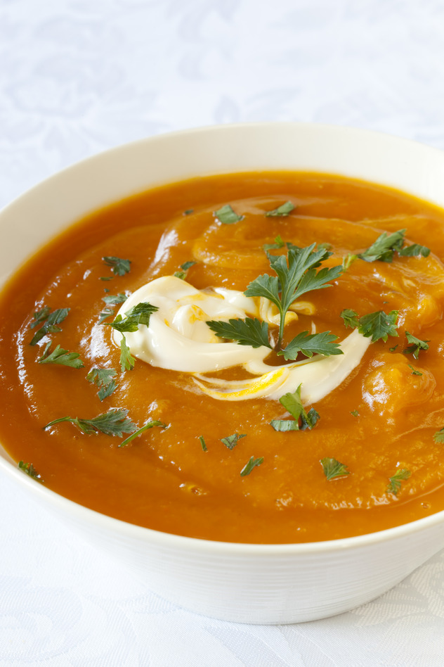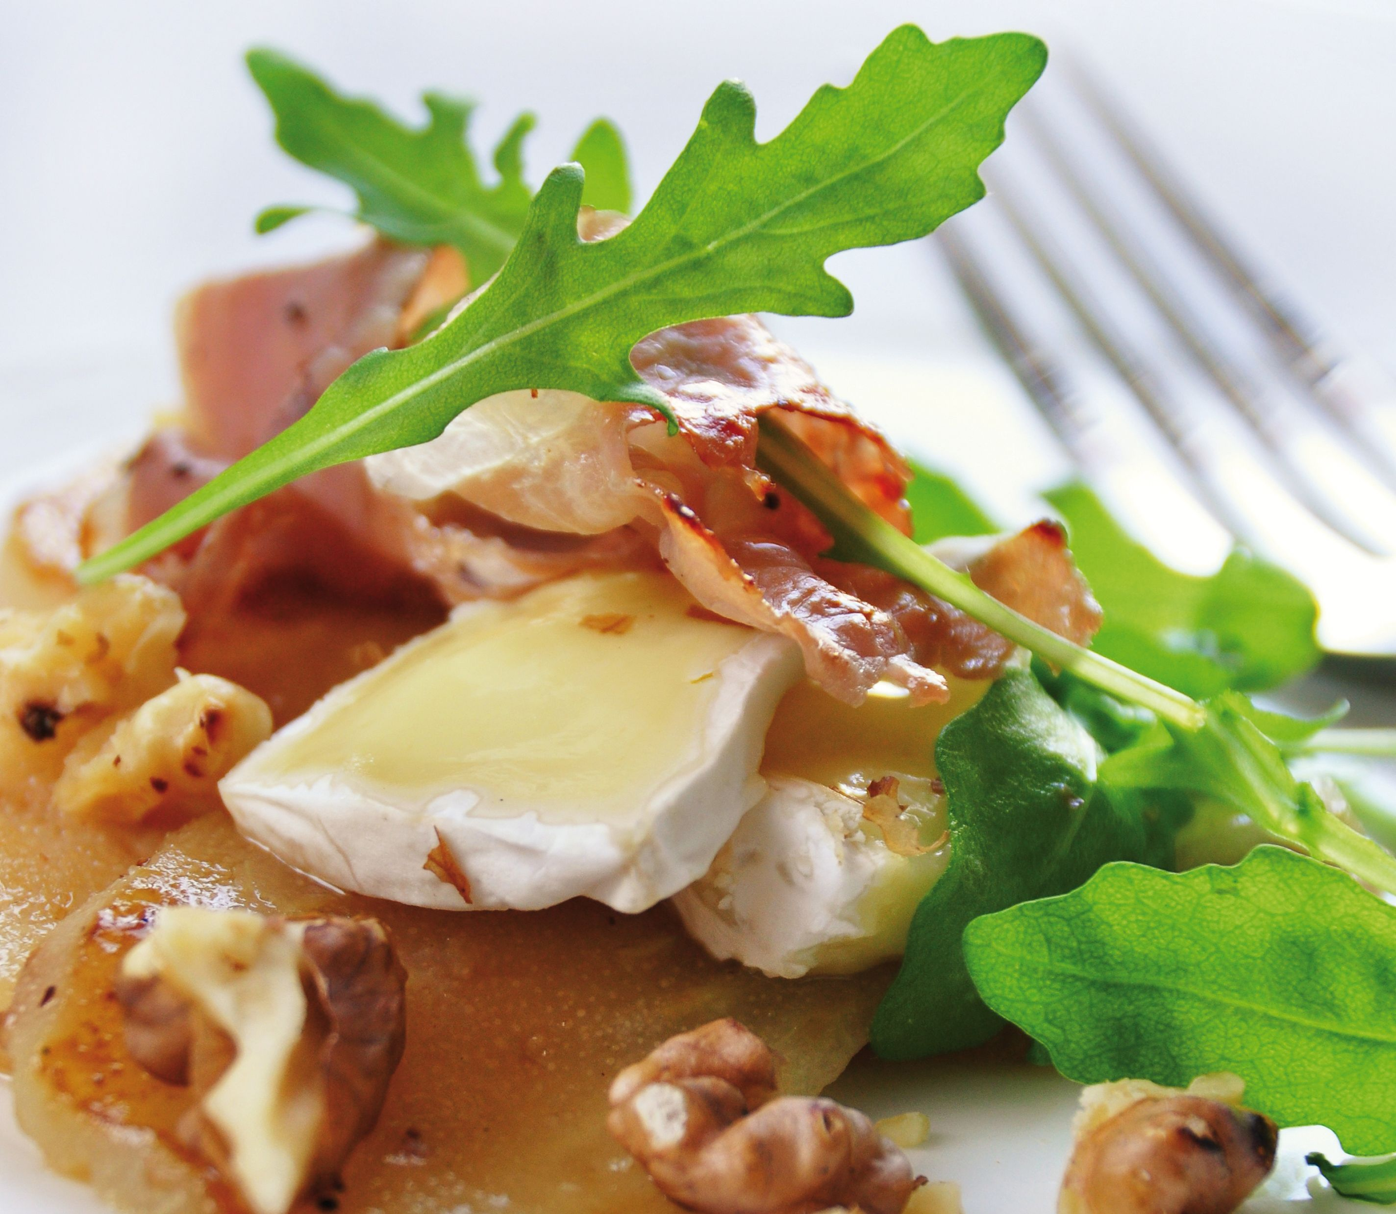

Ingredients: Ingredients: Ingredients:
- kg of fresh pumpkin 1. 2 pears
- 2 onions 2. brie 1 two scoops of vanilla ice cream
- 2 garlic cloves 3 walnuts 2 warm cherrie
- 250 gram winter carrots 4 arugula 3 tufts of whipped cream
- olive oil 5 honey
- 2 dried Laurel leaves
- 1 teaspoon {djinten}
- 1 liter of tap water
- 1 vegetable stock tablet
- 2 drops of tabasco
- 125 g of crème fraiche

Despription
appetizer
Cut the pumpkin into slices. Remove the seeds and the stringy inside and cut off the skin with a sharp knife. Cut the pumpkin into large pieces. Slice the onion and garlic. Peel the winter carrot and cut it into slices.
Heat the oil in a large pan and fry the pumpkin, winter carrot and onion for 5 minutes. Add the garlic, bay leaves and cumin. Pour in the water and add the bouillon tablet. Bring to a boil and let everything cook for 30 minutes.
Remove the bay leaves. Puree the soup with the hand blender and season with the tabasco, pepper and salt. Stir in the crème fraîche with a spoon so that it becomes smooth. Spoon the soup into deep plates or bowls and add crème fraîche.

main dish
cut the pear into pieces and then cut the brie and place it in a bowl.
then you put the walnuts, arugula and a little honey on it to finish it

dessert
scoop two scoops of vanilla ice cream into a bowl and then put the hot cherries on it.
finish it with a whipped cream

