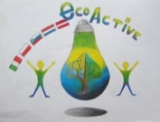 LESSON PLAN 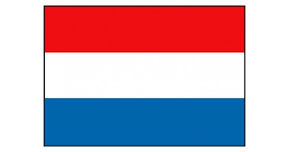
SCHOOL | De Weijerwereld Boxmeer NL
THEMATIC AREA | ENERGY,
TEACHER | Huub Creemers
SUBJECT | Kinds of energy and what we use in The Netherlands
AGE GROUP  (approximately) | 11-12 (oldest pupils)
TIME REQUIRED | 2 lessons (2 hours)
PLACE | Classroom
LESSON OBJECTIVES | - Pupils find out about kinds of energy we have  - Pupils know how every kind of energy is working  - Pupils know about the advantage and disadvantage of every kind of energy  - Pupils know what kind of “alternative” energy is used in our country
REGULAR LESSONS YOU CAN USE | - Language, for translation in English of course the English lesson  - Nature knowledge
CLASS ORGANISATION | - Pupils work in groups
MATERIALS | ICT
ICT TOOLS | Internet, PowerPoint
PROCEDURE | - Discussion in the whole group of pupils: how do we generate energy? What kinds of energy do you know? Wind, Solar, Fossile etc.  - Then group is divided in subgroups : for example 3 pupils for every kind of energy.  - Every group goes to the internet and tries to find out:  - How do we generate energy by using (for example) wind?  - What are the advantages of wind energy?  - What are the disadvantages?  - How many percent of the Dutch energy is generated by using wind energy?  - Search for a little experiment about wind energy and describe the experiment.  - Make a PowerPoint Presentation about “Wind energy”  - Show your presentation to your classmates.
EVALUATION | Discussion about the presentations (content and design) of the presentations
ATTACHEMENTS | PowerPoint Presentation of “ENERGY”

