**Water recreation**

* **Fishing**
* **Surfing**
* **Swimming**
* **Sailing**

[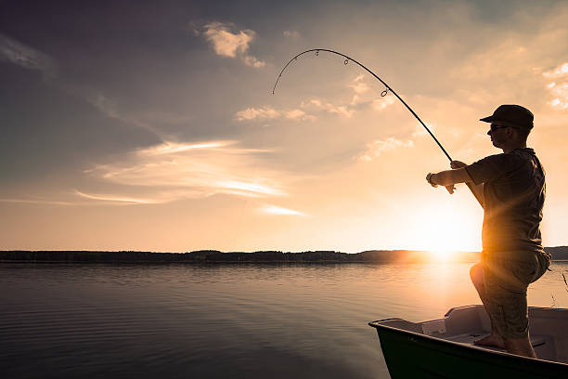](http://www.google.nl/url?sa=i&rct=j&q=&esrc=s&source=images&cd=&cad=rja&uact=8&ved=0ahUKEwiD1-7WwJDWAhWJY1AKHWvmAMwQjRwIBw&url=http://www.istockphoto.com/photos/fishing&psig=AFQjCNH0Y6S8j8jQSOu69K5xU9k5b2LHvA&ust=1504785409050497)

**Water recreation**

* **Fishing**
* **Surfing**
* **Swimming**
* **Sailing**

**Water recreation**

[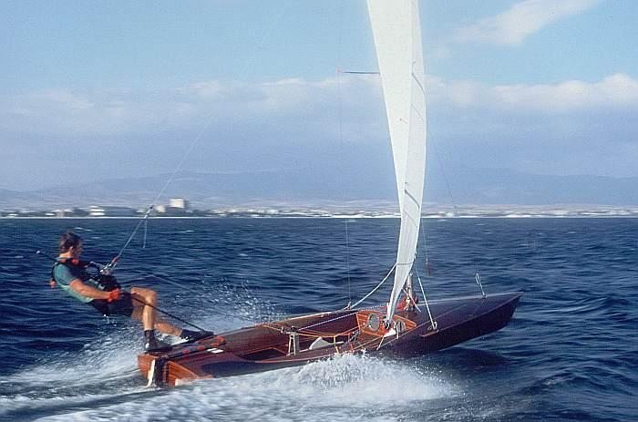](https://www.google.nl/url?sa=i&rct=j&q=&esrc=s&source=images&cd=&cad=rja&uact=8&ved=0ahUKEwjhjeT6wJDWAhVFJVAKHZtbAGcQjRwIBw&url=https://en.wikipedia.org/wiki/Sailing&psig=AFQjCNFIFnIICb5xywGVQgkr5gg7zHQs6w&ust=1504785494684896)

* **Fishing**
* **Surfing**
* **Swimming**
* **Sailing**

**Water recreation**

[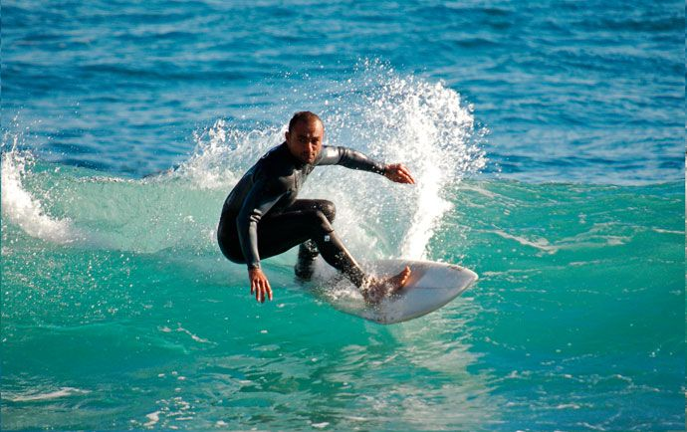](http://www.google.nl/url?sa=i&rct=j&q=&esrc=s&source=images&cd=&cad=rja&uact=8&ved=0ahUKEwjqjrvkwJDWAhVJYVAKHeDEDKMQjRwIBw&url=http://www.villasalgarveportugal.com/nl/activiteiten-algarve/watersport/surfen/&psig=AFQjCNEl2A8Xu8gABaRWkz9gj6acjomu5w&ust=1504785449131013)

* **Fishing**
* **Surfing**
* **Swimming**
* **Sailing**

**Water pollution**

* **Chemical industry**
* **Water treatment**
* **Housekeeping**
* **Oil**

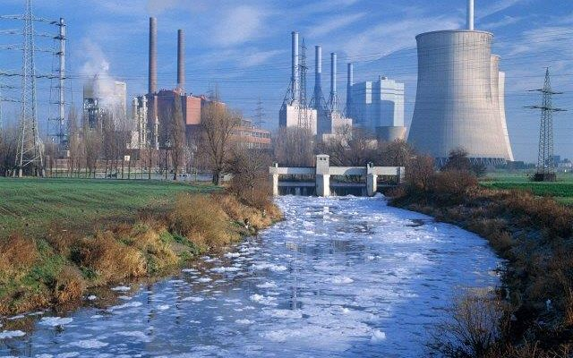

**Water pollution**

* **Chemical industry**
* **Water treatment**
* **Housekeeping**
* **Oil**

**Water pollution**

Recre

ation

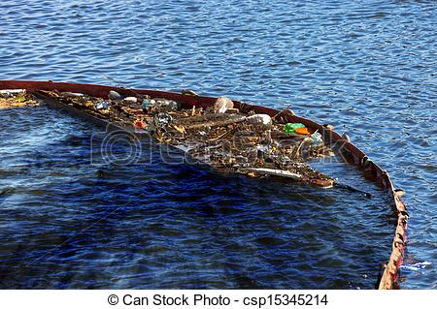

* **Chemical industry**
* **Water treatment**
* **Housekeeping**
* **Oil**

**Water pollution**

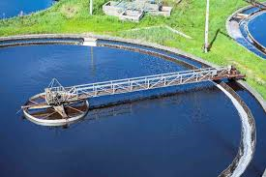

* **Chemical industry**
* **Water treatment**
* **Housekeeping**
* **Oil**

