Breakfast on Monday (by Beaza)
Fresh pancakes
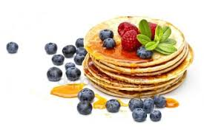
Ingredients:

Description

Put the flour with the milk in a mixing bowl. Scoop through. Now add the yogurt and the eggs and mix until smooth. Finally add the baking powder and a pinch of salt the batter and beat one last time. The batter is pretty thick now. Put a pan on the fire and put a drop of oil in it. Let the pan warm up well and ensure that the oil is well distributed. Now carefully pour some of the batter into the pan andspread the batter well over the pan. Put the fire soft and let the pancakeslowly yarn and brown. Is the bottom nicely brown and the top solidified, Then turn the pancake over and let the bottom turn brown. Repeat until the batter is finished. Serve with some leftover yogurt and of course it fresh summer fruit.

Enjoy your meal!

for 6 pancakes
● 100 grams of flour
● 150 ml of milk
● 100 ml of Greek yogurt
● 1 teaspoon baking powder
● pinch of salt
● (coconut) oil for baking
● blue berries
● raspberries
● extra yoghurt to spread the pancakes with

Breakfast on Tuesday (by Danique)
yogurt with berries

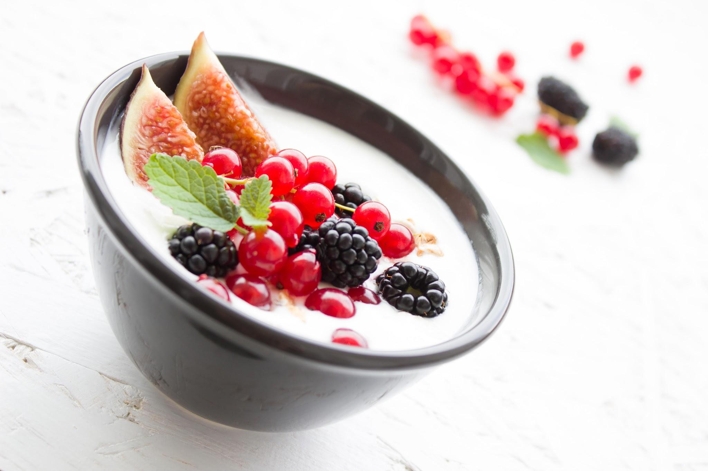

Ingredients:

Description:
- Put the yogurt in a bowl.
- Cut the nectarine into pieces.
- Put the nectarine, berries and raspberries in the yogurt.
- Enjoy your delicious breakfast!

- Yoghurt
- Berries
- Raspberries
- 1 nectarine

Breakfast on Wednesday (By fabian)
Breakfast pizza with egg and bacon

Ingredients:
Preheat oven to 180 degrees.
Remove the baking sheet from the oven and cover it with baking paper.
Fold the edges of the puff pastry to, making the edges stand higher here.
Sprinkle the grated cheese over the puff pastry.
Break up any piece of puff pastry egg and season with salt and pepper.
Put the last two slices of bacon on top of each egg and top everything with Italian herbs.
Put the breakfast pizzas 20 minutes in the oven.
Puff have golden brown and the eggs must be solidified.
- 1. 4eggs
- 2.4plakjes blaaderdeeg
- 3. 8 (thin) slices of bacon
- 4. 100g low-fat shredded cheese
- 5. Italian seasoning
- pepper and salt 6.

Breakfast on Thursday (by Luuk)
oatmeal with rye bread special

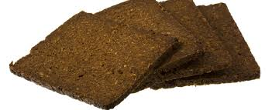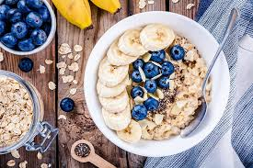

Ingrediënten:
Description
pick up the bowl and add the greek yochurt and the oatmeal.
boil the eggs in the pan with water for 4 minutes.
pick up the plate and put the rye bread on it [with cheese].
pick up the bowl again and put in the black berries.
cut the bananas and put it in the oatmeal bowl.
- rye bread 4 pieces
- oatmeal 500 gram
- 2 bananas
- 20 black berries
- possibly 1 piece cheese
- greek yochurt
- 2 eggs

Breakfast on Friday (by Max)
Dutch bouncer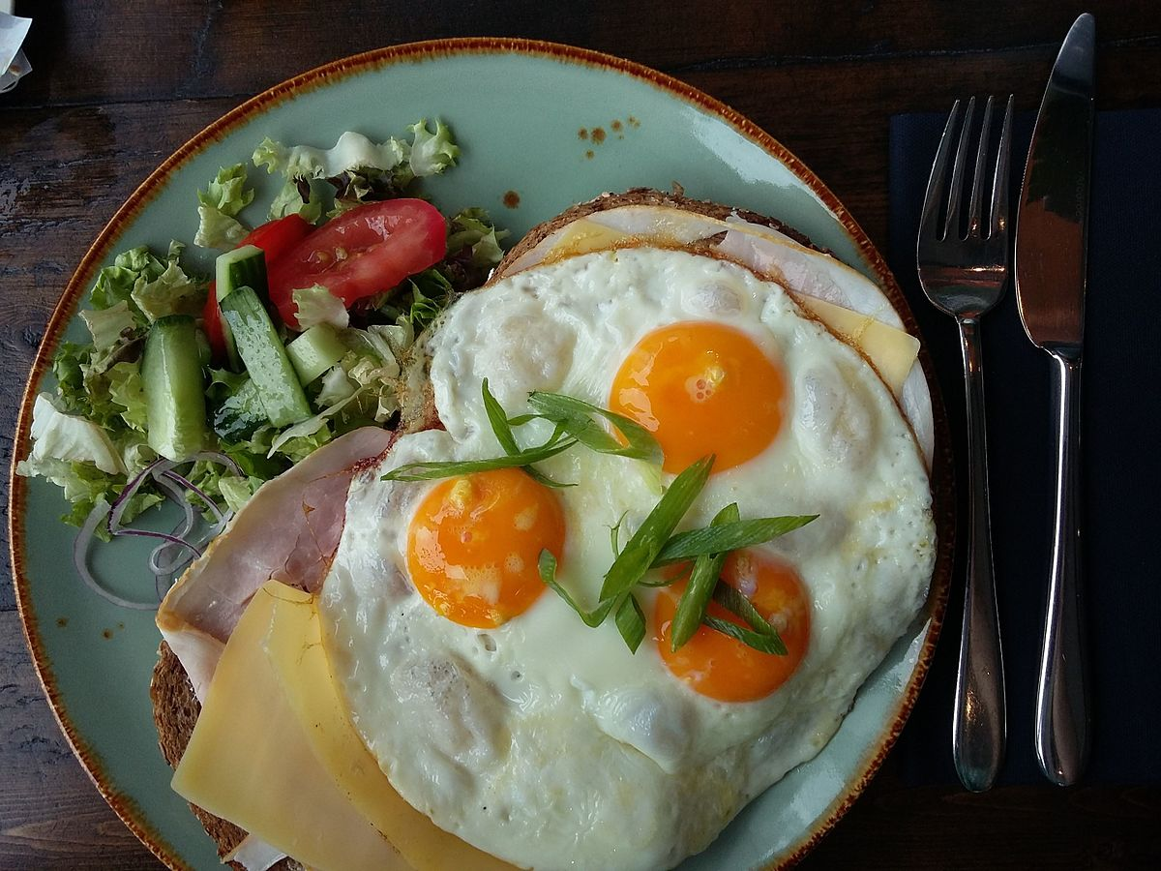
ingriedients
- 1 egg

description
break the egg into the pan and put the ham and cheese over it wait 3 to 5 minutes and remove the egg and add the lettuce,the tomatoes and the gherkins

- 1 slice ham
- 3 leaves of lettuce
- butter
- cheese
- 2 tomatos
- pickles

Breakfast on Saturday (by Tijn)

Yogurt Granola + Raspberries Berries Cereal cracker + Cheese and Cucumber
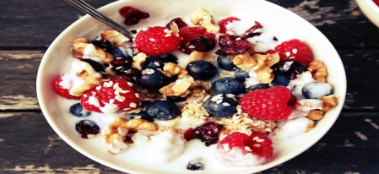

Ingredients:

Description
Step 1: Grab a pack of yogurt and place in a bowl.
Step 2: Hold the muesli and put it in there.
Step 3: Pick Raspberries Berries and put it in there.
Step 4: Take a Cereal and cracker cuts the cheese
Step 5: do it and cut two cucumber slice do that there is and you're done

- Yogurt
- Granola
- Raspberries + Berries

- Cucumber
- Cereal cracker
- Cheese

And on Sunday?????
We sleep in and have brunch form 11.00 until 13.00!

