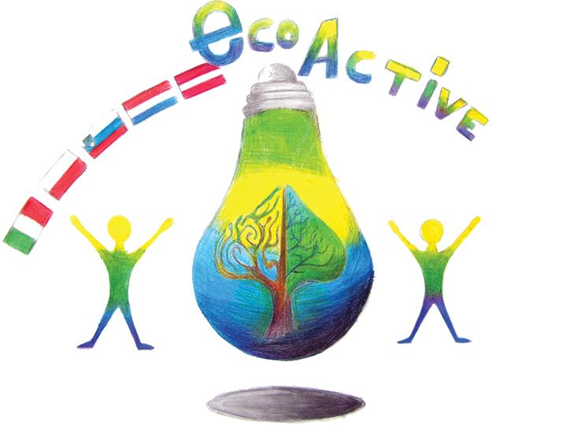 LESSON PLAN
SCHOOL | Primary School number 2 in Puławy
THEMATIC AREA | WATER
TEACHER | Katarzyna Matraszek-Mirosław
SUBJECT | English, Science, Ecology
AGE GROUP  (approximately) | 12-14 –older students
TIME REQUIRED | 45 minutes
PLACE | CLASSROOM
LESSON OBJECTIVES | -broadening knowledge about water on Earth  -realizing the importance of water in everyday life  -becoming aware of the water crisis  -coming up with the ways of saving water in everyday life  -enhancing cooperation skills between students
LESSONS YOU CAN USE | - Language  - Biology  - Nature knowledge
CLASS ORGANISATION | - Pair work  - Group work
MATERIALS | - Drops of water cut out of paper;  - Crossword worksheet  - Matching exercise (printed, laminated)  - Magnets
ICT TOOLS | - Interactive board  - Smartphones or tablets with access to the Internet
PROCEDURE | Class divided into groups of 4-6 pupils. Start the presentation. Ask: How often do we use water? Expected answer- “every day”. Present till the moment of the using of water resources. Divide the board(blackboard or whiteboard) into 3 parts:  - Household  - Personal use  - Recreational use  Give the groups sheets of paper cut into drops. Kids write their ideas of how we use water in everyday life. They present their ideas and pin them (using magnets) to the board. Each drop goes to the right category.  When it is finished, continue the presentation, compare pupils’ answers with the answers given in the presentation.  Continue the presentation a film water crisis.  Ask: what can we do to save water? Distribute matching game to the pupils the sentences will be created - the tips on how to save water.  Set time limit. Check the answers, chosen pupils read aloud their sentences. Distribute the crossword in paper version. One sheet per group. Students fill in the crosswords. In the meantime, the teacher projects the electronic version of this crossword on the board(LearningApps). Pupils read the questions and answers and do the crosswords on the board. The password: ECO-ACTIVE
EVALUATION | Kahoot game: Water crisis  Students visit page: kahoot.it and log in using a pin given by a teacher. Everyone plays on his or her smartphone or tablet; they can play also in pairs. This game evaluates the whole lesson. It is also fun for children.
ATTACHEMENTS | Materials created for the lesson:  Prezi Presentation: http://prezi.com/dldvduqy573y/?utm_campaign=share&utm_medium=copy  Crossword – paper version  Crossword – learning apps link: http://LearningApps.org/watch?v=pi5rp4ocj17  Kahoot game: https://create.kahoot.it/details/water-crisis/3e7852b1-6134-40e2-99d7-5c491f0ebe11

