**Water and weather**

* **Rain**
* **Snow**
* **Hail**
* **Fog**

[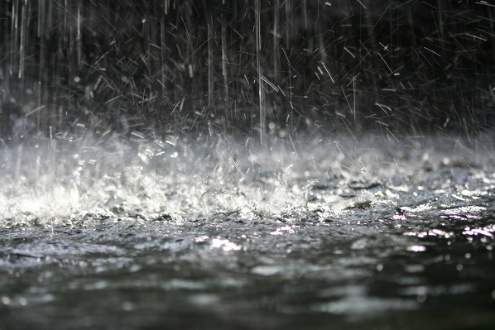](http://www.google.nl/url?sa=i&rct=j&q=&esrc=s&source=images&cd=&cad=rja&uact=8&ved=0ahUKEwjpkJLjiJDWAhWBb1AKHblLB7QQjRwIBw&url=http://www.digifotostarter.nl/content/tips-regen-fotograferen&psig=AFQjCNFrlt_NI2AOYkiP9oqTY-lLM40NWw&ust=1504770389709429)

**Water and weather**

[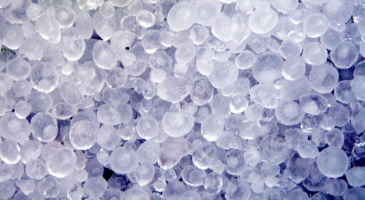](http://www.google.nl/url?sa=i&rct=j&q=&esrc=s&source=images&cd=&cad=rja&uact=8&ved=0ahUKEwiD2460iZDWAhWPJlAKHb7dAmIQjRwIBw&url=http://www.raiznerlaw.com/blog/el-paso-hail-storm-damage-claims/&psig=AFQjCNECIOqrqw0Vmt26IyxnXMrgNyRkig&ust=1504770557727237)

* **Rain**
* **Snow**
* **Hail**
* **Fog**

**Water and weather**

[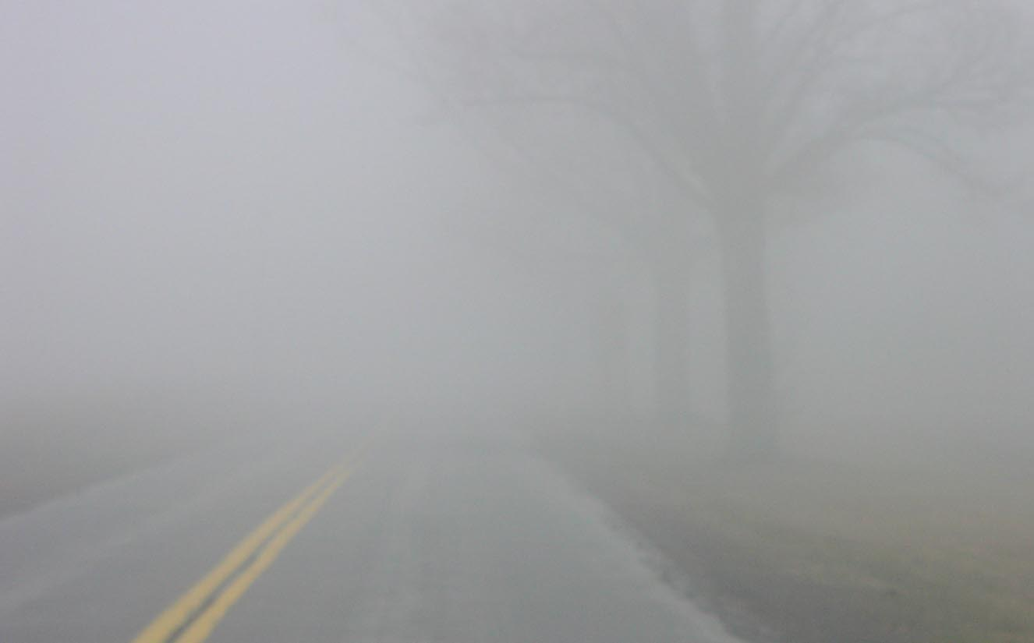](http://www.google.nl/url?sa=i&rct=j&q=&esrc=s&source=images&cd=&cad=rja&uact=8&ved=0ahUKEwiM9rvNiZDWAhUFJ1AKHXvPCRcQjRwIBw&url=http://phobia.wikia.com/wiki/Homichlophobia&psig=AFQjCNEMapbEXRZMtySH1gHMfh4oUiZilA&ust=1504770615717897)

* **Rain**
* **Snow**
* **Hail**
* **Fog**

**Water and weather**

[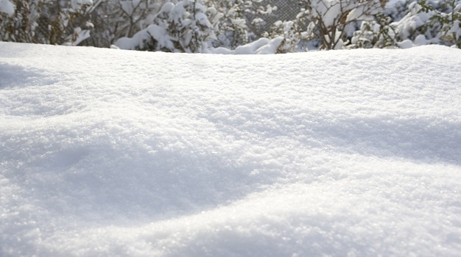](http://www.google.nl/url?sa=i&rct=j&q=&esrc=s&source=images&cd=&cad=rja&uact=8&ved=0ahUKEwiSr8j_iJDWAhWCYVAKHUp8A4YQjRwIBw&url=http://www.traveller24.com/News/WeatherUpdate/weather-update-heavy-rain-disruptive-snow-ahead-20160916&psig=AFQjCNEs6-xbiosPE3f_Dnv8TaaLLEQG9g&ust=1504770458957835)

* **Rain**
* **Snow**
* **Hail**
* **Fog**

**Waters**

* **Lake**
* **Sea**
* **Ditch**
* **River**

[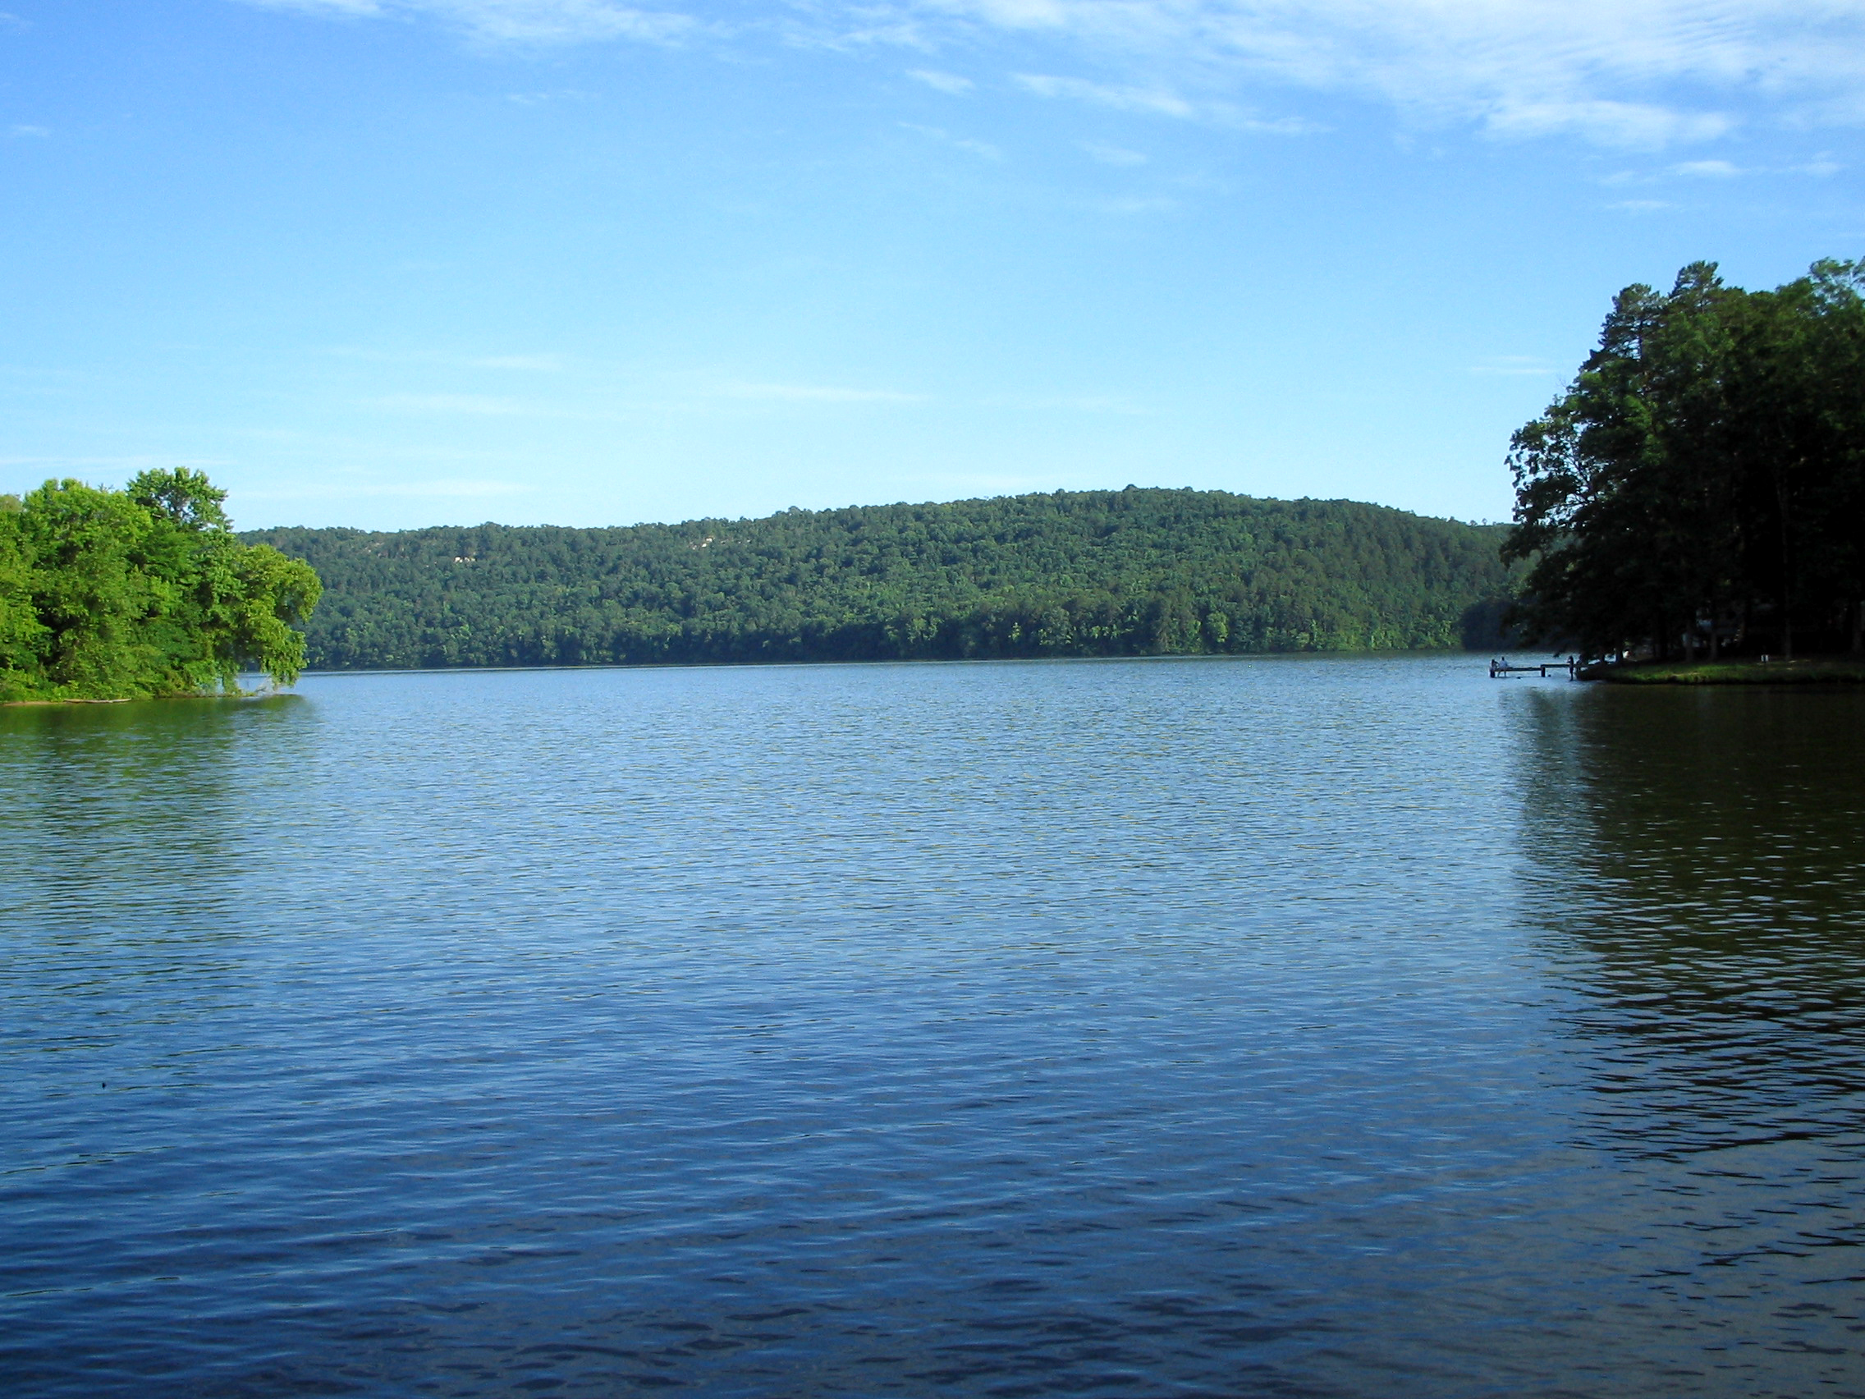](https://www.tes.com/lessons/gx5izhQ_unMWaw/lakes)

**Waters**

* **Lake**
* **Sea**
* **Ditch**
* **River**

**Waters**

Recre

ation

[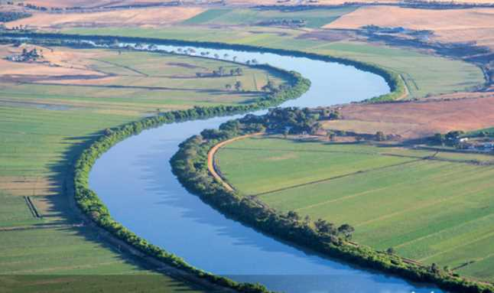](http://www.google.nl/url?sa=i&rct=j&q=&esrc=s&source=images&cd=&cad=rja&uact=8&ved=0ahUKEwjpw6Guip3WAhWMblAKHQAEAasQjRwIBw&url=http://www.karper-forum-online.nl/viewtopic.php?f%3D90%26t%3D2381&psig=AFQjCNFmy_EWLR35Zmiyy7dim-y3ohnO-Q&ust=1505217510446197)

* **Lake**
* **Sea**
* **Ditch**
* **River**

**Waters**

[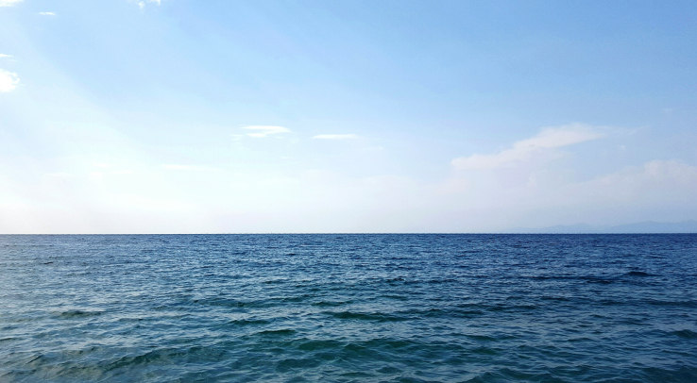](https://techcrunch.com/2017/05/07/sea-change/)

* **Lake**
* **Sea**
* **Ditch**
* **River**

[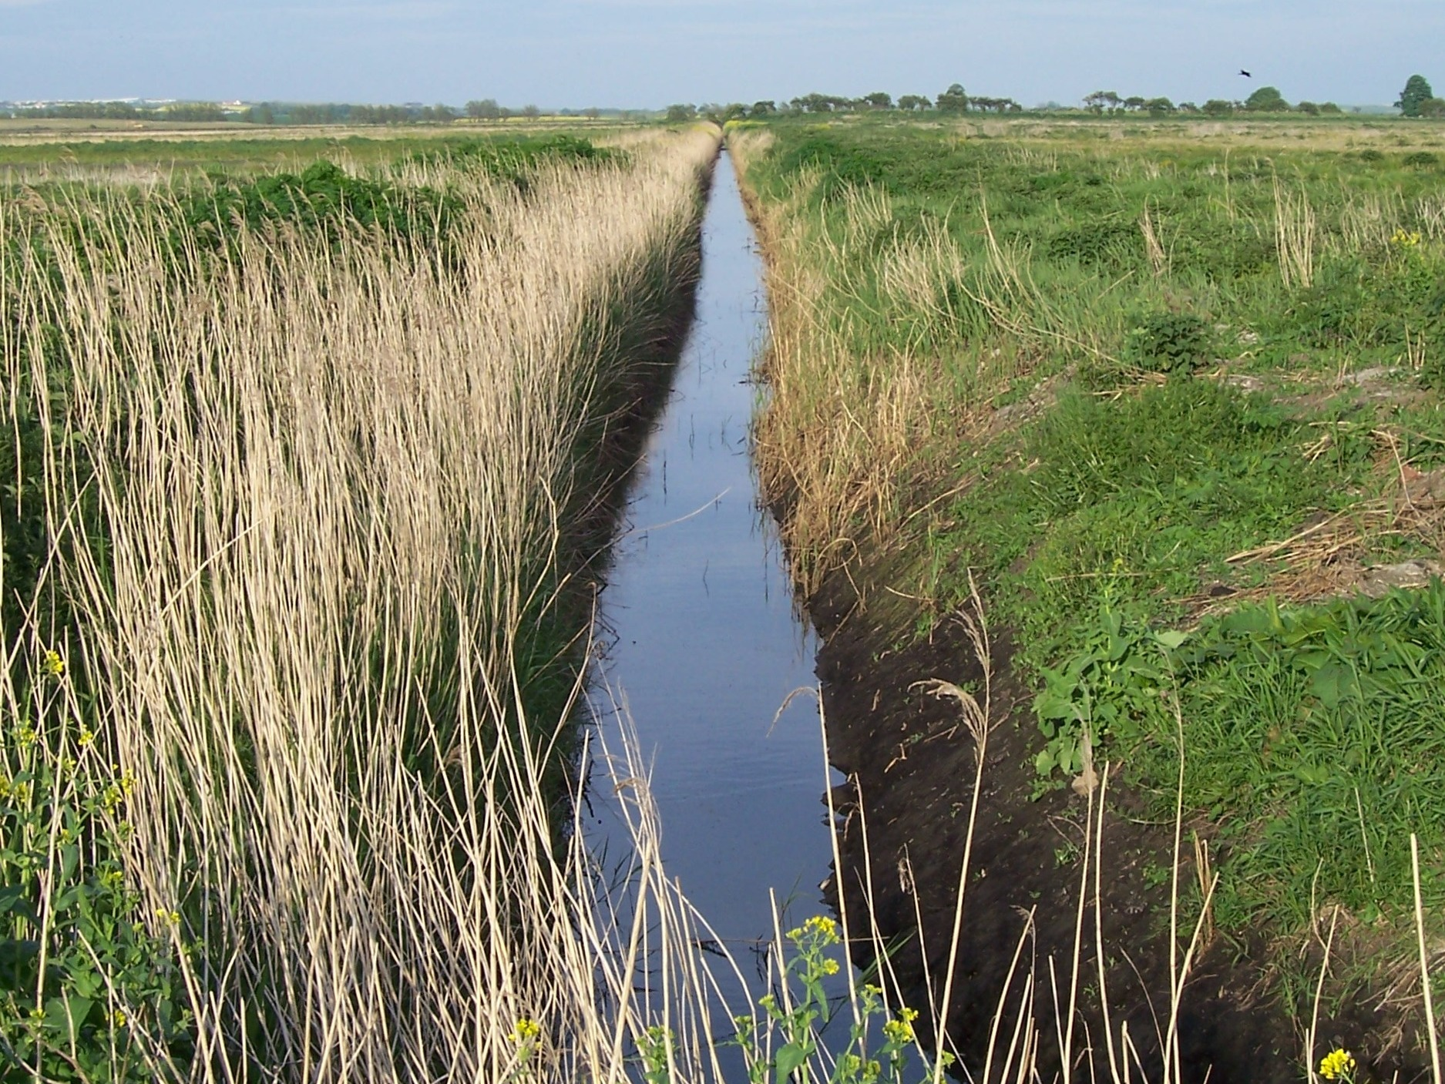](https://carrswetland.wordpress.com/2013/09/20/578/)