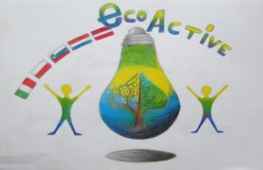
LESSON PLAN

SCHOOL | Annas Brigaderes primary school
THEMATIC AREA | Water
TEACHER | Sandra Geislere, Evita Deičmane, Maija Klāsupa
SUBJECT | Nature knowledge
AGE GROUP  (approximately) | 12-15
TIME REQUIRED | 40 min
PLACE | CLASSROOM
LESSON OBJECTIVES | Water filtering
LESSONS YOU CAN USE | - Language, for translation in English of course the English lesson  - Biology  - Nature knowledge  Integrative learning connecting skills and knowledge from multiple sources and experiences CLIL Content and Language Integrated Learning
CLASS ORGANISATION | - Pair work or group work
MATERIALS | Worksheet, water, 3 liter jar, sand, woodchips,  coal powder, dirt/soil, small rocks, gauze, cotton, plastic cups,  10 empty 2 liter PET bottles
ICT TOOLS | -
PROCEDURE | Preparing:  Divide the class into teams, let choose a leeder, name the team  Teacher asks:  1.What is the chemical name of this solution? (Water in the jar)  2. What do we know about water? (it can be sweet, salty etc.)  Teacher explains:  3.Today we are going to make water unclean.  We will add: sugar (mmm delicious), salt, coffee grind thickness, paper, black coal  4.What we have? A pond (writes down on the blackboard)  5. Our task is: make it clear, clean, useful for drinking.  6. The teacher gives to their students the worksheets.  7. Teacher lets students write down their team’s name.  8. From all materials on the desk, each team has to choose 3 materials to work with. Advise: Put coal in the middle! Don’t put it on the top or on the 1.1ayer! Coal absorbs smell and bacterias.  Students choose 3 materials in the little cups (sand, coal, woodchips, stones, dirt)  9. Students choose a material for filtering (cotton or coffee filter) and put it in the bottle as a filter.  10. Students lay layers of choosen materials.  11. Teacher pour unclean water in the glass and give it to each team, another empty glass is given to each team.  12. Pour very slowly!  13. Students filter many times till water is clear (use second bottle)  14.Compare and show to whole class (students can put all glasses on the teacher’s desk, then sit down)  15. Teacher asks: What have you absorved?  Would you like to taste it? Where can we use it? Etc.
EVALUATION | selfassesment
ATTACHEMENTS | worksheet

