**Water management**

* **Canals**
* **Polders**
* **Dikes**
* **Sluice/Lock**

[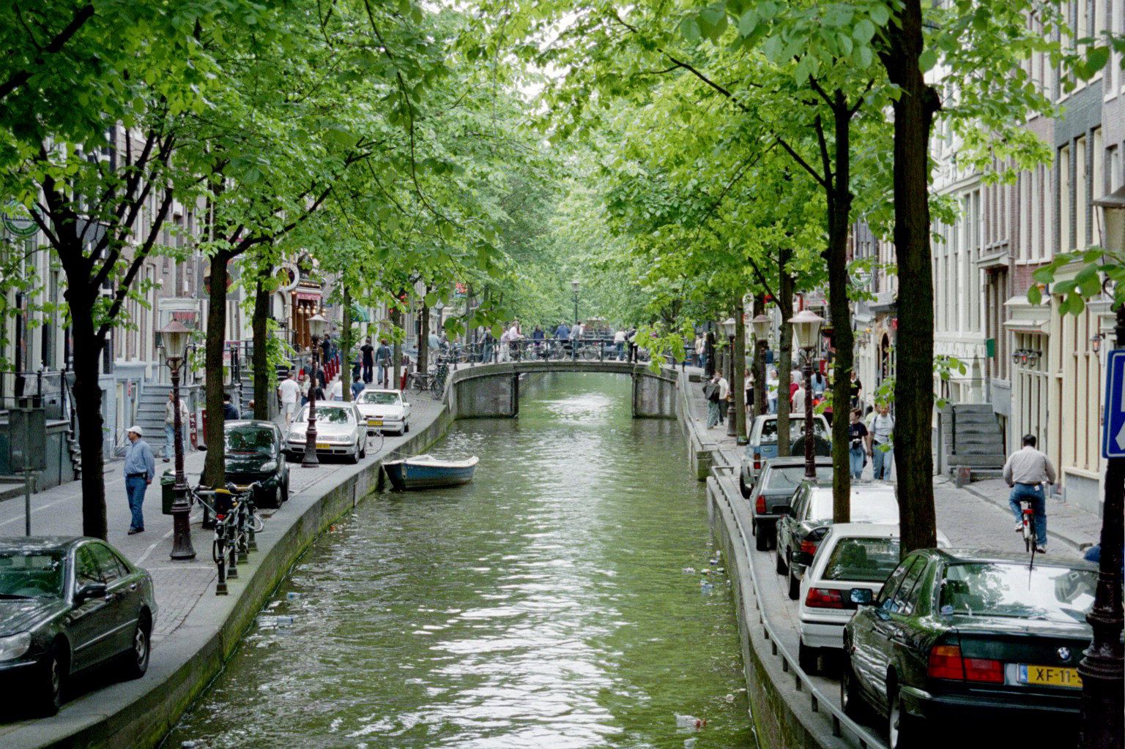](https://www.google.nl/url?sa=i&rct=j&q=&esrc=s&source=images&cd=&cad=rja&uact=8&ved=0ahUKEwjJioKKipDWAhXRZVAKHfXXB_AQjRwIBw&url=https://hollandvsnetherlands.wordpress.com/2013/01/15/amsterdam-400-years-of-canals/&psig=AFQjCNEBobL6FhF0rKAKERTQ9OrBq7Mc5Q&ust=1504770683283883)

**Water management**

[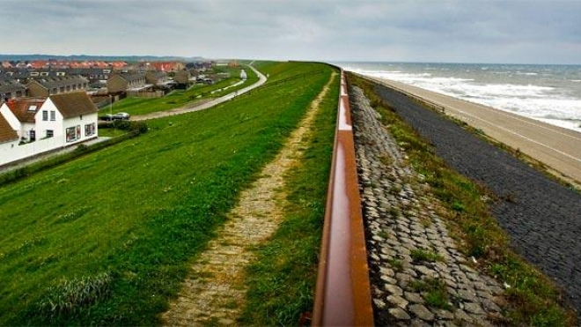](http://www.google.nl/url?sa=i&rct=j&q=&esrc=s&source=images&cd=&cad=rja&uact=8&ved=0ahUKEwietc_9ipDWAhUPUlAKHb4sDE8QjRwIBw&url=http://www.melody-marketing.com/achter-de-dijken&psig=AFQjCNFQZQrYhrTi6QAeJzkwBNvpoewSOw&ust=1504770970525240)

* **Canals**
* **Polders**
* **Dikes**
* **Sluice/Lock**

**Water management**

* **Canals**
* **Polder**
* **Dikes**
* **Sluice/Lock**

**Water management**

[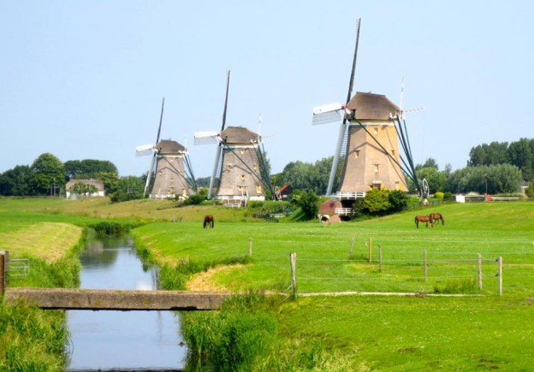](http://www.google.nl/url?sa=i&rct=j&q=&esrc=s&source=images&cd=&cad=rja&uact=8&ved=0ahUKEwiqie6zipDWAhVEL1AKHTudCiAQjRwIBw&url=http://www.directdutch.com/2013/07/word-of-the-day-polder-polder/&psig=AFQjCNHcPev5Bn3lUtwp8mFuIF-HWpMHSw&ust=1504770799427033)

* **Canals**
* **Polders**
* **Dikes**
* **Sluice/Lock**

**Water energy**

* **Steam**
* **White coal**
* **Water power**
* **Watermill**

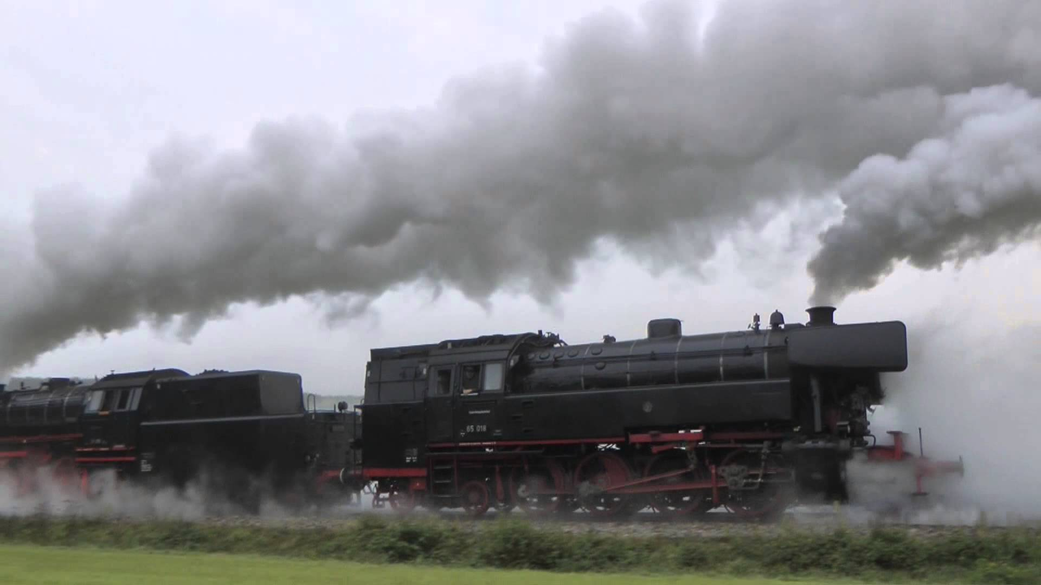

**Water energy**

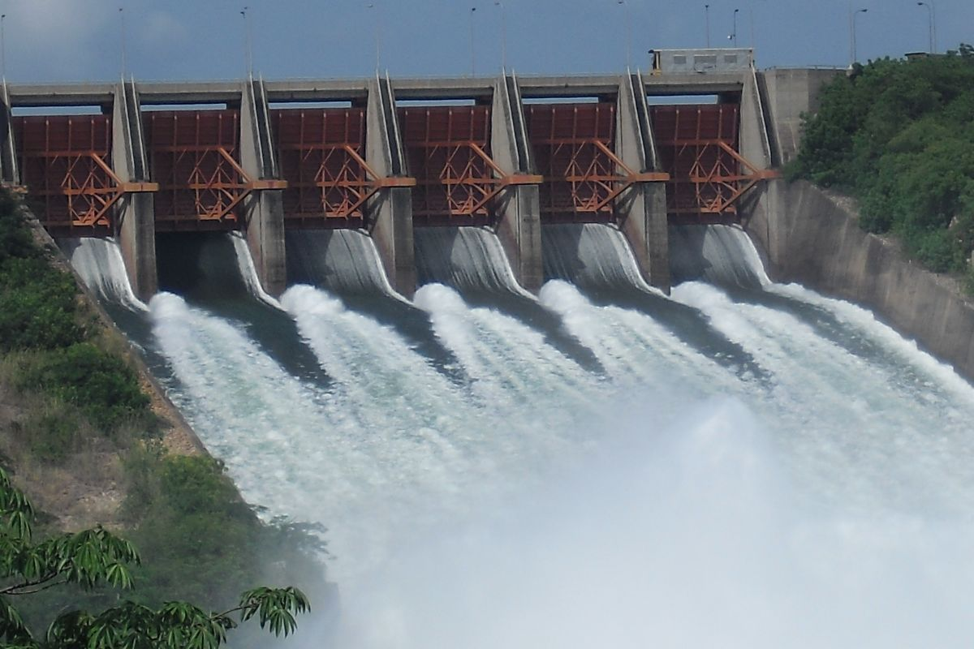

* **Steam**
* **White coal**
* **Water power**
* **Watermill**

**Water energy**

* **Steam**
* **White coal**
* **Water power**
* **Watermill**

**Water energy**

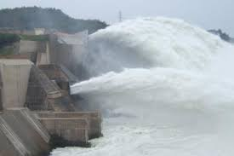

* **Steam**
* **White coal**
* **Water power**
* **Watermill**

