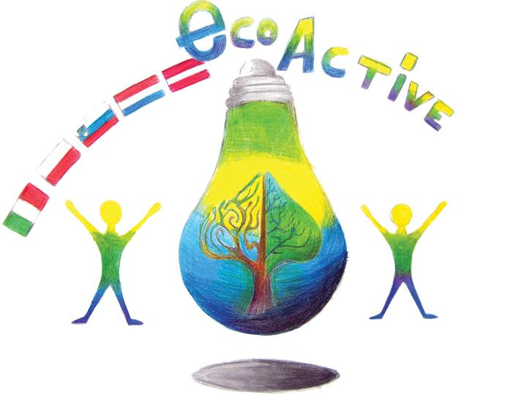 LESSON PLAN
SCHOOL | PRIMARY SCHOOL NO2 IN PULAWY, POLAND
THEMATIC AREA | RESOURCES
TEACHER | Joanna Ludwicka
SUBJECT | Why do we recycle?
AGE GROUP  (approximately) | 9 - 13
TIME REQUIRED | 45 min
PLACE | (CLASSROOM/GYM/PLAYGROUND ETC.)
LESSON OBJECTIVES | To understand the consequences of not recycling.
LESSONS YOU CAN USE | - Language, for translation in English of course the English lesson  - Biology  - Nature knowledge  - Science
CLASS ORGANISATION | - Pupils work individually  - Pupils work in pairs  Pupils work in groups
MATERIALS | Cards with statements / laptops/ artefacts
ICT TOOLS | - computer apps on www.learning apps  - a video on you tube  - IWB flipcharts
PROCEDURE | - INTRODUCTION  A warm up activity to make students get to know one another at tables of 6:  Task: Use the laminated cards and match 2 halves of 5 statements about eco actions  Extension activity: Look at the posters and key words on IWB and try to make a new statement about eco activity. Write the statements on mini whiteboards. Work with your partner. Each table is given a different set of pictures and words.  - MAIN TEACHING  Reveal the Learning Objective of the lesson: To understand the consequences of not recycling?  A ) Show the poster asking to recycle on IWB and ask students: Why do we recycle? Then show the picture of a landfill / selection of rubbish and make sure that students understand the words: rubbish/landfill  B) Ask students to use laptops, work in pairs and do the app teaching them the names of different types of rubbish: http://LearningApps.org/display?v=p4ct9weik17 ,  Make sure that the students understand the words decompose/slow/fast and then ask questions: What will happen to the rubbish in the landfill?  Which will decompose at the fastest/ slowest rate?  C) Show studenst a selection of rubbish items and ask them to put them in order from the fastest to the slowest decomposing ones. Then reveal the right order and ask them to do the next app of matching the types of rubbish with its decomposition times: https://learningapps.org/display?v=p1hygcqvt17  Ask children questions: What will happen eventually to landfills?What can we do to prevent it?What will happen if we do not recycle?  D) Remind the students about the objective of this year’s Eco activity – to collect waste paper. Show students some posters with the facts about collecting waste paper and recycling paper. Ask students to do a word problem on collecting waste paper and saving trees. You need to collect 1 ton of waste paper to save 17 trees. If this year our school has collected about 95 tons of waste paper, how many trees has it saved?  3) PLENARY  Remind the students about the last year’s Eco active objective: to collect plastic bottle lids. Ask them to watch the film about a small plastic workshop and ask them the question: What objects were made in the workshop? As the last task ask the studenst to work in groups and brainstorm ideas of what other objects could be made in a small plastic recycling workshop? https://www.youtube.com/watch?v=76AFNIxYjUE  Extension interactive apps about eco activity:  WORD GRIDS - ECOLOGY  EASY: https://learningapps.org/1420418  HARD: https://learningapps.org/3444885  HORSE RACE - WHAT MUST I DO?  https://learningapps.org/2172959
EVALUATION | Ask students to assess their understanding of the lesson and the progress they have made with the thumbs up and down technique.
ATTACHEMENTS | Smart board slides/flipcharts  Word document with statements about eco actions  Word document with links for students.

