**Water cycle 2**

* **Surface water**
* **evaporate**
* **condens cloud**
* **rain snow hail**

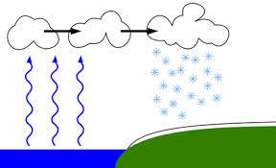

**Water cycle 2**

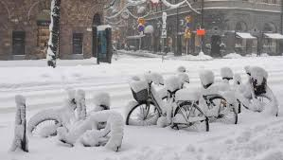

* **Surface water**
* **evaporate**
* **condens cloud**
* **rain snow hail**

**Water cycle 2**

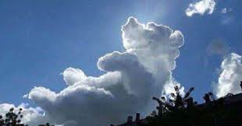

* **Surface water**
* **evaporate**
* **condens cloud**
* **rain snow hail**

**Water cycle 2**

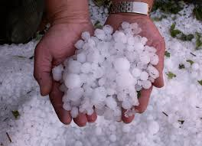

* **Surface water**
* **evaporate**
* **condens cloud**
* **rain snow hail**

**Water cycle 1**

* **Evaporate**
* **Condens**
* **Melt**
* **Freeze**

[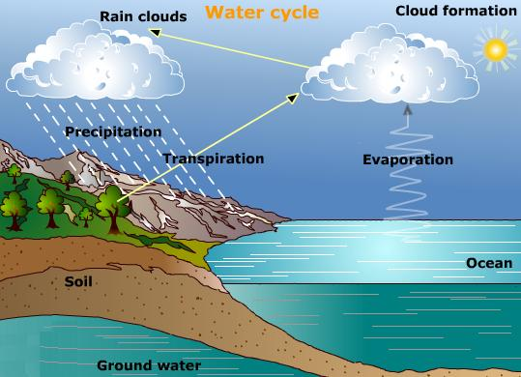](https://www.google.nl/url?sa=i&rct=j&q=&esrc=s&source=images&cd=&cad=rja&uact=8&ved=0ahUKEwjB0YbYu5DWAhWFbVAKHWzlCD4QjRwIBw&url=https://laydiegrey.wordpress.com/2012/03/09/why-does-water-evaporate/&psig=AFQjCNHO1LxoPEuNoPoaLpenJRTNlZkCkw&ust=1504784019481792)

**Water cycle 1**

* **Evaporate**
* **Condens**
* **Melt**
* **Freeze**

**Water cycle 1**

[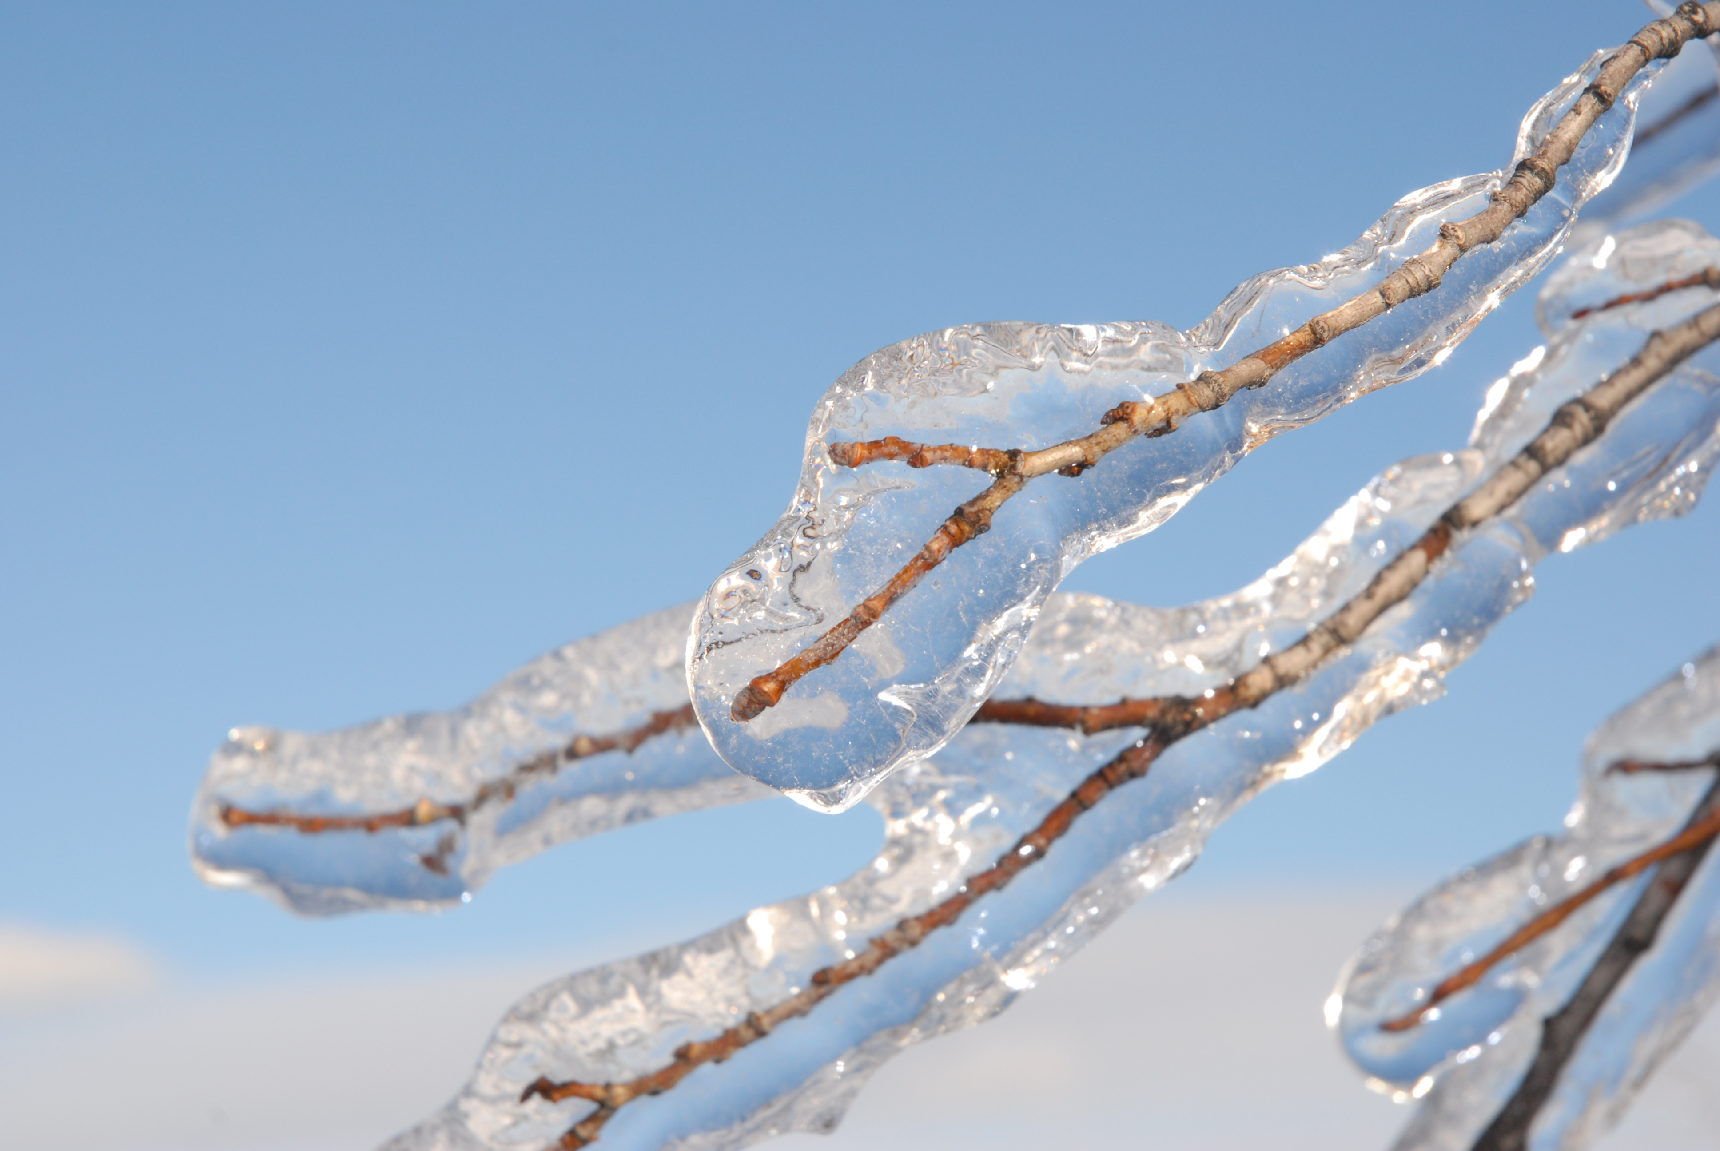](http://www.google.nl/url?sa=i&rct=j&q=&esrc=s&source=images&cd=&cad=rja&uact=8&ved=0ahUKEwjN0s-DvZDWAhXMa1AKHbsKARoQjRwIBw&url=http://www.wikiwand.com/en/Freezing_rain&psig=AFQjCNFOoEcPsCjxqxbNs1fvzmygfkWqOA&ust=1504784380881770)

* **Evaporate**
* **Condens**
* **Melt**
* **Freeze**

**Water cycle 1**

[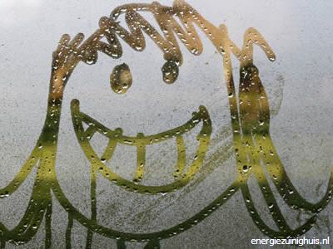](http://www.google.nl/url?sa=i&rct=j&q=&esrc=s&source=images&cd=&cad=rja&uact=8&ved=0ahUKEwjJncr_u5DWAhWMJlAKHdC_DtYQjRwIBw&url=http://www.energiezuinighuis.nl/kijknaardeoplossingen/condens/index.php&psig=AFQjCNGt98c8dHy2dqiIuq9IQca4jTLSbA&ust=1504784150445039)

* **Evaporate**
* **Condens**
* **Melt**
* **Freeze**

[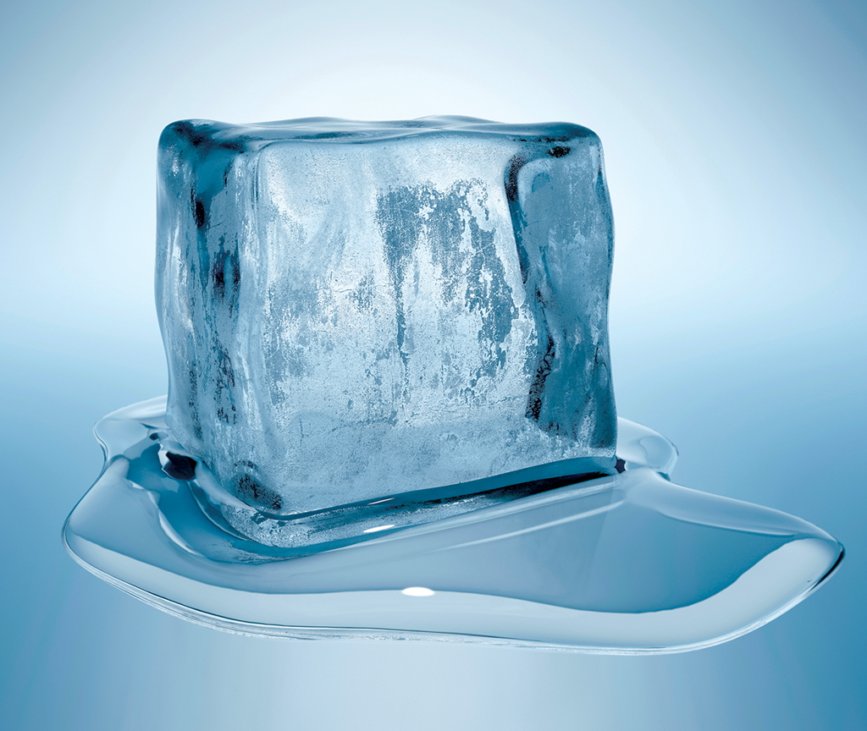](https://phys.org/news/2013-03-unusual-recrystallization-behavior-one-dimensional-electron.html)