Dear Parents,

St Brigid`s Primary School, as you may know, has successfully applied for a 3 years project, funded by the ERASMUS+ (European Fund), called TMTGuMI. For its second year, we are running this project in our P5 class, where various new activities we introduce to promote Dr Gradner`s Multiple Intelligences Theory (http://multipleintelligencesoasis.org) in practice.

Please read our short project description below:

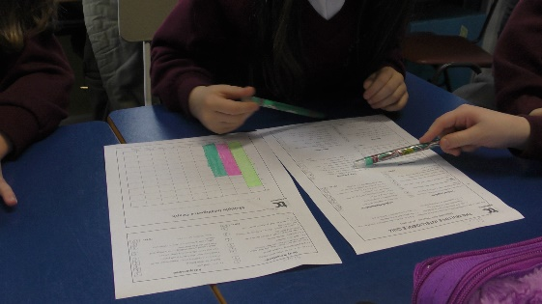
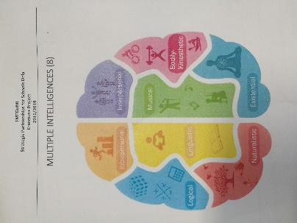
Opposite of traditional views that perceive intelligence as one dimension, being good at maths or science, Howard Garner suggested eight different intelligent types. Early childhood educators should have a good understanding of each intelligent types, should identify which each child’s intelligent types that is dominated others to support children’s all intelligences and dominated intelligence. By doing so early childhood educators might discover next generations’ Picassos, Mozarts or Dostoyevskys. Therefore, this Erasmus+ project aims to increase primary school educators’ understanding of multiple intelligences and to help them increase their abilities to create early learning activities that serves all kinds of intelligences, i.e. all individual child in their classrooms.

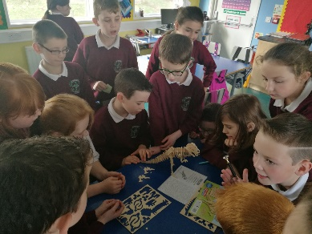
Objectives:
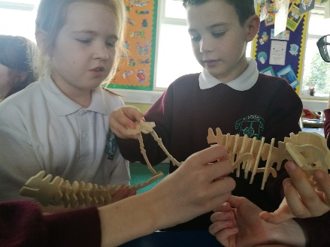
This course is designed to increase awareness of the fact that there are different kinds of intelligences and it is possible to support each intelligence through creative and integrated activities in early childhood classrooms.

There are 6 partners in the project:
5 Transnational meetings (UK, ITA, TUR, POR, BEL)

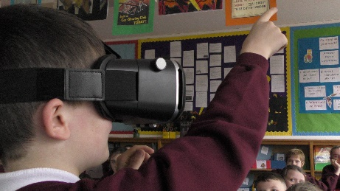

The reasons why it's vitally important to run this project trans-nationally are:
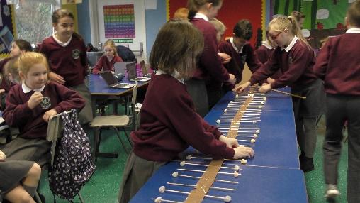
– To move the issue to the European dimension.
– To provide opportunities for teachers and students from partner schools to work closely together and enhance transferability of experiences and expertise

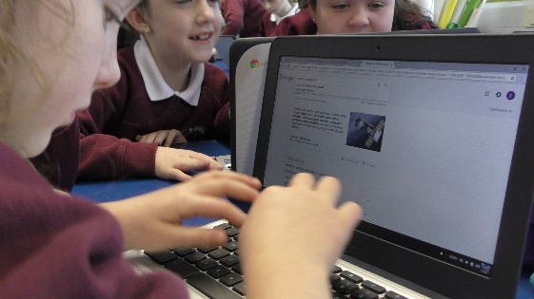
Our P5 class will become active participants in a team within an international framework which will give them a unique experience on reflecting, comparing, evaluating logical thinking issues from different perspectives.

Please support our effort in promoting our TMTGuMI project by following our progress on:
- eTwinning (https://twinspace.etwinning.net/44910/home),
- Padlet (https://padlet.com/bkecskemeti/teachingmathsthroughmultipleintelligence)
- or our school`s FB page (https://www.facebook.com/stbrigidspsmayogall )

Thank you for your help and support in advance.

Best regards,
Balazs Kecskemeti
Project Co-ordinator
Erasmus+

