What do you know about Southern Italy?
- Historical facts
Which of the biggest italian cities was founded by the Greeks in the 8th century BC and takes its modern-day name from the Greek word “new city”?

- Naples c..Palermo
- Rome d. Reggio Calabria

- Art
How many UNESCO World Heritage sites are there in the region of Campania?

- Two c..Three
- Four d. Five

- Food
Which Southern Italy region does the dish “Pasta Norma” originate from?

- Calabria c..Sicily
- Campania d. Puglia

- Specific words
The apulian town of Alberobello is very famous for its traditional “trullo”. What is it?
- A local wine c. A popular festival
- A rural dwelling d. A typical hat

- Music
Which one is the Neapolitan worldwide known song whose title means “My sun”?

- Aurora c. Volare
- O Sole Mio d. Con te partirò

- Greetings
“Buona giornata” is the most common greeting in Southern Italy. What is the rightest English translation?

- Goodbye c. Good morning
- See you d. Have a good day

Keys
1.a;
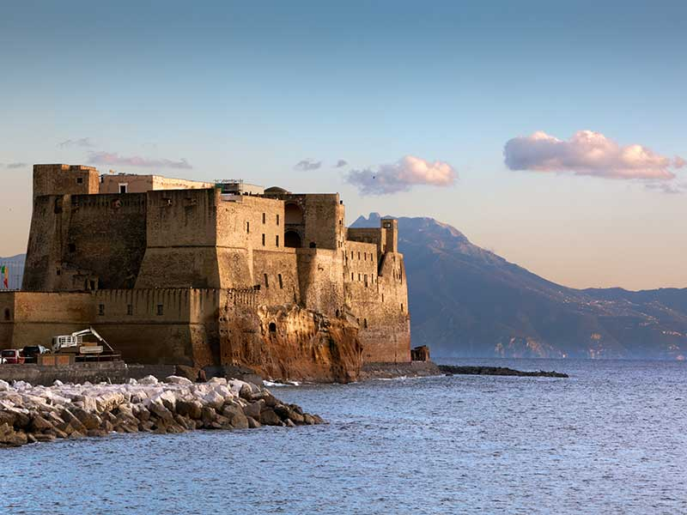
2.d;
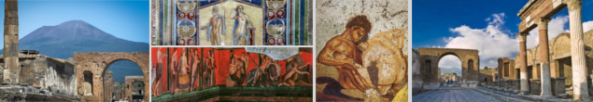
Figura 1 Archeological Areas of Pompeii, Herculaneum and Torre Annunziata
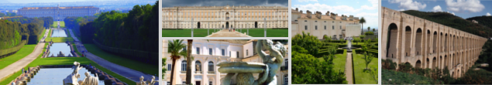
Figura 2 The Royal Palace of Caserta and the San Leucio Complex
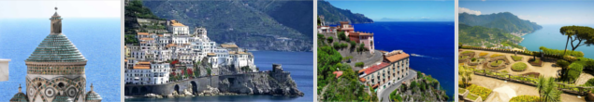
Figura 3 Costiera Amalfitana
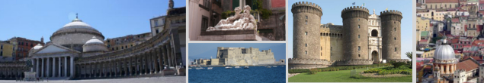
Figura 4 Historic Centre of Naples
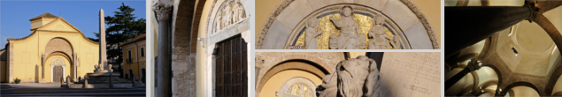
Figura 5 The Santa Sofia Complex in Benevento
3.c;
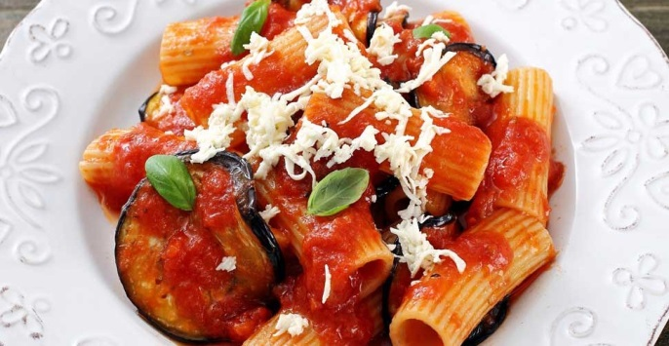
4.b;
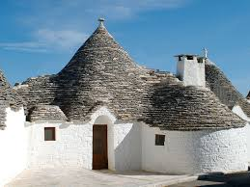
5.b;
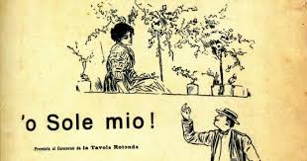
6.d
