Virtual mobility
Portici 2021

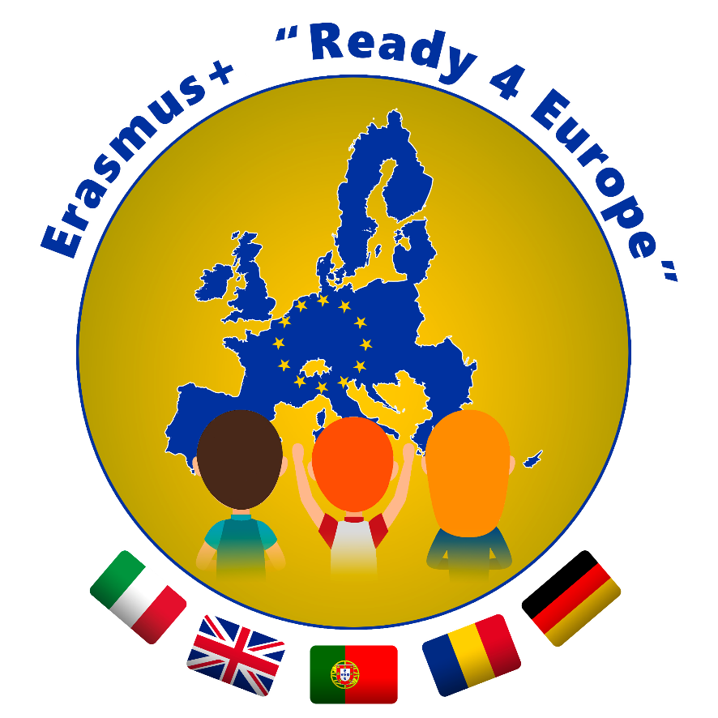
23. März, DAy 2

BBS Wirtschaft Bad Kreuznach
Esther Barkanowitz

Erasmus+ Ready4Europe
10 -11 am Working on a common presentation in each of the 4 groups

11-12 am Presenting your findings to all students and teachers

Cover letters/ motivation letters

Dear students,
from 10 -11 am you will work together in international teams to discuss the similarities and differences of cover letters/ motivation letters and create a presentation. One teacher will be present in each group to make sure you work on your task There are four groups altogether. Make sure you introduce yourselves to the other students before starting to work
Since most of you presented „classic“ cover letters yesterday it would also be interesting to have a look at motivation letters together task 3!
From 11 – 12 am one student or some of the students in your international group will present your findings to the whole group.
The following questions will help you create your presentation:

Task: Creating a presentation
Time: 60 min maximum
- Discuss which type is most common in your countries: cover letter or motivation letter?
- Compare the content and form of the cover/ motivation letters and work out differences and similarities.
- Motivation letters: what are the benefits of motivation letters? In which fields do you need them?

