Jamilah Khatun
HR Manager
North Chadderton OL9 0BN
JKHATUN855@northchaddertob.oldham.sch.uk
SKILLS
- Work well in a team, as well as independently.
- Can adapt well to changes.
- Good leadership skills.

EXPERIANCE
Amazon Warehouse Administrator, Manchester
12.03.21 - 14.03.23
- I recorded all the supplies coming in and out of the warehouse
- I managed the clock in and out system for the other employees
- I was to record any accidents that happen on-site.
Innocent Marketer, Manchester
26.11.20 - 07.03.23
- I worked with my colleagues to come up with marketing strategies
- I would report to my team manager if any ideas were worth funding
- I gave presentations to other marketing teams for others input

EDUCATION
North Chadderton School, Oldham
- GCSE’s - One Grade 6, Four Grade 7s, One Grade 8.

OTHER INTERESTS/INFORMATION
- I like to be very active. Basketball and badminton are my favorite sports to play, especially with family and friends.
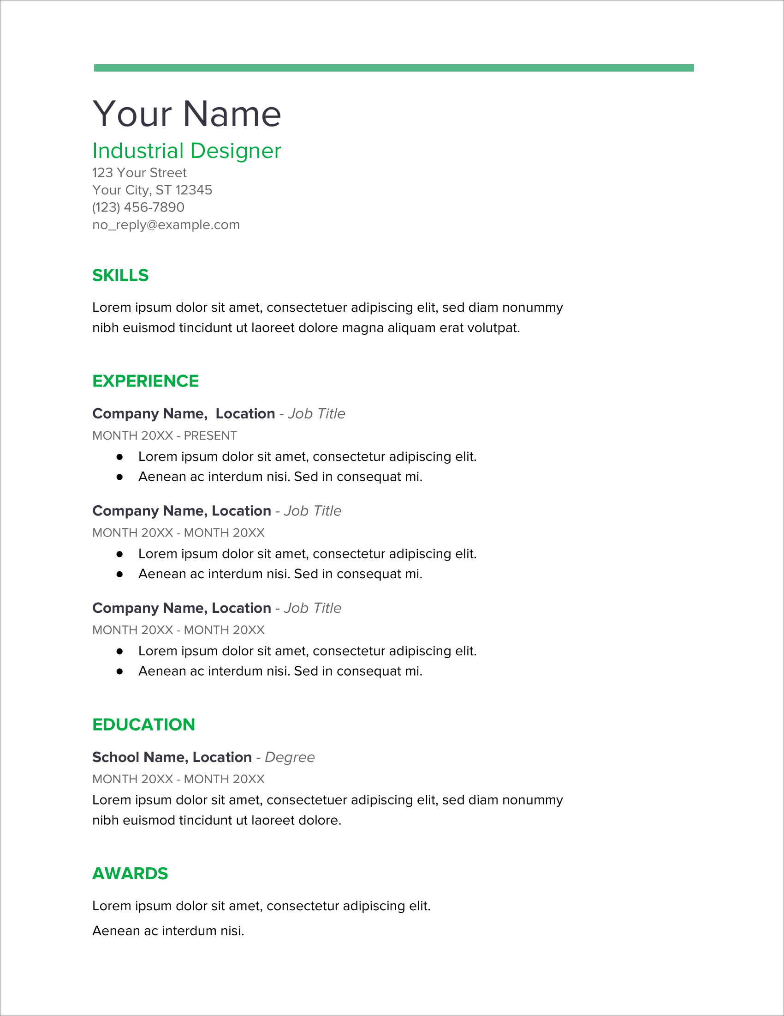
NAME:

