WHAT DO YOU KNOW ABOUT ITALY?
ART
1. Which famous Italian polymath created the 'Vitruvian Man' and painted 'The Last Supper' and the 'Mona Lisa'? 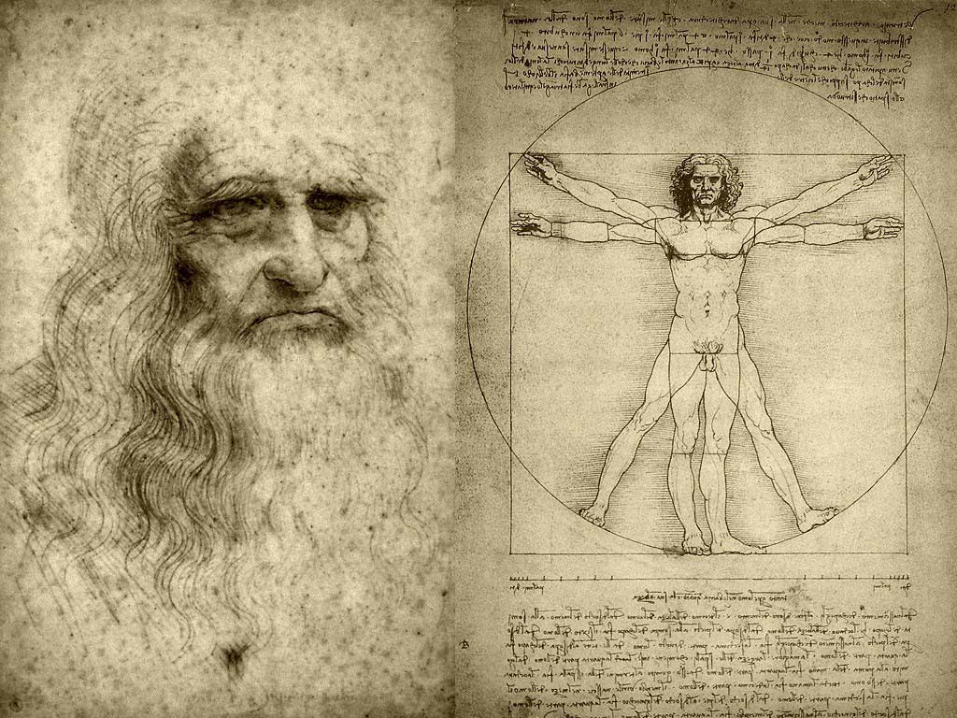
a. Donatello b. Michelangelo
c. Sandro Botticelli d. Leonardo da Vinci

2. How many Italian UNESCO World Heritage sites are located in Campania?
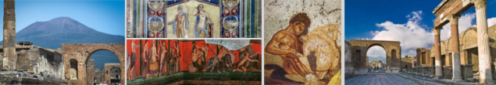
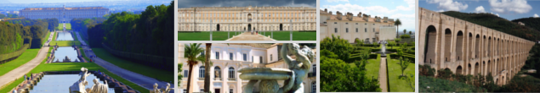
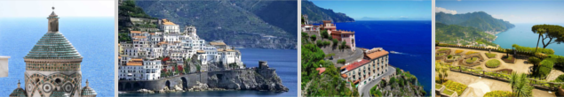
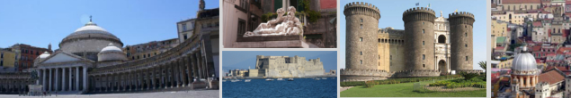
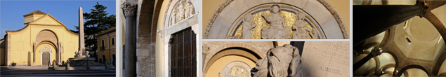
a. Two b. Three
c. Four d. Five
- What did the Romans call the Colosseum?
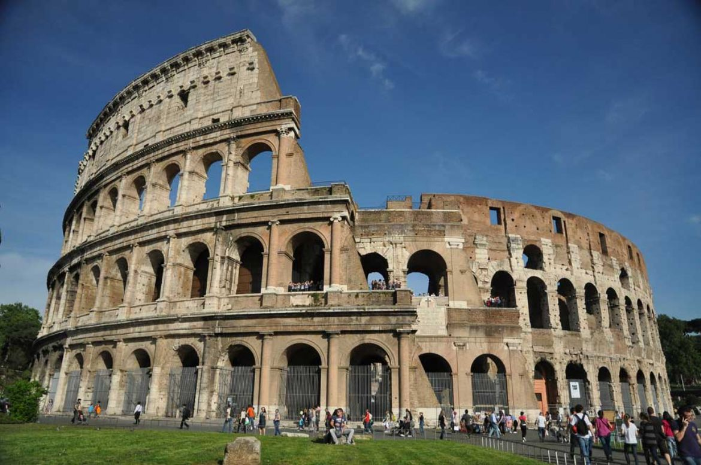
a. Circus Maximus b. Colosseum
c . Flavian Amphitheatr d. Caesarian Colosseum

- Who was the ceiling of the Sistine Chapel painted by?
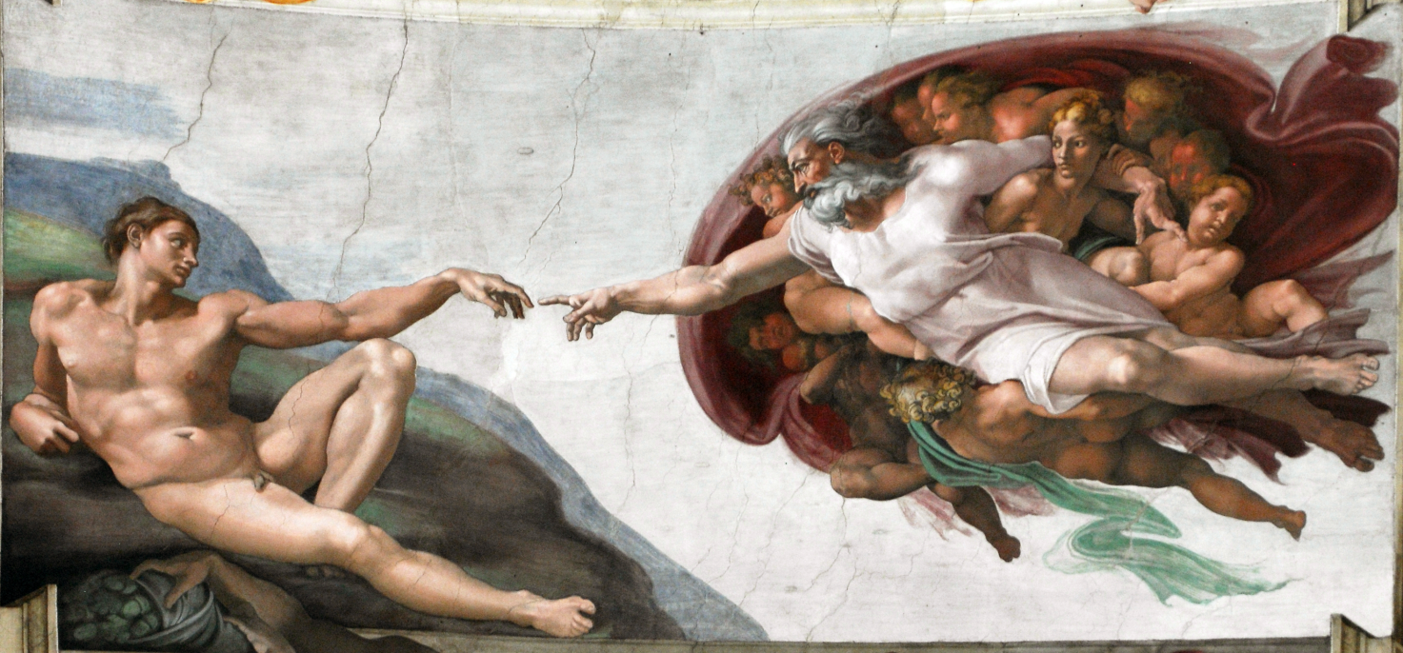
a. Raphael b. Leonardo da Vinci
c. Michelangelo d. Titian
5. Which school of thought coincided with the Renaissance?
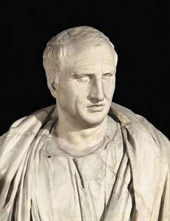
a. Positivism b. Humanism
c. Marxism d. Existentialism

MUSIC
- Composers use Italian words for musical terms to tell us how they want their music to be played. Which term means “gradually getting quieter”?
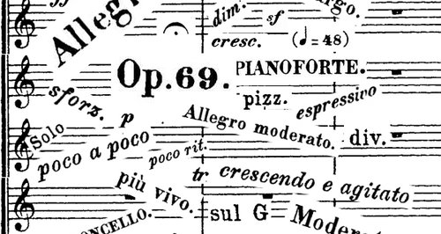
a. crescendo b. decrescendo
c. ritardando d. rallentando
1. Which Italian composer of the 19th century produced famous works such as 'La Traviata', 'Rigoletto,' and 'Aida'? 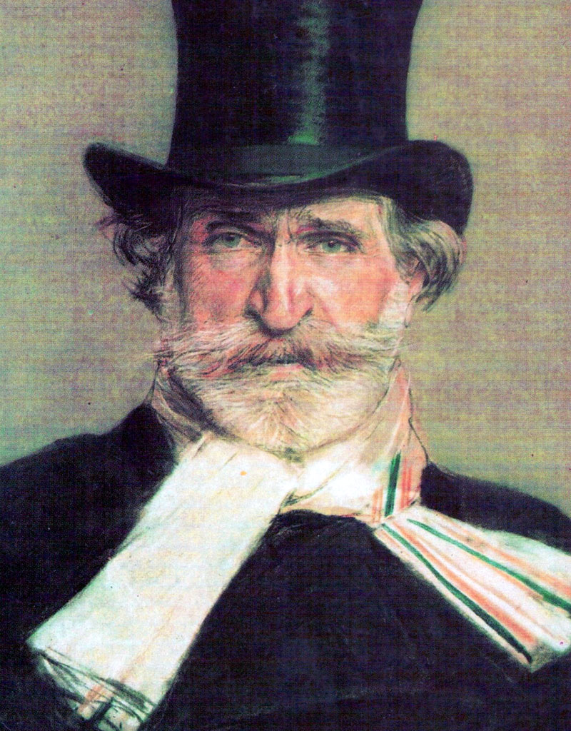
a. Vincenzo Bellini b. Gioacchino Rossini
c. Giacomo Puccini d. Giuseppe Verdi

HISTORICAL FACTS
1. One of Italy’s biggest cities was founded by the Greeks in the 8th century BC and takes its modern-day name from the Greek word ‘new city’. What is it called?
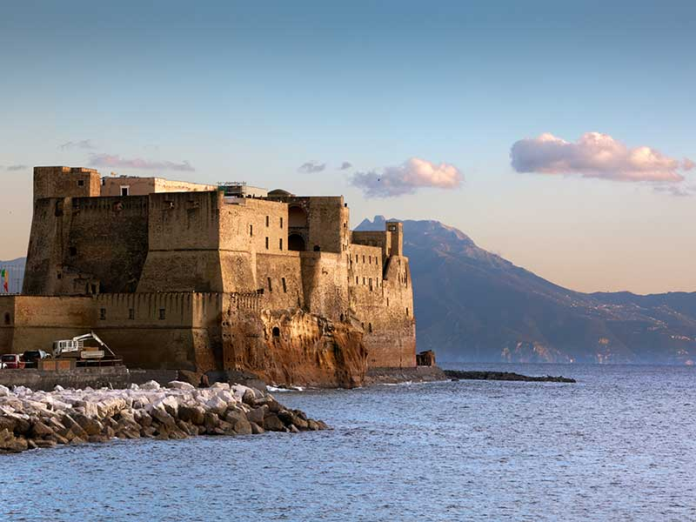
a. Naples b. Milan
c. Venice d. Rome
2. Which Italian led an expedition to the west and 'discovered' America in 1492? 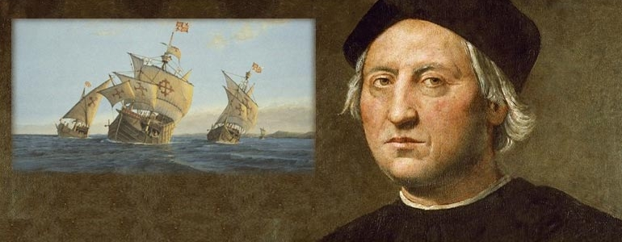
a. John Cabot b. Marco Polo
c. Amerigo Vespucci d. Christopher Columbus

3. On the 25th of March 1957 six European countries signed in Rome an important treaty. What multilateral subject was created?
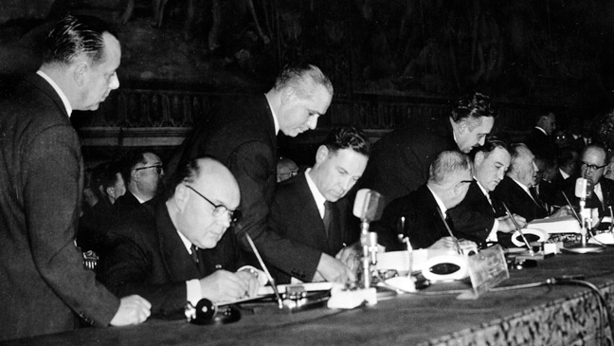
a. European Economic Community b. World Trade Organization
c. European Union d. United Nations Organization
4. How many times has Italy won the Football World Cup?
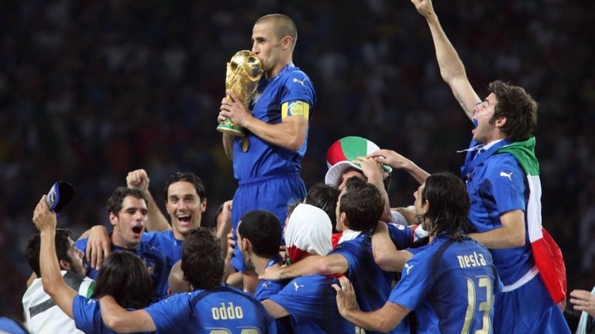
a. one b. two
c. three d. four

FOOD
- Where does the Italian dish “Pasta Norma” originate from?
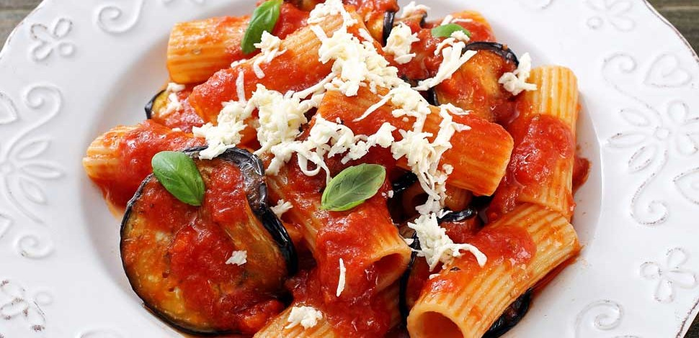
a. Sicily b. Campania
c. Sardinia d. Tuscany
- Basil, Garlic, Tomatoes and mozzarella cheese are the ingredients of the authentic Pizza Margherita. What do they stand for?
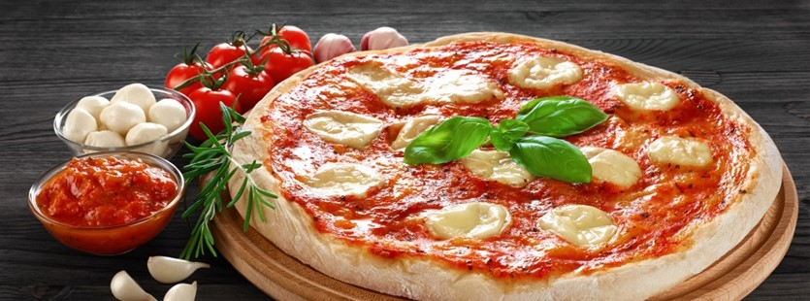
a. The Four Seasons b. The colours of the Italian flag
c. Queen Margherita’s clothes d. The best nutritional mix

- Which of these is a traditional Christmas cake or sweet bread?
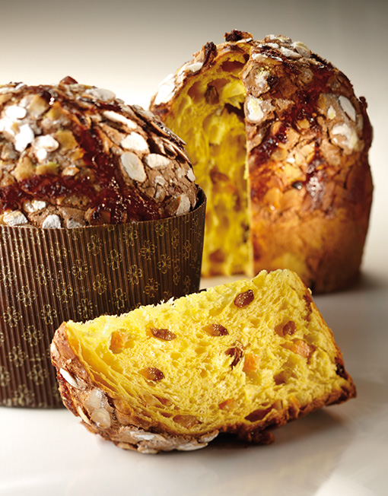
- Panna c. panettone
- Panforte d. pastiera

- What is the name of a celebrated Neapolitan type of wine produced on the slopes of Mount Vesuvius?
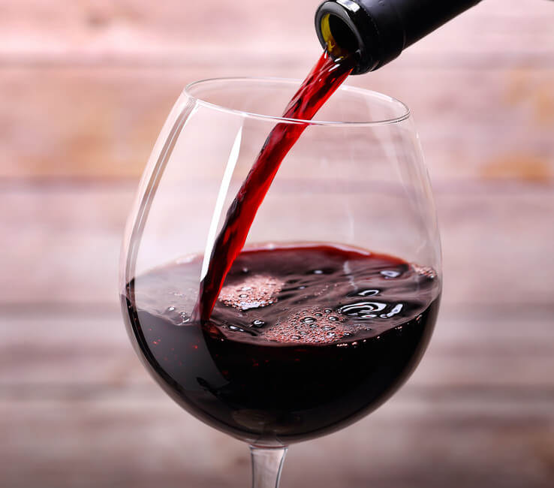
- Lacryma Christi c. Pallagrello
- Chianti d. Barolo
SPECIFIC WORDS
- What do Italians understand by 'un caffe americano'?
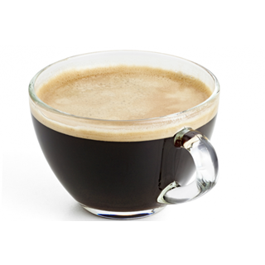
a. a shot of coffee in cold milk
b. extra water poured through
c. cappuccino with more milk and less foam
d. espresso stained with just a dot of milk

- What is the name of the popular appetizer or starter made of grilled bread seasoned with olive oil, tomatoes and garlic?

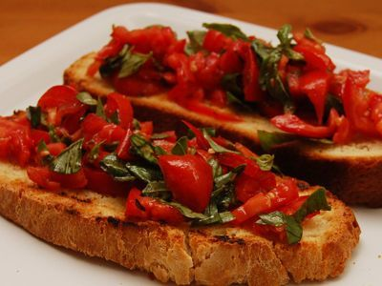
- Panino b. bruschetta
- Torrone d. arancino
- What is the meaning of “caffè sospeso” (suspended coffee), the widespread Neapolitan practice which boomed during World War II?
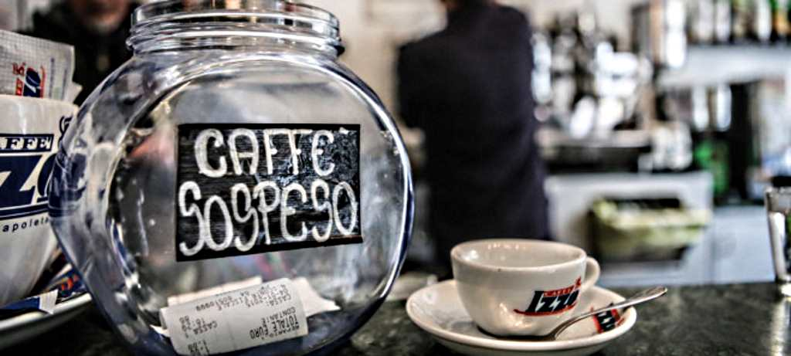
- The anonymous act of gifting an espresso to strangers never seen
- The habit of having coffee after lunch
- A deal to delay the payment
- The practice of leaving a tip of one euro to the bartender

4.What is the meaning of the italian expression “a babbo morto” (on dad’s death)?
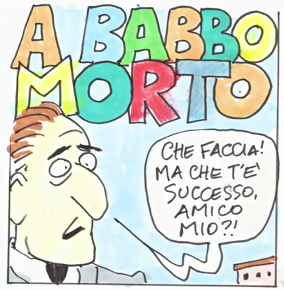
a. In abunfance
b. Going away silently
c. Become extremely happy
d. Any payment or debit that includes very long waits for its repayment

