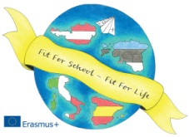
Erasmus+
“Fit for School – Fit for Life”
May 5th-11th, 2019

Arrival
Saturday 4th: Estonia 23.50 Bergamo Airport (by bus form Bergamo to Lavarone, night in Hotel Nazionale-Lavarone, on Sunday 5th families will pick the students up)

Sunday 5th:
AUSTRIA: 11.47 Trento Rail Station (families will pick the students up)
SPAIN: 9.00 Bergamo Airport

Monday 6th

- 8:00-8:40 students arrive at school and come to the Congress Hall near the school
- 8:40-9:30: Welcome Party
- 9:30-10:30: Music Workshop (We try and record the songs for the final show (Ode to Joy in the partner languages), if you send me a tipical song from your country, we will try it together, you can try in the Conference Hall what your team prepared for the final show on Friday, if you want. Children from The Kindergarten come at 10 o'clock to sing a song)
- 10.30-11:00 Break (I’ll buy a snack for the students)
- 11:00-13:00: Wallpapers “Let’s move in our classrooms”, team work and presentation of games or exercizes to do in the classroom to learn better and in a more pleasant way (Body-Brain Connection; 53 students, groups of 10 students, one exercize for each group)

LUNCH IN THE SCHOOL CANTINE for students and teachers and then break

- 14.20-16:30/17:00: Team Work “Calendar”
- 14.30-16.30: a small group of students from the partner countries who are very good in Art will work at the same time with some Italian students at our Erasmus+ Murales
- 14.30-15.30/16.00: a small Austrian Team will go to the Primary School to show to the small children some games (Let’s move in the classroom) to play in the classroom to learn German as foreign language.
- 17:00-18:00: Free Time
- 18:00: students from Lavarone/Luserna go home with the parents

DINNER FOR TEACHERS

- 20:30-22:00: Disco-Welcome-Party in the school to welcome our new friends

Tuesday 7th
- 8:00: students arrive at school
- 8.20: Bus to Mattarello (Bouldering and Climbing Gym)

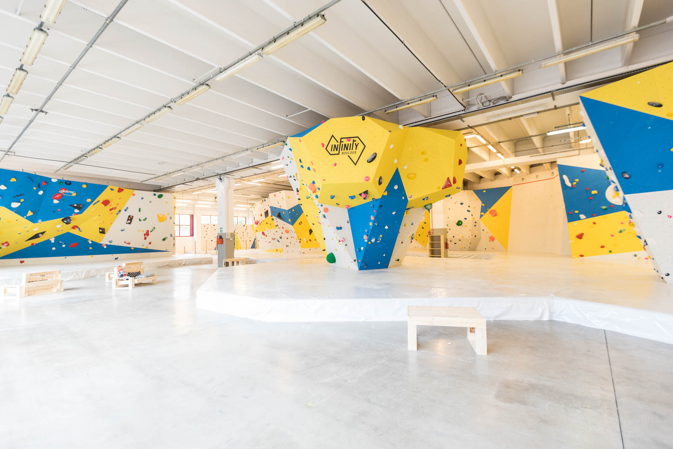

- 9.30-12.00: Bouldering and Climbing
- 13.00: Lunch (Pizza) in the Old Town
- 14.30-16.00: Treasure Hunt in the Old Town
- 16.00-17.00: Free Time in the Old Town
- 17:00: Bus back to Folgaria/Lavarone for the students who go back home with some Italian teachers
- Partner Teachers remain in Trento

- Wednsday 8th
- If the weather conditions are good:
- 8:00-8:30 students arrive at school
- 8.30 Bus to Caldonazzo
- 9:00-15:20: Dragonboat, Sup, Sail boat, Beach Volley and Slackline

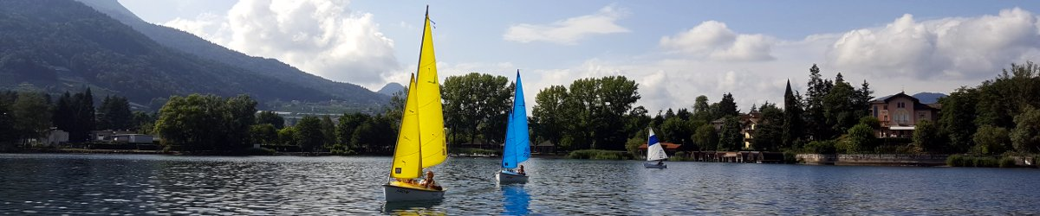

- Lunch Packet from the families and from the hotel for the teachers
- Walking along the sea shore till Calceranica

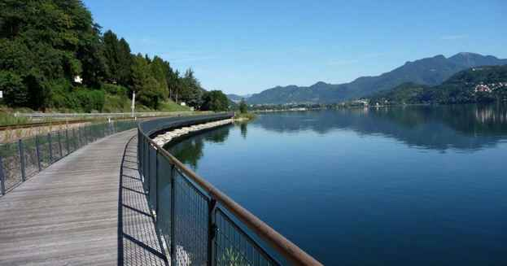

- 17.00: Bus back home
- Important: students need for these activities swimmsuit, towel, plastic slippers and a T-shirt to wear under the life jacket (this T-shirt will be wet after the activity so they have to bring another one). Hosting families will be informed and help the partner students.

- If the weather conditions are NOT good:
- 8:00-8:30 students arrive at school
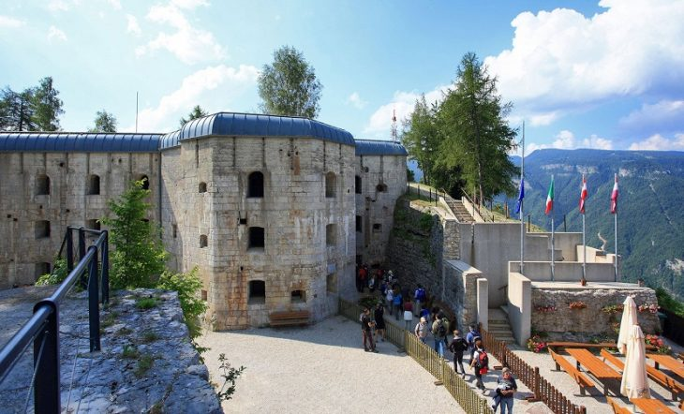
- 9.00-11.30 walk to fort Belvedere, important historical witnes of the First Wold War on our Highland (as the weather will be in this case not very good, students must bring an umbrela; hosting families will be informed)

- Lunch Packet from the families (too late to book the lunch in the school cantine for so many people) in the school
- 13.30-16.00 Activity at school: Cooking contest, Team Games at school, Yoga, Murales
- Free time
- 18.00 Bus back home
DINNER FOR TEACHERS

Thursday 9th “Europe Day” (Scuole in Festa)
- 8:00-8:30 students arrive at school
- 8.30 Bus to Folgaria
- 9.30 we sing all together “Ode to Joy” in German and English for the “Europe Day”
- 9.45-12.00: Team Games (all the students of the school will take part, the event is organized from the parents and involves all our community with mayors, press)
- 12.00-13.00: Lunch for all thanks to the parents who will cook for everybody
- 13.30 walk to Maso Spilzi if the weather is good (more or less 5 km). At 16.00 the event is over and the Erasmus Team will go to Folgaria and has free time in the village. If the weather is not good, the event is over after lunch and the Erasmus Team will go to Folgaria and have some free time. At 15.30 we come back to Lavarone and students will go home.

DINNER FOR TEACHERS

Friday 10th
- 8:00-8:30 students arrive at school
- 8.30-12.30 Para Olympic Games; students will be divided in mixed Teams and play basketball with special rules. Also grade 4th and 5th of our primary school will take part. The Games will be organized from our friend Mauro Bernardi, a Ski teacher on weehl chair.
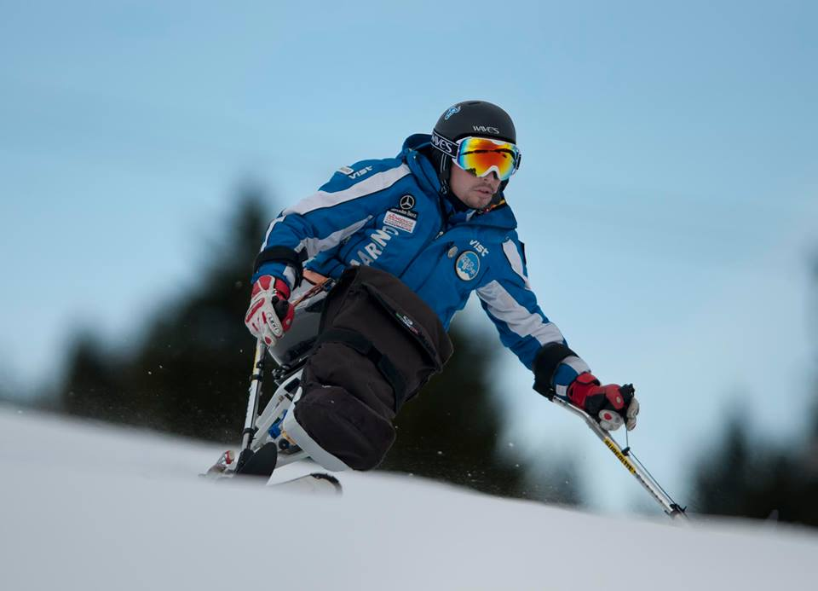

- 13.00 Lunch in the school cantine
- 14.00-16.00: walk to Lavarone Lake or to Palù Park, free time to play together
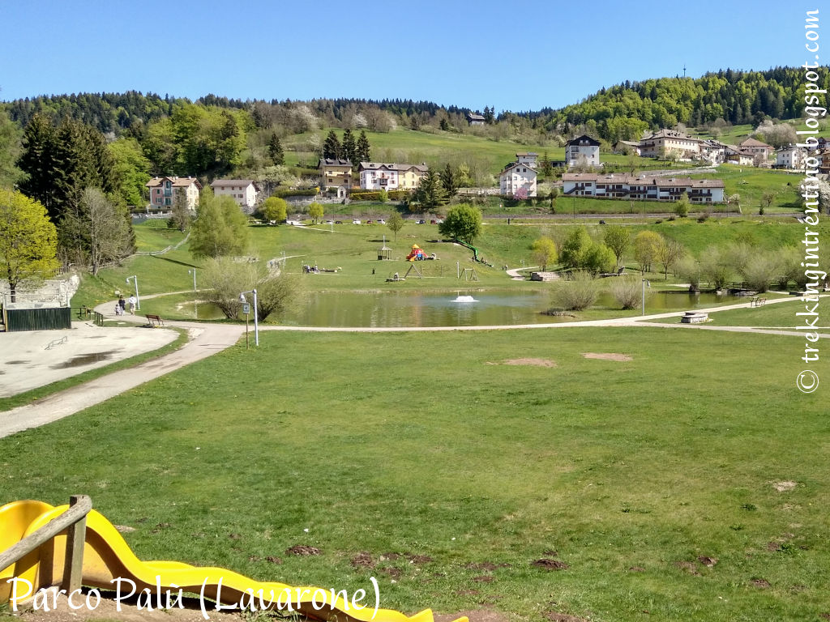
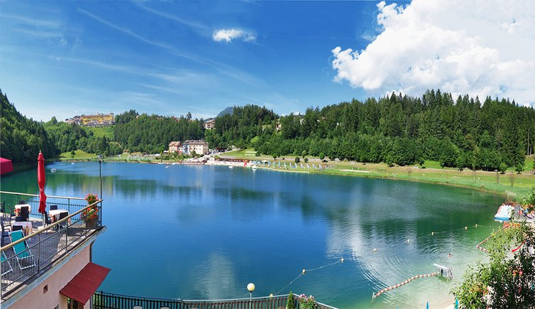

- 16.00 students go home
- 16.00-17.00: Coordinator Meeting
- 20.00-22.00 ERASMUS+ SHOW (Each partner team has 5’-10’ to present on the stage its country and school)

Saturday 11th
Departure of the Teams
AUSTRIA: 11.59 from Railway Station Trento
ESTONIA: 10.45 from Trento by bus to Bergamo. Flight from Bergamo Airport at 17.30
SPAIN: flight on May 12th from Bergamo at 9.25

