WALNUT ROLL

Ingredients
Dough
- 20 g fresh yeast
- 2 dl milk
- 550 g bread flour
- 60 g of sugar
- 1 dl oil
- 3 tbsp cream
- 2 tbsp rum
- 1 small pack of vanilla sugar
- a bit salt
- 1 egg
- 1 egg yolk
- some grated lemon zest
Filling
- 500 g minced walnuts
- 150 g sugar
- 2 dl very hot milk
- 1-2 tea spoons cinnamon
- 1 tea spoon rum
- 1 small pack vanilla sugar

Preparation
Mix the fresh yeast into the warm milk (8 tbl spoons), add some sugar (1 tea spoon) and flour (2 tbl spoons) and let it rise.
Mix the egg, egg yolk, sugar, salt, vanilla sugar, rum, oil, cream and grated lemon zest together.
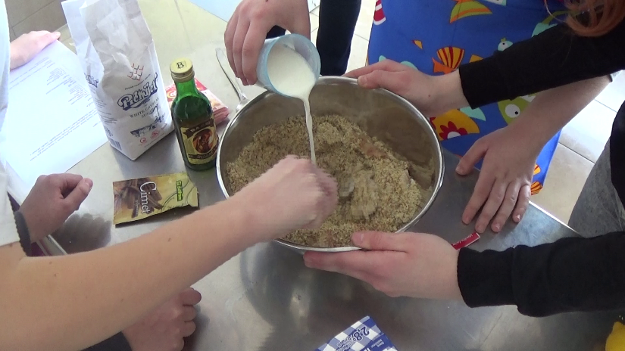
Combine the risen yeast, the above mixture, and the rest of the warm milk with flour.

Mix the dough with a ladle until it starts separating from the bowl and bubbles start appearing.
Leave the dough to rise. When risen mix it some more with a ladle, place it on a flour covered surface, split it in half, knead it with your hands, let it rest for a while and then roll it with a rolling pin.
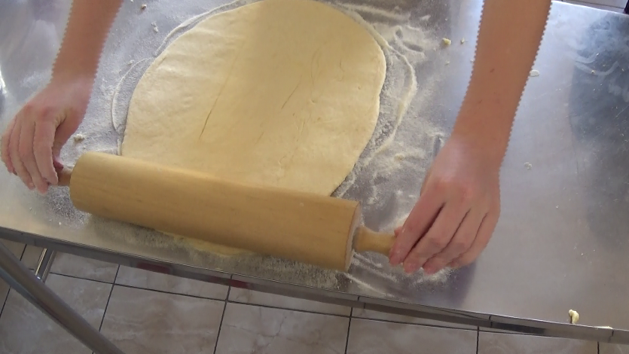

Spread the filling over the rolled dough, roll it over tightly, put it in a pan and wait for it to double.
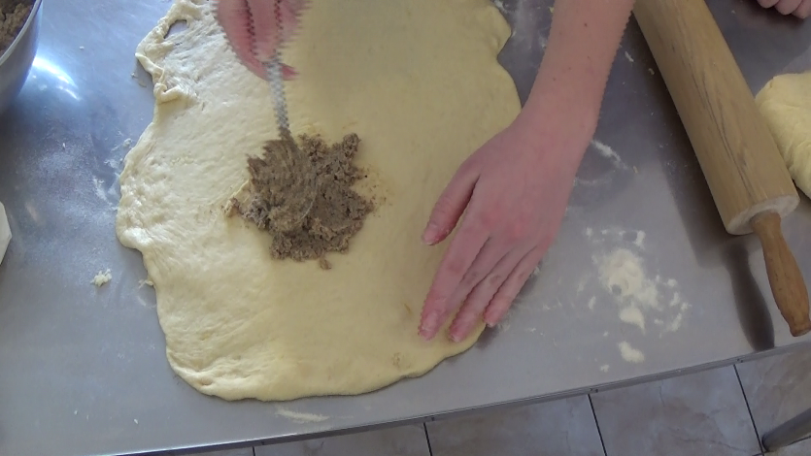

When the dough doubles bake it at 175°C for 50 minutes.

When baked cover it with a piece of cloth and let it cool.

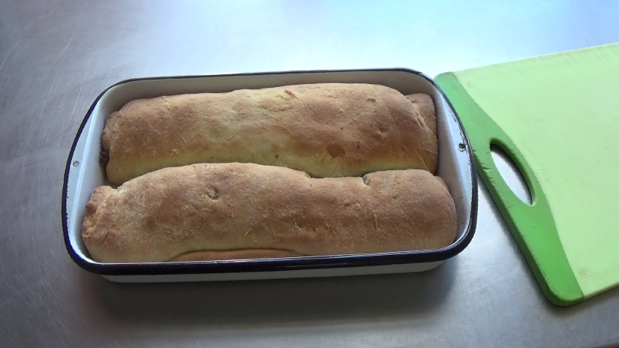

Add powdered sugar if you wish.

Filling

Mix minced walnuts with sugar and cinnamon. Add some rum to the boiling milk and pour it over the minced walnuts.

