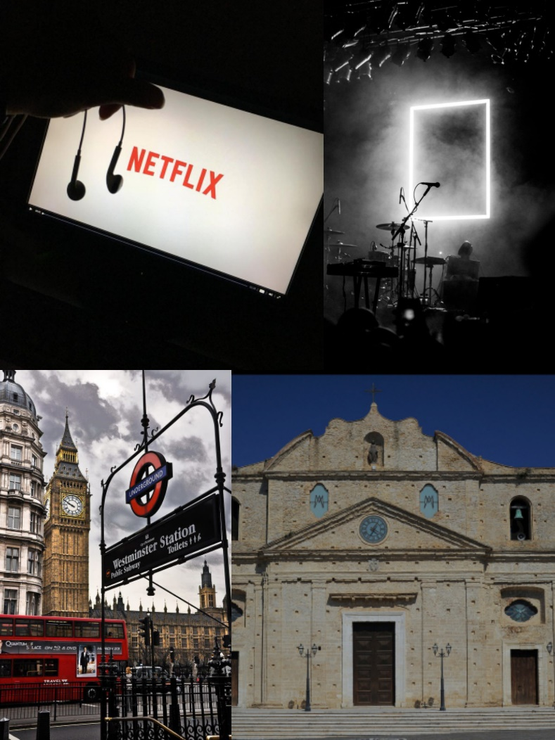

Hello! My name is Maria Grazia Mesoraca, I’m twelve years old.

I attend the second year, at “Fabio di Bona” secondary school. In my class we’re twenty-one students.

I like listening to music, learning English and watching tv series. My favourite subjects are maths and English.

I live in Cutro, in south italy. It’s a small town; with few people.