A story about forest
Kalju Kask
It was the march of the year 1949. It went to school back then. A boy who lived near me got deported. The whole deportion happened very fast, and quietly. When I told my mom about it, she didn’t know what happened. The Soviet army and a bunch of soviets took many people from our village and unicipality. Over the whole Estonia.
In the night, people were awakened and given an hour to pack up their stuff. Even if people had little babies or were sick, they were still sent. T’was a horrible event.
My brother was wanted too, but he moved to another unicipality earlier. Mom was scared, because the soviets had asked questions about him earlier and she thought that maybe they are gonna return and take us away because we were relatives. So we took our horses and rode to a nearby forest. We spent a night there. We slept on the blankets we took from home. In the morning we returned home. The following night was alike the first. In the third night we slept on the threshing floor.
Luckily, no one from our family was taken away.
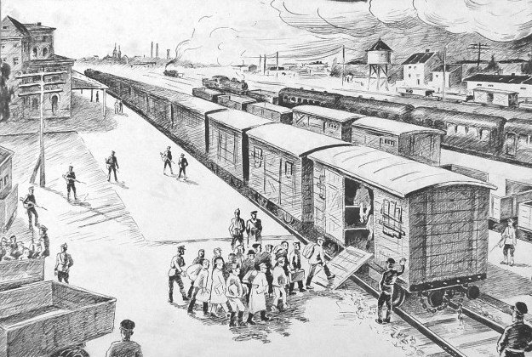
Link to the original recording: https://soundcloud.com/triin-nooska/jutt-metsast-kalju-kask-19012020/s-TuZD8

