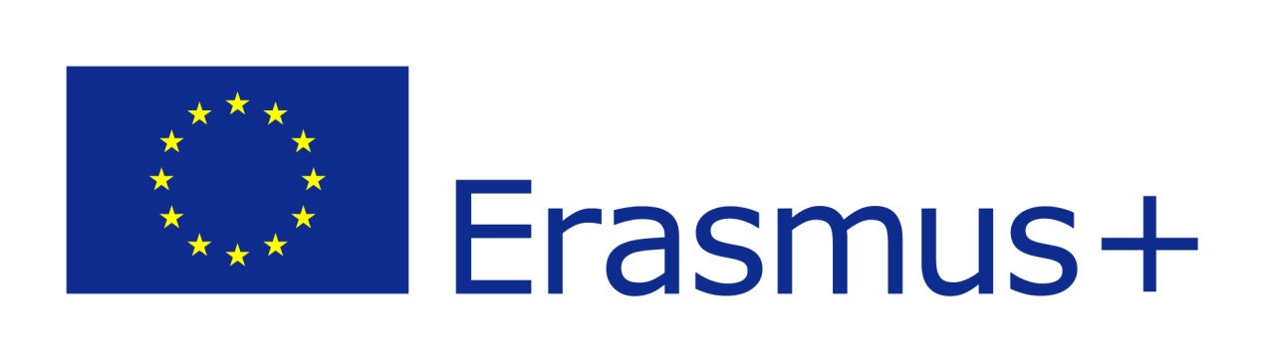

24th of May
12:00 – 14:00

- All activities will be posted by each country, on our e-twinning site and will be placed in relevant files.
- A file including all activities that should have been completed, was created and then posted on e-twinning, to indicate the activities which are on or out of schedule.
- It was agreed that at the next meeting of 26th May, there should be a PC, so that the coordinator could present the activities through internet connection.

26th of May
10:00 – 13:00

- An official big poster for the programme will be created by the coordinator (Spanish school).
- Database. There will be postings and new activities announced on the “Projectos Europeos S/he is equal in Europe” site. E-mails will be sent to each country indicating the steps that should be followed.
- Database-Equality library. After its creation, each country should mention the books being used for the promotion of equality.
- Mobility tools. Reference to the European form that each school should complete. Evaluations will take place at the end of the programme by each school separately.
- Ping pong story. It was agreed to prepare a booklet or short play relevant to the story already created. This activity will be presented during the last meeting in Turkey.
- It was suggested that at the end of the school year, each school could invite parents in order to inform them about the programme and its activities.
- Schools which have not completed their activities yet, were reminded to do so, according to schedule.
- All participating countries were also reminded about the e-twinning project, which is already open for everyone to use, upload and add relevant materials.
- The coordinator explained how to use the platforms related to the programme (e-twinning, mobility tools, Erasmus platform).

