We all share our results about this questionnaire during our meeting in Veliko-Tarnovo (Bulgaria).
Spain
These are the results of our questionnaires:
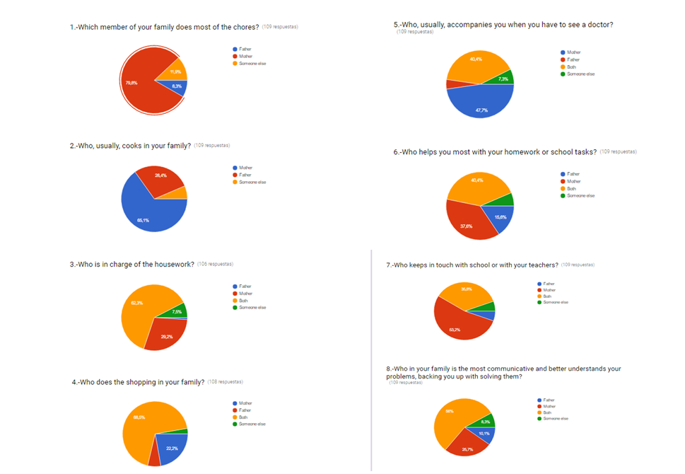

We can see women are in charge of most of the tasks related to house chores and children. I have to say that in Spanish society, sharing houseworks and parents’ corresponsability is an objective that has not yet been achieved. Even if things are changing and we can see that men and women do together some of the task (going shopping or understanding children), it is a slow process that sometimes has regressions and that is not spreaded in a uniform way in all the sectors of the society. So the reality shows us that is important to keep working about equality with children and young at school. For this reason the purpose of this project that is to promote equality in all of its aspects suits one of the main finalities of our school project.

In my personal opinion, women are responsible of this situation of "inequality" related to house chores, because they have been in charge of educating their daughters and sons for many years, and they have been transmitting these cultural stereotypes, sometimes without realising it. The school can help women and families to avoid these sexist behaviors through educating children in equality. In this way, the current Erasmus+ project can be a useful tool for teachers.

GREECE
“WHO DOES HOUSEWORK?"

1.Which member of your family does most of the chores?
father 5.5%
mother 70.0%
both 22.5%
someone else 2.0%

2. Who, usually, cooks in your family?
mother 64.0%
father 2.50%
both 19.0%
someone else 14.5%

3. Who is in charge of the housework?
father 0.0%
mother 49.0%
both 43.0%
someone else 8.0%

4. Who does the shopping in your family?
mother 15.0%
father 21.0%
both 58.5%
someone else 5.5%
5. Who, usually, accompanies you when you have to see a doctor?
mother 36.0%
father 15.0%
both 47.0%
someone else 2.0%

6. Who helps you most with your homework or school tasks?
father 17.0%
mother 26.50%
both 49.0%
someone else 7.5%

7. Who keeps in touch with school or with your teachers?
father 7.5%
mother 51.0%
both 39.5%
someone else 7.5%

8. Who in your family is the most communicative and better understands your problems, backing you up with solving them?
father 7.5%
mother 33.0%
both 50.0%
someone else 9.5%
Our results show that mother has the most important role in the house concerning the chores and the cooking.She is in touch with the teacher at school in order to keep up with the children’s progress. Both mother and father are in charge of the shopping or when there has to be a visit to the doctor. Both of them help with the school lessons. Together communicate with their children and help them deal with any problem that may exist.An “alarming” result,though, is that the role of the father alone, regarding the houseworks or things that involve children, has gained a very small percentage! Something like that reflects the way that children are brought up in Greek society.

GREECE
CONCLUSIONS
I believe that through this erasmus project equality in all aspects is promoted and will help teachers to make their students see beyond the stereotypes that our society imposes on all of us. It is a small step that will lead to bigger ones which will help minimise sexist behaviors in our lives.

ROMANIA
Theese are the results of the questionnaire about house role:
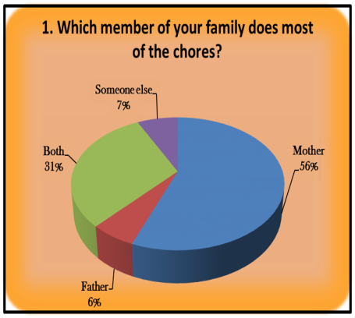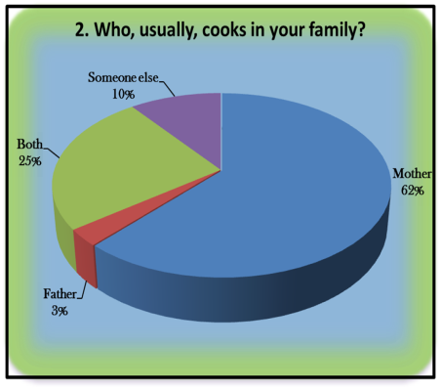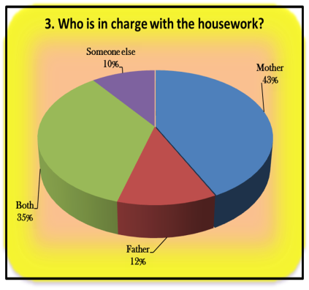
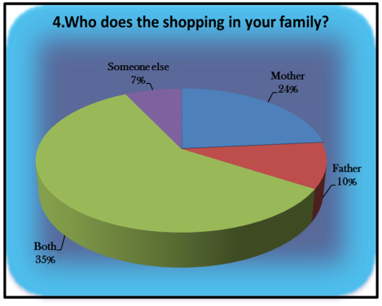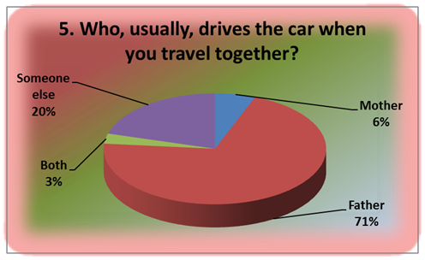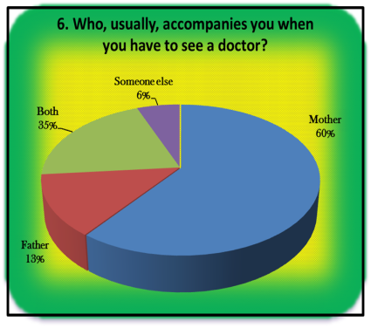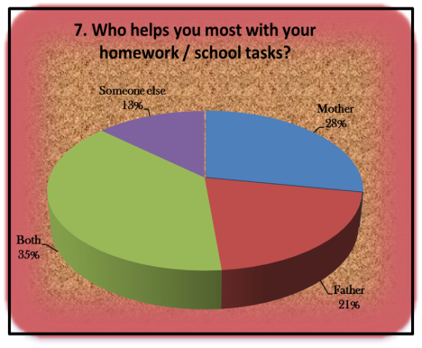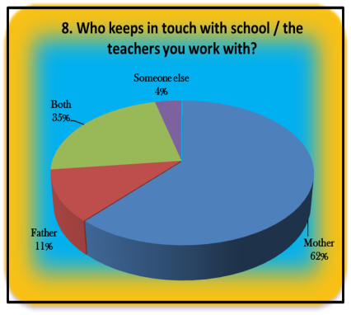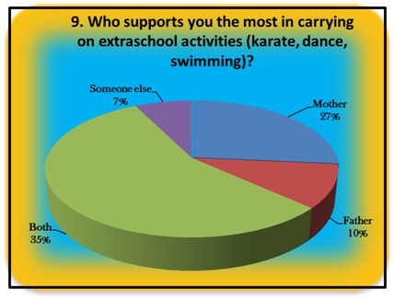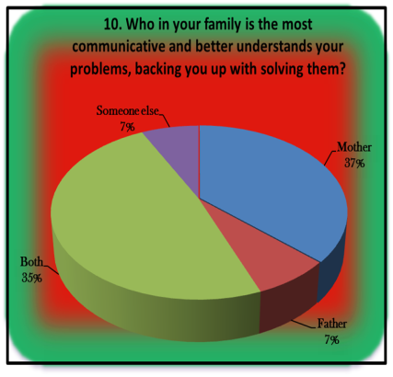
Conclusions: In every house mothers do most of the chores, usually they cook, they are in charge with the housework, keep in touch with the school, they are going with children to the doctor. But when we speak about communication and understanding problems, both of parents are good listener and try to solve children`s problems, mother and father are going together for shopping or they are helping the kids with their homework and they both are involved in kid`s extraschool activities.

POLAND

“WHO DOES HOUSEWORK?"

1.Which member of your family does most of the chores?
father 21.0%
mother 73.0%
both 0%
someone else 6.0%

2. Who, usually, cooks in your family?
mother 73.0%
father 16.0%
both 0%
someone else 10.0%

3. Who is in charge of the housework?
father 9.0%
mother 30.0%
both 57.0%
someone else 4.0%

4. Who does the shopping in your family?
mother 29.0%
father 13.0%
both 56.0%
someone else 2.0%
5. Who, usually, accompanies you when you have to see a doctor?
mother 54.0%
father 19.0%
both 23.0%
someone else 4.0%

6. Who helps you most with your homework or school tasks?
father 17.0%
mother 44.0%
both 17.0%
someone else 23.0%
nobody 4.0%
7. Who keeps in touch with school or with your teachers?
father 19.0%
mother 60.0%
both 19.0%
someone else 2.0%

8. Who in your family is the most communicative and better understands your problems, backing you up with solving them?
father 10.0%
mother 50.0%
both 33.0%
someone else 6.0%

PORTUGAL

Who does housework?
Questionnaire among students and families

1 – Which member of your family does most of the chores?
Father - 0%
Mother – 80%
Both – 20%
Someone else – 0%

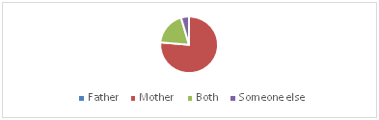

2 – Who, usually, cooks in your family?
Father – 24%
Mother – 52%
Both – 0%
Someone else – 24%

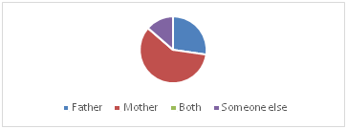

3 – Who is in charge of the housework?
Father – 0%
Mother – 92%
Both – 8%
Someone else – 0%

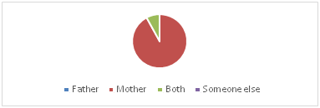

4 – Who does the shopping in your family?
Father – 4%
Mother – 68%
Both – 28%
Someone else – 0

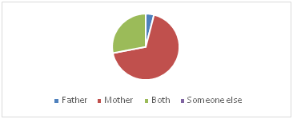

5 – Who, usually, accompanies you when you have to see a doctor?
Father – 0%
Mother – 67%
Both –33%
Someone else – 0%

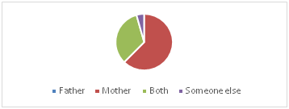

6 – Who helps you most with your homework or school tasks?
Mother – 16%
Father – 16%
Both – 55%
Someone else – 13%
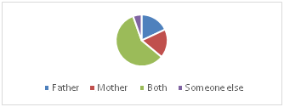

7- Who keeps in touch with your school or with your parents?
Father – 8%
Mother- 64%
Both- 28%
Someone else – 0%

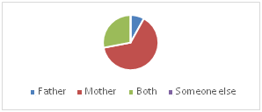

8- Who in your family is the most communicative and better understands your problems, backing you up solving them?
Father- 2%
Mother- 45%
Both – 45%
Someone else – 8%

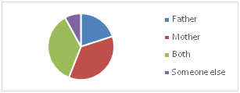

Conclusion:

"It is considered a domestic job everyone with 18 years that perform long duration services without profit."

It is common to think that every job did at home is a domestic job.

We are guided with our traditions and what the society tells us to do. The men’s usually work outside home and the women’s inside of it, although, today the tradition is a little changed.

Many years ago it was common to think that women’s should do all chores. Currently we say that almost all housework is shared between the whole family but that does not translate to the reality.

Conclusion:

Although mother’s do almost all the chores... For Example they cook, the clean the house, the keep in touch with the school.

There are some chores that are more shared then others, for example the school tasks are equally realized with mother's help and father's help. Both tend to be very communicative, both actively help the children with the homework and school task.

Overall, we think that with the Erasmus+ Project we will be able to promote and help everyone in the school environment to see beyond the rules imposed by our society and through small task and changes equalize this diferences between genders

