Team members: Buğlem, Elanur

Kind of game  (write the name of the game) | Ideas from the web (links) | Photos from the web | Your idea (drawing, sketch) | Materials | Equipment
Basketboll | https://www.youtube.com/watch?v=xO0uX7m7bXs | 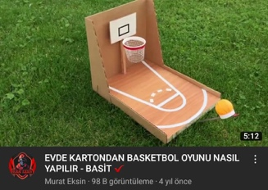 | 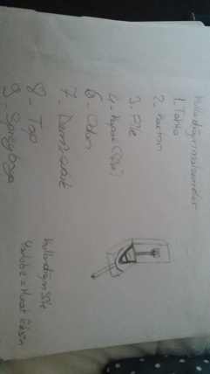 | Cardboard  Paper  spray paint  wood  net  bottle cap  iron bar | Scissors  utility knife

