Team members: Muhammed Emin, Çınar

Kind of game  (write the name of the game) | Ideas from the web (links) | Photos from the web | Your idea (drawing, sketch) | Materials | Equipment
pinball | http://www.kagitvs.com/pages/langirt.php | 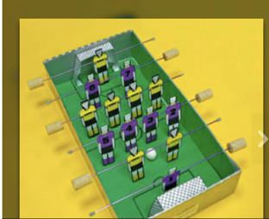 | 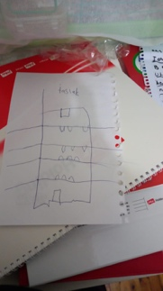 | Cardboard  Styrofoam  Paper | Scissors  spray paint  cardboard,  rod  felt-tip pen  utility knife  ping pong ball

