Team members: Besir Memishi, Simone Porchetti, Raffaello Marcucci, Pasquale Piedepalumbo

Kind of game  (write the name of the game) | Ideas from the web (links) | Photos from the web | Your idea (drawing, sketch) | Materials | Equipment
Tris | https://www.cartonemagico.it/shop/gioco-tris-giochi-duna-volta/ | 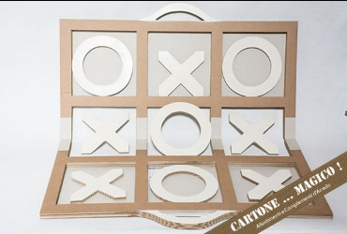 | 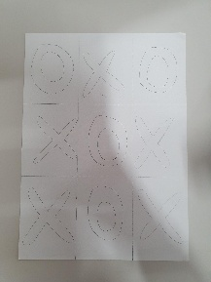 | Cardboard | Scissors
 |  |  |  | Paper | Glue
 |  |  |  |  | Ruler

