Team Member: Tabarek

Kind of game  (write the name of the game) | Ideas from the web (links) | Photos from the web | Your idea (drawing, sketch) | Materials | Equipment
Money Game | https://www.youtube.com/channel/UCaZcP6xzf61PJLTwCMh0fRg | 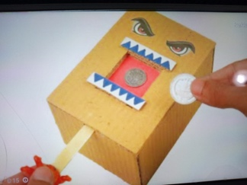 |  | Cardboard  Paper  ruler  wood stick | Scissors  utility knife  rubber

