Team Member: Yusuf Eymen, Fikret Yağız, Mehmet Efe

Kind of game  (write the name of the game) | Ideas from the web (links) | Photos from the web | Your idea (drawing, sketch) | Materials | Equipment
Football | https://www.youtube.com/watch?v=Jy26C2K9VkQ | 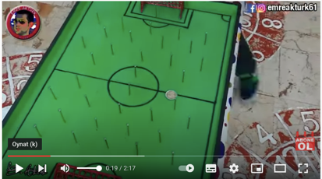 |  | Cardboard  Paper  Nail  spray paint | Scissors  utility knife  rubber  hammer

