Kind of game  (write the name of the game) | Ideas from the webs | Photos from the web | Your idea (drawing,sketch) | Materials | Equipment
An old cardboard landline telephone | https://funfamilycrafts.com/cardboard-telephone/ | 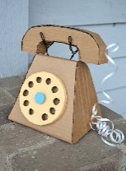 | 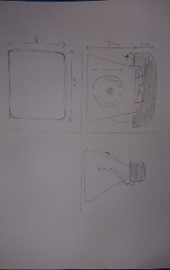 | Cardboard  Colors  Tape  Iron wires | Marker  Scissors  Ruler  Adhesive tape  Pencil  Compass

