Tradicional herbs and spices of Korčula

There are a lot of herbs and spices on the island of Korčula that make our island special and unique and can even be used in medicine or in a special diet, for example herbs like rosemary, laurel, basil, mint, sage, marjoram.
Rosemary or “ ružmarin “ in Croatian is used when cooking meals with pork, on steaks, and fish, especially oily fish, or even to make medicines which can ease muscle pain, improve memory, boost the immune and circulatory system and promote hair growth. 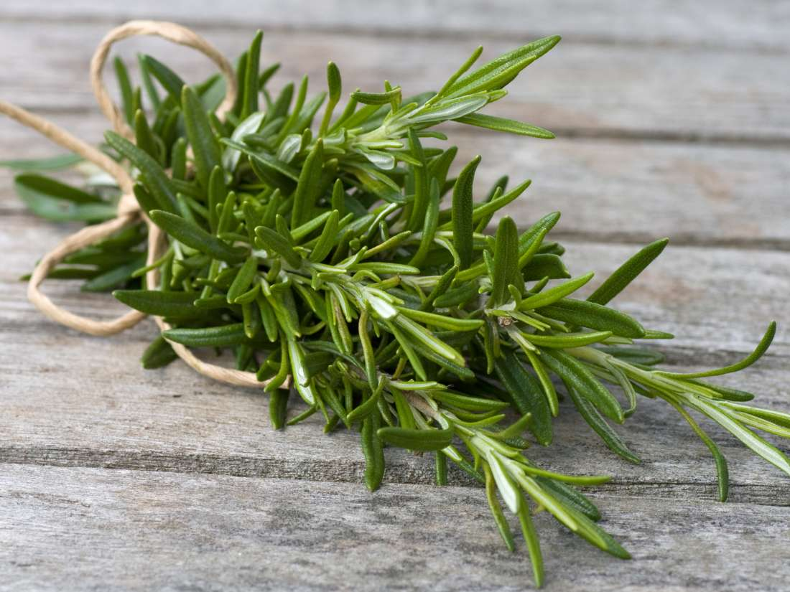
Laurel (bay leaves) or “ lovor “ is commonly used in cooking to add flavor to soups and stews.
Basil or bosiljak can be used as a topping to your pizza, a flavour booster in tomato souce or just as a garnish on a soup. As for health, it can help treat respiratory and chest problems such as bronchitis or coughs and relieve cold and flu symptoms.
Mint or “ metvica “ even menta is a herb most commonly used in teas to help when having stomachaches and indigestion.
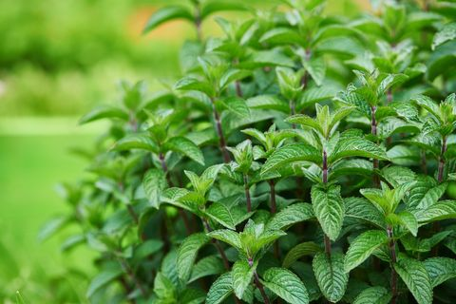
Sage or “ kadulja “ is a very common plant that is naturally found in the wild like wild mint and it is used to help with the loss of appetite, stomach pain, bloating and heartburn and can even be used as a flavour booster in meals that include pork, beef, and chicken and fatty meats, in particular.
And one of the last of many herbs is marjoram or “ mažuran “ , used in both fresh and dried form and it is subtler than its relative oregano and well suited to delicate vegetables, tomato-based dishes, such as tomato sauce and pizza. It is also benifitial when it comes to a runny nose, coughs, colds and infections.
All of these plants are the most used and the most popular spices and herbs, not just on Korčula, but in a lot of places in the world. Are they used in your area as well?

